Indiana Department of Child Services Child Welfare Title IV-E Waiver Demonstration Project Extension
FINAL report
Prepared by: the Indiana university evaluation team & the department of child services
Contents
Executive Summary 3
Background for Current Waiver Project 7
Numbers in the Demonstration 8
Evaluation Team 10
Outcome Study 15
Re-entries and Relative Placements 15
Relative Placements (QSR Data) 16
Substance Use Impact on Youth Outcomes 23
Concrete Services as a Prevention Service: The Evidence Base 26
Process Study 54
Concrete Services Spending pre and post-Waiver by Region 56
Regional Manager Interviews 2019 61
Regional Manager Interviews 2013-2019 64
Family Case Manager (FCM) Survey 71
Cost Study 102
Sub-Study: Family Centered Treatment (FCT) 106
FCT background 106
Research Questions: 107
FCT comparison 107
Extension Period Sub-study Activities 108
Updated Sub-study Analyses 108
Summary and Conclusions 115
Appendix A: QSR Outcome and Practice Indicator Scoring and Definitions 117

Executive Summary
In the years of the current Title IV-E Waiver demonstration period, Indiana was able to spend dollars more flexibly to expand services and to invest in evidence-based services on a statewide level. These investments aimed to provide new and effective services to support youth and families in the child welfare system.
During the demonstration period, the landscape of the population shifted in a way that was unexpected and to the extent that surprised a nation. Since 1999, Indiana has seen drug overdose deaths increase more than 500%. In a Jointpoint regression examining trends from 2010 to 2015, the CDC found that Indiana was one among 30 states to have significant increases in the rate of drug overdose deaths. And in 2013-2014, Indiana saw a statistically significant increase in the drug overdose death rate (increasing by 9.6%).
Public health reporting data are usually three to five years behind what is actually happening. Today we can see that the trend was beginning to increase significantly. During this time, DCS tried to implement better service recommendations and to incorporate better, real-time solutions to addressing their changing population.
During the Extension period of the IV-E Waiver in Indiana, the Evaluation Team and DCS have started two other evaluations, both of which address findings in the Final Report from the original Waiver. One is evaluating a Kinship Navigator Program with the implementation in Region 7 of the state with a comparison in Region 13. The other is a Peer Recovery Coach Program implemented in Marion Country, where entry into the program can occur from a random set of Family Case Managers who offer the program at the assessment or through the court, where only one court offers the program (the entry of any particular case into one court versus the other is also random).
The Title IV-E Waiver evaluation identified a number of successes and strengths. Our DCS/IU collaboration also noted some areas for continuing improvement. Brief overviews of the Outcome Study, Process Study, Cost Study, and Sub-study are presented in this section.

Outcome Study
During the extension period, the Evaluation Team investigated four of the major findings of the original Final Report: Re-entries, relative placements, substance use, and concrete service use. The Evaluation Team used administrative data and Quality Service Reviews (QSRs) to investigate re-entries, the outcome data on the use of relative placements and concrete services, and the impact of parent substance abuse on youth outcomes.
Administrative data of all children in the system from Waiver years 2012 to 2017 was used to investigate re-entries and relative placements. Re-entry data indicate that any re-entry within 360 days was more likely with: older age at case entry; more time out of the home; removal reasons of neglect, physical abuse, inability to cope, and parent in jail; greater number of removal reasons (Informal adjustment vs. child in need of CHINS), resource type-residential vs. foster family or placement provider vs. foster family; residential placement vs. child not removed; and a service recommendation of high intensive vs. no treatment or intensive community vs. no treatment. Re-entry was less likely when the child had a disability or was in an adoptive home.

In regards to relative placements, cases factors including cases with a lower number of placements and cases with caregivers who can manage the child’s stress and who have a significant network were associated placed with relatives. Having a relative licensed was associated with a lower number of placements and that the caregiver is able to manage the child’s stress and has a significant network.
Five rounds of the Quality Service Reviews (QSR) were completed from July 2007 to June 2017 consisting of 2611 of case reviews. Using the QSR data, use of relative care, effects of caregiver substance abuse, and concrete services were investigated. Relative care was a good alternative to in-home care when trying to reunify families. Children were scored higher in maintaining family relationships, stability, permanency, and well-being than non-relative placements. QSR data was then used to understand the impact of parental substance abuse on safety, permanency, and well-being. 41.9% of youth 10-18 in the QSR had a parent with substance use. Parent substance use did not impact safety or permanency, but did impact well-being. For youth that have a parent with substance use, maintaining relationships positively impacted well-being and teaming negatively impacted well-being. Finally, QSR and administrative data were merged to investigate concrete service use with placement stability. Stability increased over time for those who used concrete services and decreased for those who did not use concrete services. Overall, the use of concrete services was associated with increases in stability for youth at a higher level of need and this is particularly important for those at a higher level of instability. Both permanency and stability were associated with total concrete service spending providing evidence that concrete services may assist in maintaining placement stability.

Process Study
In the first year of the evaluation, DCS consistently used the phrase, “simply a funding mechanism” to refer to the Waiver and focused solely on making service enhancements. This philosophy changed starting in late 2013 with Casey Family Programs helping to direct better alignment of the Waiver with other established DCS goals. Through this mid-course correction of the process, DCS invested heavily in a Continuous Quality Improvement (CQI) strategy throughout the agency.
DCS invested in evidence-based programs, including Family Centered Treatment (FCT), which is the topic of the sub-study. The overall array of services available was expanded to include more programs and practices that have effectiveness data for children and youth in child welfare settings.
In the extension years, DCS invested in their internal evaluation capacities. They hired a team of analysts under the Deputy Director of Strategic Solutions and Agency Transformation, who manages the oversight of federal compliance requirements, grant reporting and grant applications according to federal guidelines. The research analysts evaluate the necessary data to assess the impact of system interventions in improving outcomes for Hoosier children and families. That office also works on the program improvement plan (PIP) planning and implementation process for the agency along with overseeing the agency’s continuous quality improvement efforts.
Concrete service use increased in all but one region over the demonstration period and had a significant increase before and after Waiver implementation in 13 regions. Regions without a significant change in spending were all adjacent to other states who were not involved in this State’s Waiver. This might suggest that individuals or families are using/accessing resources from contiguous states or private agencies.
Regional and Executive Managers were interviewed four times during the original demonstration and once in the extension period totaling 100 interviews that provided rich, compelling findings that contextualized the implementation of the 2012 Waiver. These interviews assisted in establishing trusting relationships with key members of the Department’s executive team, which aided the evaluation overall. During the extension, the evaluators observed Managers’ enhanced understanding and articulation of the Waiver across rounds of data, a positive culture shift between central office and the field, and more dedication enhanced data usage.
Five iterations of the Family Case Manager (FCM) Survey were completed as part of the Process Study with an additional 6th round in the extension period. From Rounds 1 to round 6, FCM perceptions of safety, permanency, and well-being at case opening decreased and at case closure perceptions increased. At case closure, current living arrangement, health, emotional status, developmental status, learning status, and independence development increased from Rounds 1 to Round 6. FCMs in round 6 had worked for DCS for a shorter period than any other iteration. In regards to turnover, emotional supervision, distributive justice, and professional self-care increased FCM intent to stay in child welfare, where secondary traumatic stress decreased their intent to stay. The secondary traumatic stress was greater for ongoing and child service workers than assessment workers. FCMs had a positive outlook on FFPSA. Overall, FCMs perceived motivational interviewing as the most effective service, and although the evidence-based programs were rated as the most effective, they were not necessarily the most needed. Relating to Child and Family Team Meetings (CFTMs), fidelity fell in 2018 compared to 2017. Interestingly, FCMs with social work degrees had lower fidelity to CFTMs. Higher fidelity was associated with better workload manageability and confidence in implementation of CFTMs. but the teamwork indicator increased significantly. The results suggest that organizational support and effective supervision are necessary to effectively manage FCMs’ workloads so that they have enough time to prepare and implement the high-quality of CFTM.

Cost Study
As part of the overall Terms and Conditions for the 2012 Title IV-E Waiver, the impact of the Demonstration Program was evaluated by examining costs related to this program. Any costs saved by the improved Waiver activities were to be re-invested into the provision of services at an earlier point in the exposure of youth and families to the DCS system.
Our DCS/IU team evaluated the cost effectiveness of Waiver services and described the allocation of costs over time. Total spending by the Indiana Department of Child Services increased significantly from the beginning of this Waiver until 2017, where considerably smaller increases occurred in 2018 and 2019. This increase in spending was driven by the significant increase of cases from over 12,000 in 2012 (beginning of this Waiver) to 29,000 at present. Over this time, the proportion of case types (e.g., In-home, relative, foster home, residential, and other) remained fairly stable, with a slight drop in in-home cases in the extension period, which would be expected after policy changes aimed at keeping families out of care when there is not a true reason to intervene.
Given the funding structure for the State of Indiana, DCS has relied on the flexible funding of the Waiver to address this overall increase in case costs. By moving Waiver funding forward, DCS has responded to these increased needs by providing appropriate services. Details about cases and funding will be provided in the main report below.
Overall, the State has reduced Waiver utilization in 2017 and 2018 so that Waiver spending remains cost neutral. The use of Waiver funds were able to slightly increase in 2019. Waiver funding allowed DCS to provide more services earlier for families entering the system so that higher cost services (e.g., residential) were avoided – which saved money. Waiver funds that were saved from these higher cost services were shifted to families as early interventions – which is stated in the terms of this funding.

Sub-study
Also, as part of the original Terms and Conditions of the 2012 Waiver, our project team developed a sub-study which focused on the implementation and effectiveness of a specific treatment program. After considering options, we developed a research design that evaluated the impact and effectiveness of Family Centered Treatment (FCT) which was implemented due to Waiver funds. During the extension period, the Evaluation Team provided the original and updated sub-study data to other jurisdictions who were submitting FCT for transitional payments to the IV-E Clearinghouse. Following the work, FCT was approved for use by all states during the transition period as a ‘well-supported’ evidence-based practice.
The effectiveness of the Family Centered Treatment (FCT) intervention was studied from January 1, 2015-December 31, 2015. All children referred for FCT received services as indicated via the model. Fidelity was established using a manualized training and certification of home based workers, supervision, consultation with national FCT Foundation clinicians, and monthly compliance checks on dosage of the intervention. Children (and families) in the FCT treatment group were matched with children (and families) who received usual and customary care using propensity score matching. Matching characteristics were age, gender, race, region, county, number of focus children, involvement status, permanency goal, CANS score, and risk score. Overall, 20, 779 children were within DCS between January 1, 2015 and December 31, 2015 and 230 of those children not involved with the justice system received FCT. Matching characteristics were too restrictive and we were unable to obtain sufficient number of pairs to conduct an analysis. Therefore, two matching criteria, region and permanency were removed as they were the characteristics restricting matching. The final data set then included 187 children who received FCT and 187 children who did not. The sample set demonstrated similar demographic characteristics with no significant differences.
During the extension period, we performed updated analyses on CANS scores, risk and safety assessment, and cost. In regards to CANS scores, the FCT group had higher CANS than the non-FCT group at the beginning of their cases and lower CANS scores than the non-FCT group at the end of their cases. FCT families had a median score of “moderate risk” at their last visit compared to a median score of “high risk” at their first visit. In regards to their safety score, FCT families had a median safety score of “safe” at their last visit compared to a median score of “conditionally safe” at their first visit. FCT youth had a significantly higher cost in services than non-FCT youth (t[df]= -5.41 [26566],p< .001). FCT youth were significantly less likely to receive services classified as preservation services (n=10,539 vs. 9,256) and care of wards in foster homes (n=1,556 vs. 1,139) than non-FCT youth. FCT youth were significantly more likely to receive miscellaneous costs for wards (n=973 vs. 324) and care of wards in institutions (n=1,522 vs. 762) than non-FCT youth $(χ^2 [df]=738.76 [6],p< .001).$

Background for Current Waiver Project
Indiana has had the benefit of participating in a Child Welfare Waiver Demonstration Project (herein referred to as the ‘Waiver’) since 1998. Indiana’s Waiver was extended in 2003, 2005, 2010, 2012, and most recently, in 2017. On September 14, 2012, the U.S. Department of Health and Human Services (HHS), Administration for Children and Families (ACF), approved the Waiver Terms and Conditions for an expansion of the State’s Waiver project. Indiana DCS accepted the Terms and Conditions on September 27, 2012. This Waiver period covered five years, beginning July 1, 2012 and ending June 30, 2017. An extension was granted, and this report covers the reporting period from January 1, 2019 through September 30, 2019 and provides an overview of Waiver activities completed to date, in addition to project evaluation efforts, findings, and planned activities in the future beyond the Waiver.

During the final report preparation period, changes in leadership positions have occurred. Eric Miller became the new chief of staff in late 2017. On December 28, 2017 the Governor of Indiana announced the new director of DCS, Terry Stigdon. In February 2018 the current Deputy Director of Field Operations retired. Sarah Sailors was named the new Deputy Director of Field Operations in April 2018.
Through the Waiver, DCS has utilized innovative methods to ensure that families are provided with services that meet their needs, and when possible, allow children to remain safely in their home. Waiver funding is integral to the agency’s delivery of services as it enables DCS to offer an expanded array of concrete goods and services to help families succeed. These types of services are typically only available through other funding sources. Some of the concrete services supported by Waiver funding include: payment of utility bills, vehicle repairs, before/after school care, respite care, baby monitors, and cleaning of the home environment. These valuable services for families often prevent the need for removal of one or more children.

The Waiver also allows the State to invest in an improved and expanded array of in-home and community-based family preservation, reunification and adoption services. Examples of new programs implemented as a result of the Waiver flexibility include: a Children’s Mental Health Initiative, a Family Evaluation/Multi-Disciplinary Team, Child Parent Psychotherapy, Sobriety Treatment and Recovery Teams, and comprehensive home-based services, such as Family Centered Treatment, Motivational Interviewing, and Trauma-Focused Cognitive Behavioral Therapy. Additional information regarding key projects is described below:

Sobriety Treatment and Recovery Teams (START): This promising practice model is currently being utilized in Kentucky and piloted in Indiana. The program is intended to alter the child welfare and service approach to serving parents with substance use disorders who have children under the age of 5. The service includes a triad approach with a specially trained Family Case Manager, a Family Mentor (someone with experience in the child welfare system and a history of addiction), and a Treatment Coordinator. This team provides quick access to assessment and services, as well as increased support and monitoring. For more information, please reference:
https://www.zerotothree.org/resources/907-sobriety-treatment-and-recovery-teams-ohio

Trauma Focused Cognitive Behavioral Therapy (TF-CBT): This evidence-based practice model is being provided as a component of DCS’ Comprehensive Home Based Services. Indiana is utilizing service mapping to identify appropriate families to participate in this service. Children who have experienced significant trauma and have a non-offending caregiver who is able to participate in services are included in the target population. Children are identified utilizing the Child and Adolescent Needs and Strengths (CANS) Assessment. The number of children who have been assessed for TF-CBT and the number of referrals are listed in Table 1.

Currently, Indiana has 127 certified TF-CBT clinicians. They can be found at https://tfcbt.org/members/. The certification process requires the clinician be licensed and includes training, coaching and consultation which can take up to 2 years to complete. The number of therapists in the training process who will become certified is unknown. DCS has provided Trauma Focused - Cognitive Behavioral Therapy (TF-CBT) training opportunities for therapists throughout Indiana during SFYs 2014 and 2015. The Indiana Division of Mental Health and Addiction (DMHA), the Indiana Association of Resources and Child Advocacy (IARCA) and other agencies also provided training during this time period. DCS does not have data for every person taking part in the training, but estimates the number in process to be greater than 500.

Indiana’s Waiver project remains focused on improving the effectiveness and efficiency of child welfare services through expanded eligibility and a broader service array. DCS has routinely monitored the effectiveness of their practice model in order to establish goals and direction with regard to Waiver spending and service delivery. To further support these efforts, DCS has implemented a Continuous Quality Improvement (CQI) process to serve as the foundation for our continuum of service provision. This CQI framework will serve as the method for evaluating service needs, determining the quality of service being delivered and the impact of services on child and family outcomes for existing as well as new Waiver-funded services.

Numbers in the Demonstration
All children and families in Indiana receiving services from DCS after July 1, 2012 have been assigned to the Waiver demonstration and are thus considered Waiver cases. Since all children are covered under the Waiver, DCS is providing the number of cases referred for initiatives that began following the 2012 Waiver initiation. The services outlined below include those provided through the Children’s Mental Health Initiative and the Comprehensive Home Based Services programs. Because of the extensive training funded by DCS and provided throughout the State, there are many more families receiving the Evidence Based Practice models outlined below. For example, DCS continues to offer trainings in TF-CBT throughout the State for residential and community based providers. Many families are receiving the service through residential programs and home-based therapy programs. At this point, those services are not easily identified and isolated in the service tracking system. DCS continues to work toward improving data collection for these services.

*Children’s Mental Health Initiative (CMHI)
- Assessment for Eligibility: The total number of children who were referred for a CMHI assessment between the dates given.
- Services: The total number of children who had at least one referral for a CMHI service, other than an assessment, between the dates given. The same children may be counted as being referred for multiple years. Please note: the methodology for counting service referrals has changed from previous reports to provide more consistent reporting across demonstration programs. As a result, some counts may have changed.

Table 1. Numbers in the Demonstration
Service* Referrals | SFY2012  7/1/11-6/30/12 | SFY2013  7/1/12-6/30/13 | SFY2014  7/1/13-6/30/14 | SFY2015  7/1/14-6/30/15 | SFY 2016  7/1/15-6/30/16 | SFY 2017  7/1/16-6/30/17 | SFY 2018  7/1/17-6/30/18 | SFY 2019 7/1/18-6/30/19
Alternatives for Families Cognitive Behavioral Therapy | 0 | 0 | 0 | 11 | 5 | 2 | 5 | 1
Cognitive Behavioral Therapy | 0 | 0 | 4 | 25 | 37 | 28 | 42 | 11
Family Centered Treatment | 0 | 0 | 272 | 359 | 401 | 422 | 340 | 333
Intercept | 116 | 182 | 201 | 193 | 187 | 175 | 175 | 246
Motivational Interviewing | 0 | 0 | 7 | 82 | 157 | 219 | 241 | 273
Trauma Focused Cognitive Behavioral Therapy | 0 | 0 | 18 | 98 | 110 | 83 | 61 | 56
START | 0 | 0 | 14 | 20 | 19 | 21 | 9 | 0
* Referrals counted during SFY during which they were created. All referrals are only counted once in Table.

Evaluation Team
On August 20, 2018, the Principal Investigator (PI), James A Hall, Ph.D. passed away. Barbara Pierce, Ph.D. has stepped into the PI role.
An Evaluation Team from the Indiana University School of Social Work and School of Medicine is conducting the evaluation of the Waiver. The Evaluation Team consists of:

- Principal Investigator: Barbara J. Pierce, Ph.D., Associate Professor in the School of Social Work, Robert Wood Johnson Clinical Scholar Fellow.
- Project Manager: Teresa (Tracy) M. Imburgia, MPH, Certified Clinical Research Professional (CCRP).
- Data Manager: Pediatrics IT Services
- Statistician: Devon J. Hensel, Ph.D., Associate Research Professor of Pediatrics and Sociology
- Research Assistants:
  - Jangmin Kim, Ph.D, former IU doctoral student now Assistant Professor, Texas State University
  - Eprise Armstrong-Richardson, M.S.W., Ph.D. candidate, IU Presidential Scholar
  - Kori R. Bloomquist, Ph.D., former IU doctoral student now Assistant Professor, Winthrop University,
  - Drew Winters, Ph.D., M.S. W.
  - Finneran K. Muzzey, doctoral student, Michigan State University.

In addition to the work provided for the evaluation terms and conditions, the Evaluation Team has been productive over the demonstration period with the following contributions to science as listed below.

Peer-reviewed Publications
- Kim, J., Trahan, M., Bellamy, J., & Hall, J. A. (2019). Advancing the innovation of family meeting models: The role of teamwork and parent engagement in improving permanency. Children and Youth Services Review, 100, 147-155.
- Kim, J., Yi, E., Pierce, B., & Hall, J. A. (2019). Effective workload management in child welfare: Understanding the relationship between caseload and workload. Social Policy & Administration. DOI: https://doi.org/10.1111/spol.12499
- Trahan, M., Kim, J., Bellamy, J., & Hall, J. (2019). Parenting engagement in foster care placement stability and permanency. The Journal of the Society for Social Work and Research (In press).
- Bloomquist, K. R., Imburgia, T. M., Danh, M., Pierce, B., & Hall, J. A. (2018). Studying process in a Title IV-E waiver evaluation project: Interviews with regional and executive managers. Journal of Public Child Welfare, 1-24.
- Kim, J., Imburgia, T. M., Armstrong‐Richardson, E., Jaggers, J. W., & Hall, J. A. (2018). Effects of case characteristics on teamwork in family meetings. Child & Family Social Work.
- Kim, J., Park T., Pierce B.J., Hall J.A. Interaction of Work Experience and Educational Background of Frontline Child Welfare Workers. (2018). Child Welfare Workers’ Perceptions of Supervisory Support: A Curvilinear Interaction of Work Experience and Educational Background, Human Service Organizations: Management, Leadership & Governance. 42:3, 285-299, DOI: https://doi.org/10.1080/23303131.2017.1395775
- Jaggers, J. W., Richardson, E. A., & Hall, J. A. (2018). Effect of Mental Health Treatment, Juvenile Justice Involvement, and Child Welfare Effectiveness on Severity of Mental Health Problems. Child Welfare, 96(3).
- Jaggers, J. W., Beerbower, E., Kondrat, D., Aalsma, M. C., & Hall, J. A. (2018). Contextual Factors Influencing Recommendations for Service Provision by Guardian ad litem and Court-Appointed Special Advocates. Families in Society, 99(3), 244-255.
- Hall, J. A., Imburgia, T. M., Bloomquist, K. R., Kim, J., Pierce, B. J., Jaggers, J. W., Armstrong-Richardson, E., Danh, M., & Hensel, D. J. (2017). Partnership for Multimethod Evaluation in Child Welfare: Title IV-E Waiver Demonstration Program. Child Welfare, 95(5).
- Pierce, B.J., Jaggers, J.W., Bloomquist K.R., Imburgia T.M., Danh, M., Hall, J.A. (2017). Utilization of concrete services in child welfare: A mixed-method analysis of a title IV-E Waiver demonstration program. Journal of Public Child Welfare. http://dx.doi.org/10.1080/15548732.2017.1377139
- Kim, J., Pierce, B. J., Jaggers, J., Imburgia, T., & Hall, J. (2016). Improving child welfare services with family team meetings: A mixed methods analysis of caseworkers’ perceived challenges. Children and Youth Services Review 70 (2016): 261-268. http://dx.doi.org/10.1016/j.childyouth.2016.09.036
- Jaggers, J.W.; Armstrong Richardson, E.; Aalsma, M.; Hall, J.A. (2015). Resources, Race, & Placement Frequency: An Analysis of Child Well-Being. Child Welfare, 94(6).
- Bloomquist, K.R., Imburgia, T.M., Danh, M., Pierce B.J., Hall, J.A. (2018) Studying process in a Title IV-E waiver evaluation project: Interviews with regional and executive managers. Journal of Public Child Welfare. https://doi.org/10.1080/15548732.2018.1473823

Oral Presentations at National Conferences
- Pierce BJ, Imburgia TM, Winters DE, Muzzey FK, Armstrong-Richardson E. Interventions of Indiana’s IV-E Waiver Demonstration. Oral symposium led by Pierce at the Society for Social Work and Research. Washington, DC in January, 2020.
- Muzzey FK, Imburgia TM, Pierce BJ. Effectiveness of Family Centered Treatment Using Propensity Score Matching in the Indiana IV-E Waiver Demonstration. Oral symposium presented by Muzzey at the Society for Social Work and Research. Washington, DC in January, 2020.
- Imburgia TM, Armstrong-Richardson E, Winters DE, Pierce BJ. The Increase and Impact of Relative Placements on Safety, Permanency, and Well-Being during Indiana's IV-E Waiver. Oral symposium presented by Imburgia at the Society for Social Work and Research. Washington, DC in January, 2020.
- Winters DE, Imburgia TM, Armstrong-Richardson E, Pierce BJ. Effects of Concrete Service Spending on Stability for Youth Receiving Child Welfare Services. Oral symposium presented by Winters at the Society for Social Work and Research. Washington, DC in January, 2020.
- Kim J, Pierce BJ. Model fidelity and child well-being in family team conference: The moderation effect of racial matching. Presented by Kim at the Society for Social Work and Research, Washington, DC, January 2020.
- Kim, J., Choi, M. J., & Pierce, B. Does parent engagement enhance children’s well-being in Family Team Conference? Not a panacea for families with domestic violence. Poster presented at the 32nd Annual Research and Policy Conference on Child, Adolescent, and Young Adult Behavioral Health, Tampa, FL, March 2019.
- Trahan, M., Kim, J., Bellamy, J., & Hall, J. Parenting engagement in foster care placement stability and permanency. Paper presented my Trahan at the Society for Social Work and Research, San Francisco, CA, January 2019
- Yi, EH, Kim J, Jaggers JW, Pierce BJ, Hall JA. Evaluation of Service Quality in the Title IV-E Waiver Demonstration Program in Indiana. Oral presentation presented by Yi at the 63rd Annual Council on Social Work Education Annual Program Meeting. Dallas, TX, October 2017.
- Kim J, Park T, Pierce BJ, Hall JA. Supportive Supervision in Child Welfare: Interaction of Work Experience and Educational Background. Oral presentation presented by Kim at the 63rd Annual Council on Social Work Education Annual Program Meeting. Dallas, TX, October 2017.
- Armstrong-Richardson E, Kim J, Imburgia TM, Jaggers JW, Hall JA. Relationship between Systems-Related Indicators and Connectivity among Transition Aged Youth in Foster Care. Oral platform presentation presented by Armstrong-Richardson at the Society for Adolescent Health and Medicine Annual Meeting, New Orleans, March 2017.
- Hall JA, Imburgia TM, Kim J, Armstrong-Richardson E, Bloomquist KR, Pierce BJ. Symposium: Multimethod Evaluation: Title IV-E Waiver Demonstration Program. Symposium presented by Hall and Pierce at the Society for Social Work and Research, New Orleans, January 2017.
- Imburgia TM, Pierce BJ, Danh M, Bloomquist KR, Hall JA. Building Partnerships between Evaluators and Child Welfare Agencies through Continuous Quality Improvement and Instrument Development. Symposium presented by Kim at the Society for Social Work and Research, New Orleans, January 2017.
- Kim J and Armstrong-Richardson E. Improving the Quality of Teaming from Multiple Stakeholder Perspectives. Symposium presented by Imburgia at the Society for Social Work and Research, New Orleans, January 2017.
- Bloomquist KR and Imburgia TM. Exploring the Use and Impact of Concrete Services in Child Welfare Practice. Symposium presented by Bloomquist at the Society for Social Work and Research, New Orleans, January 2017.
- Bloomquist KR, Danh M, Imburgia TM, Pierce BJ, Hall JA, Jaggers J, Kim J. Using Qualitative Interviews in State-level Child Welfare Evaluation Research. Oral platform presented by Bloomquist at the Annual meeting of the Tenth Annual Congress of Qualitative Inquiry, University of Illinois at Urbana-Champaign, Urbana, IL, May 2016
- Hall JA, Cummings T, Danh M, Bloomquist KR, Pierce BJ. Symposium: Mixed Methods Evaluation: Title IV-E Waiver Demonstration Program. Oral symposium presented by Hall at the Society for Social Work and Research. New Orleans, LA, January 2015.
- Cummings T, Danh M, Bloomquist KR, Hensel D, Barton WH, Hall JA. Measuring child and adolescent well-being in the child welfare system. Oral symposium presented by Cummings at the Society for Social Work and Research. New Orleans, LA, January 2015.
- Danh M, Cummings T, Bloomquist KR, Hensel D, Barton WH, Hall JA. Family Case Manager Perceptions of Client Needs and System Services. Oral symposium presented by Danh at the Society for Social Work and Research. New Orleans, LA, January 2015.
- Bloomquist KR, Cummings T, Danh M, Hensel D, Barton WH, Hall JA. Regional & Executive Manager Interviews 2013 & 2014. Oral symposium presented by Bloomquist at the Society for Social Work and Research. New Orleans, LA, January 2015.
- Bloomquist, K. R. (2014). “Communication, Communication, Communication”: Qualitative Analysis in Title IV-E Evaluation Research. Poster presented at the 60th Annual Council on Social Work Education Annual Program Meeting. Tampa, FL, October 2014.
- Bloomquist KR, Danh M, Graham-Dotson Y, Cummings T, Barton WH, Hall JA, Turney, B. Case Study Analysis in Child Welfare Evaluation Research. Oral platform presented by Bloomquist Annual meeting of the Tenth Annual Congress of Qualitative Inquiry, University of Illinois at Urbana-Champaign, Urbana, IL, May 2014.

Poster Presentations at National Conferences
- Bloomquist KR, Pierce BJ. Transitions from the Title IV-E Waiver to Family First Prevention and Services Era: Regional Child Welfare Managers’ Perceptions and Experiences. 16th International Congress of Qualitative Inquiry. Urbana, IL, May 2020.
- Bloomquist KR, Pierce BJ. Child Welfare Workforce Climate & Caseworker Professional Well-being. 35th annual International Society for Traumatic Stress Studies. Boston, MA, November 2019.
- Muzzey FK, Imburgia TM, Pierce BJ. Effectiveness of Family Centered Treatment Using Propensity Score Matching in a Child Welfare Setting. National Child Welfare Evaluation Summit. Washington, DC, August 2019.
- Imburgia TM, Armstrong-Richardson E, Hensel DJ, Hall JA. Placement decisions impact on youth well-being in the foster care setting. Poster presentation at the Society for Adolescent Health and Medicine Annual Meeting, Washington, DC, March 2019.
- Imburgia TM, Hensel DJ, Pierce BJ, Armstrong-Richardson E, Hall JA. Strategies to improve adolescents’ status in caregiver substance abuse cases in the child welfare system. Society for Adolescent Health and Medicine Annual Meeting, Seattle, WA, March 2018.
- Armstrong-Richardson E, Imburgia TM, Hall JA. Case Characteristics Influencing Difficulty Placing Child Welfare Children and Youth in Treatment Facilities. Society for Adolescent Health and Medicine Annual Meeting, Seattle, WA, March 2018.
- Bloomquist KR, Pierce BJ. Qualitative evaluation: Justifications for concrete service usage in one IV-E Waiver state. 63rd Annual Council on Social Work Education Annual Program Meeting. Dallas, TX, October 2017
- Armstrong-Richardson E, Imburgia TM, Pierce BJ, Jaggers JW. The Impact of Youth Engagement on Child Welfare Service Satisfaction. 20th National Conference on Child Abuse and Neglect. Washington, DC, August 2016.
- Cummings T, Hensel DJ, Danh M, Bloomquist KR, Pierce BJ, Kim J, Jaggers JW, Hall JA. The Difference in Age: Case Workers Perceptions of Youth in the Child Welfare System. Society for Adolescent Health and Medicine Annual Meeting, Washington, DC, March 2016.
- Cummings T, Hensel DJ, Bloomquist KR, Danh M, Pierce BJ, Hall JA. Increased Use of Concrete Services for Child Welfare in Title IV-E Waiver Expansions. Society for Adolescent Health and Medicine Annual Meeting, Los Angeles, CA, March 2015.
- Danh M, Cummings T, Bloomquist KR, Hensel DJ, Hall J, Barton WH. The Effects of Child Welfare Cases on Child Well-being. Society for Adolescent Health and Medicine Annual Meeting, Austin, TX, March 2014.

Outcome Study

Re-entries and Relative Placements
The State and the Evaluation Team prepared a data pull so that the Evaluation Team could look at case types, demographic characteristics, case characteristics, and where those cases were located around the state. Data were pulled to answer two research questions:

1. What are the case characteristics and demographics of cases that re-enter care after a CHINS case closure?

Any re-entry within 360 days was more likely with:
- Older age of the child at case entry
- More time out of the home
- Removal reasons of:
  - Neglect
  - Physical abuse
  - Unable to cope
  - Parent in jail
- Greater number of removal reasons for a child
- Informal adjustment vs. child in need of CHINS
- Resource type:
  - Residential vs. foster family
  - Placement provider vs. foster family
- Residential placement vs. child not removed
- Service rec:
  - High intensity treatments vs. no treatment
  - Intensive community services vs. no treatment

Any re-entry within 360 days was less likely with:
- Removal reasons of:
  - In adoptive house
  - Child with a disability

2. What approaches (licensed vs. unlicensed) in relative care have been successful in re-uniting families and what obstacles are found when placing children with relatives?

Having a family member (vs. non-family) is associated with:
- Lower number of placements
- Higher likelihood that caregiver is able to manage child’s stress (vs all other categories)
- Higher likelihood that caregiver has significant network (vs. all other categories)

Within Relative placements, having a licensed relative (vs. not) is associated with:
- Lower number of placements
- Higher likelihood that caregiver is able to manage child’s stress (vs all other categories)
- Higher likelihood that caregiver has significant network (vs. all other categories)

Relative Placements (QSR Data)
In the original Final Report, outcome data demonstrated that the percentage of children placed out of the home with relatives increased from the baseline to the end of the outcome years, with half being placed with relatives in 2016 (see below in Table 2).

Table 2. Relative Placements 2011-2016
 | Baseline |  | Outcome Years
 | 2011 | 2012 | 2013 | 2014 | 2015 | 2016
Percentage of children placed in out-of-home care with a relative on 9/30 | 37.0% | 39.8% | 42.3% | 45.0% | 48.3% | 50.4%
Percentage of children placed in out-of-home care with a non-relative on 9/30 | 63.0% | 60.2% | 55.4% | 53.3% | 50.0% | 47.9%

QSR data are available to better investigate relative placements in regards to the main goals of the Waiver – Safety, permanency, and well-being.
The QSR provides data from the following years:
- Round 1 (R1 in the Figures) based on a representative state-wide sample of 512 cases reviewed between July 2007 and June 2009 and
- Round 2 (R2 in the Figures), based on a representative state-wide sample of 585 cases reviewed between July 2009 and July 2011,
- Round 3 (R3 in the Figures) based on a representative state-wide sample of 515 cases reviewed between September 2011 and July 2013,
- Round 4 (R4 in the Figures) based on a representative state-wide sample of 497 cases reviewed between September 2013 and April 2015, and
- Round 5 (R5 in the Figures) based on a representative state-wide sample of 502 cases reviewed between September 2015 and June 2017.

This analysis uses all cases in the QSR (2611) from 2007 to 2017 to investigate the role of relative placements on the primary outcomes of safety, permanency, and well-being.
Definitions of the indicators can be found in Appendix A.

Table 3. Differences between Custodial (in-home), relative placements, and non-relative placements
Outcome and Practice Indicators | Custodial Home (C†) | Relative Home  (R‡) | Non-relative Home (F¥) | Significance | Post -hoc
Outcome Indicators
Safety | 4.89 | 5.20 | 5.30 | *** | RF > C
Behavioral health | 4.97 | 5.05 | 4.47 | *** | CR > F
Permanency | 4.14 | 3.46 | 3.33 | *** | C > RF
Stability | 3.97 | 3.97 | 3.91 |  | C > F
Well-being | 5.05 | 5.15 | 4.87 | *** | R > C > F
Path to independence | 3.72 | 3.57 | 3.48 | NS
Practice Performance Indicators
Assessing and understanding the child | 4.14 | 4.24 | 4.15 | NS
Cultural recognition | 4.71 | 4.99 | 4.59 | *** | R > C > F
Long term view | 3.62 | 3.24 | 3.26 | *** | C > RF
Child and Family planning process | 3.55 | 3.32 | 3.35 | *** | C > RF
Planning transition and life adjustments | 3.68 | 3.45 | 3.43 | *** | C > RF
Maintaining relationships with:
Birth mother | 3.88 | 4.13 | 3.79 | ** | R > F
Birth father | 2.87 | 3.08 | 2.71 | ** | R > F
Siblings | 4.25 | 4.44 | 3.75 | *** | R > F
Six month forecast  (range 1-3) | 2.05 | 2.16 | 2.12 | ** | R > F > C
Age of the child | 7.14 | 6.09 | 8.18 | *** | F > C > R
**p<.01, ***p<.001, NS=Not Significant †C: Custodial, in-home placement, ‡R: Relative/Kinship placement, ¥F: Non-relative foster placement

Children in relative care had significantly higher safety scores than in-home, higher behavioral health scores than non-relative placements, lower permanency scores than children in in-home care, and higher well-being scores than children in in-home and children in non-relative placements (Table 3). Children in relative care, when compared to those in non-relative placements, had higher scores in cultural recognition, maintaining relationships with family members, better six month forecast scores, and were younger children.

Table 4. Differences in case demographics between Custodial (in-home), relative placements, and non-relative placements
Case Characteristics | Custodial Home (C) | Relative Home  (R) | Non-relative Home (F) | Significance
Race |  |  |  | ***
White | 76.2% | 46.8% | 68.2%
African American | 15.4% | 13.9% | 22.1%
Gender Female | 50.8% | 46.9% | 51.7% | NS
Case Type |  |  |  | ***
CHINS | 55.1% | 83.6% | 73.6%
Adoption | 1.0% | 4.3% | 17.9%
Informal Adjustment | 20.1% | .2% | .4%
Assessment | 23.7% | 11.9% | 8.2%
Special Characteristics of the child
Behavioral Problems | 19.5% | 17.0% | 33.5% | ***
Emotional Disturbance | 11.2% | 11.7% | 23.1% | ***
History of sexual abuse | 7.8% | 5.9% | 15.3% | ***
Domestic violence | 6.1% | 7.0% | 2.9% | ***
Juvenile justice involved | 3.2% | 1.9% | 4.4% | *
Birth mother ward of the state | 17.1% | 14.3% | 30.7% | ***
Caregiver Stress Factors
Alcohol dependence | 12.8% | 15.5% | 13.1% | NS
Drug Abuse | 47.5% | 71.6% | 50.8% | ***
Mental health problems | 34.8% | 46.7% | 40.8% | ***
Domestic Violence | 31.4% | 41.6% | 30.6% | ***
Income | 37.1% | 44.2% | 37.7% | *
*p<.05, ***p<.001, NS=Not Significant

Relative placements had the highest percentage of CHINS cases at 84%, and non-relative placements had the highest percentage of adoption cases seen in Table 4. Children with behavioral problems, emotional disturbances, sexual abuse, juvenile justice involved, and having a birth mother who was a ward of the state were more likely in non-relative placements. Children with caregivers who have a history of drug abuse, mental health problems, income stress, and domestic violence were more likely to be in relative placements.

The next step of the analysis was to see if and to what degree the placement contributes to safety, permanency, and well-being. Using only out of home cases (relative and non-relative placements only), stepwise linear regressions were performed on safety, permanency, and well-being along with behavioral health and stability (Table 5).

Variables included the models: Child’s age, race (white), case open over 18 months, relative vs non-relative placement (Rel. vs Non-Rel.), caregiver domestic violence, caregiver drug abuse, child’s behavioral problems, child’s emotional distress, birth mother ward, assessing and understanding the child, assessing and understanding the family, long term view, planning transitions/life adjustments, intervention adequacy, engaging, maintaining relationships with family, case type (CHINS case).
The β or standardized beta can be interpreted as the following: for every 1 point increase in the predictor variable, the outcome (safety, permanency, or well-being) scores increases by β. All of the indicators listed in Table 6 were all statistically significant at p<.05.

Safety – Being in a Rel. vs Non-Rel. placement on average decreased the safety score by -.096.
Assessing and understanding the child had the highest impact on safety where for every 1 point increase in the assessing score, there was a .277 point increase in the safety score. Being a CHINS case (β=.128) and a having a caregiver with a history of drug abuse (β=.076) significantly contributed to higher safety scores, where a child with behavioral problems (β=-.120) contributed to a lower safety score.

Permanency – Being in a Rel. vs Non-Rel. on average increased the permanency score by .098.
Having a long term view had the highest impact on permanency (β=.621). Intervention adequacy (β=.093), planning transitions and life adjustments (β=.078), and being white (β=.054) additionally contributed to higher permanency scores.

Well-being – Being in a Rel. vs Non-Rel. placement on average increased the well-being score by .148.
Assessing and understanding the child had the highest impact on well-being (β=.360).
Children with behavioral health problems (β=-.165), older children (-.161), children with emotional disturbances (β=-.096) contributed to lower well-being scores. Being a CHINS case (β=.097), cases open over 18 months (β=.073), and caregivers with a history of drug abuse (β=.067) contributed to higher well-being scores.

Behavioral health – Being in a Rel. vs. Non-Rel. placement on average increased the behavioral health
score by .092. Children with behavioral problems had the highest impact on lower behavioral health scores (β=-.384). Assessing and understanding the child contributed to higher behavioral health scores (β=.206). Other drivers of behavioral health scores are seen in table 5.

Stability – Being in a Rel. vs. Non-Rel. placement on average increased the stability score by .071.
Being a CHINS case (β=-.194), assessing and understanding the child (β=.172), long term view planning (β=.165), planning transitions and life adjustments (β=111), cases open longer than 18 months (β=.108), and engaging (β=.75) all contributed to higher stability scores. A child with behavioral problems (β=-.130) and children with a birth mother who was a ward of the state (β=-.084) contributed to lower stability scores.

Table 5. The impact of relative placements on safety, permanency, and well-being outcomes.
Safety |  |  | Permanency |  |  | Well-being
r²=.131, p<.001 | β | p-value | r²=.576, p<.001 | β | p-value | r²=.372, p<.001 | β | p-value
Assessing/Understanding the child | .277 | .0001 | Long term view planning | .621 | .0001 | Assessing/Understanding the child | .360 | .0001
CHINS case | .128 | .0001 | Relative vs Non-Rel. placement | .098 | .0001 | Child with behavioral problems | -.165 | .0001
Child with behavioral problems | -.120 | .001 | Intervention adequacy | .093 | .001 | Child’s age | -.161 | .0001
Relative vs Non-Rel. placement | -.096 | .005 | Planning transitions/life adjust. | .078 | .015 | Relative vs Non-Rel. placement | .148 | .0001
Caregivers with drug abuse | .078 | .022 | Race white | .054 | .022 | CHINS case | .097 | .001
 |  |  | Child with behavioral problems | -.052 | .028 | Child with emotional disturbance | -.096 | .002
 |  |  |  |  |  | Case open longer than 18 months | .073 | .015
 |  |  |  |  |  | Caregivers with drug abuse | .067 | .023

Behavioral health |  |  | Stability
r²=.432, p<.001 | β | p-value | r²=.175, p<.001 | β | p-value
Child with behavioral problems | -.384 | .0001 | CHINS case | .194 | .0001
Assessing/Understanding the child | .206 | .0001 | Assessing/Understanding the child | .172 | .0001
Child with emotional disturbance | -.177 | .0001 | Long term view planning | .165 | .0001
Assessing/Understanding the family | -.200 | .0001 | Child with behavioral problems | -.130 | .0001
Child’s age | -.107 | .003 | Planning transitions and life adjustments | .111 | .009
Planning transitions and life adjustments | .103 | .012 | Case open longer than 18 months | .108 | .001
CHINS | .082 | .013 | Birth mother ward of the state | -.084 | .006
Relative vs Non-Rel. placement | .092 | .007 | Engaging | .075 | .033
Caregiver with drug abuse | .083 | .014 | Relative vs Non-Rel. placement | .071 | .027
Intervention adequacy | .091 | .031
Case open longer than 18 months | .069 | .042

Next, the evaluation team investigated which case characteristics were more likely to be in relative vs non-relative placements. Younger children, those whose race is white, females, cases with domestic violence, cases without child behavioral problems, and cases with drug abuse were more likely to be in relative than non-relative placements (p<.05) as seen in Table 6.

Table 6. Demographic characteristics are associated with relative placements compared to non-relative placements
 | Exp (B) | 95% Confidence interval |  | p-value
Waiver | 1.382 | 1.098 | 1.741 | .006
Child’s Age | .970 | .948 | .992 | .009
Race White | 1.297 | 1.004 | 1.674 | .046
Gender female | 1.297 | 1.035 | 1.624 | .024
Special characteristic of the child
Domestic violence | 2.121 | 1.243 | 3.621 | .006
Emotional disturbance | .755 | .529 | 1.076 | .120
Behavioral problems | .544 | .402 | .736 | .000
Caregiver stress factors
Income | 1.093 | .867 | 1.379 | .452
Drug abuse | 1.843 | 1.442 | 2.355 | .000
Mental health problems | 1.114 | .885 | 1.402 | .359

The final piece of this analysis was investigating which practice performance indicators were associated with relative vs non-relative placements (Table 7). Children placed with relatives had significantly (p<.05) higher scores in cultural recognition, long term view, engaging, and maintaining relationships with family than children in non-relative placements. Children in relative placements had significantly (p<.05) lower scores in assessing and understanding the family and intervention adequacy than children in non-relative placements.

Table 7. Practice performance indicators associated with relative placements compared to non-relative placements.
 | Exp (B) | 95% Confidence interval |  | p-value
Cultural Recognition | 1.604 | 1.380 | 1.864 | .000
Assessing and Understanding the Child | 0.978 | 0.828 | 1.155 | .792
Assessing and Understanding the Family | 0.836 | 0.688 | 1.015 | .070
Long term view | 1.323 | 1.046 | 1.673 | .020
Child and Family planning process | 0.993 | 0.758 | 1.300 | .957
Planning transition and life adjustments | 1.117 | 0.911 | 1.371 | .288
Intervention adequacy | 0.749 | 0.623 | 0.899 | .002
Tracking and adjusting | 0.960 | 0.779 | 1.182 | .698
Engaging | 1.236 | 1.006 | 1.520 | .044
Teaming | 0.844 | 0.711 | 1.001 | .051
Maintaining Relationships with family | 1.689 | 1.470 | 1.941 | .000

Summary of Relative Analyses
Overall, relative care provides a good alternative to in-home care as seen in Table 3 when trying to reunify families by providing a safe environment compared to the in-home option and maintaining family relationships and providing better stability, permanency, and well-being than non-relative placements. In particular, this option mostly contributes to better well-being outcomes for children seen in Table 5. This may help in reducing trauma in out-of-home placements. Behavioral problems with the child seem to be a challenge in placing with relatives and can contribute to lower safety and well-being for the child. Additional analysis on those children and interventions for these relatives caring for loved ones may be appropriate.

Substance Use Impact on Youth Outcomes
This analysis uses QSR data to investigate what practice strategies are associated with high scores in safety, permanency, and well-being for older youth (10-19) who have a caregiver with a history of substance abuse. The aims of these analyses are to investigate how practice performance domains influence safety, permanency, and well-being for cases where a parent is suffering with substance abuse in the child welfare system. These data were presented in Seattle in March 2018 at the Society for Adolescent Health and Medicine annual meeting.

Methods
Data were collected between 2007 and 2017 from five iterations of quality assurance reviews administered by the state. A sub-sample of adolescents defined by the World Health Organization (aged 10-19) with child in need of service (CHINS) cases were selected for this study (N=623).

Outcome Variables The three federal performance standards rated on a 6 point scale from adverse to optimal: Safety, Permanency (α=.676, permanency and stability), and Well-being (α=.596, living arrangement, physical health, emotional status, and learning and development).

Predictor variables Practice performance domains (range 1-6) from adverse to optimal defined as core practice functions in this child welfare setting. These include engaging (α=.553, role and voice of the youth and family members), teaming (α=.906, team formation and functioning), assessing and understanding the youth, planning (α=.899, long-term view, child and family planning process, planning transitions/adjustments), intervening (α=.728, intervention adequacy, resource availability, tracking and adjusting), maintaining relationships (α=.603, with family members).

Control variables Age, race, gender, case length, number of agencies involved with the case and year of the review.

Analyses Interactions between the practice performance indicators and parents’ history of drug use were tested in a stepwise liner regression model using SPSS 24.

Results
The sample consisted of 623 adolescents, with demographics available in Table 8. 261 (41.9%) had a caregiver with ‘drug addiction/substance abuse’ listed in their caregiver stress factors. Each stepwise linear regression was significant (p<.001) and are available in Table 9.
Higher safety scores were significantly associated with cases that were more recent, assessing and understanding the youth, intervening, and less agency involvement regardless of caregiver drug use.
Higher permanency scores were significantly associated with intervening, assessing and understanding the youth, fewer agencies, and engaging for all youth’s cases.
Higher well-being scores were associated with assessing and understanding the youth, more recent cases, those that are white and younger for all youth. For youth that have caregivers who have a substance use issue, maintaining relationships positively affected well-being and teaming negatively affected their well-being.

Table 8. Descriptive Statistics
Outcome Variables (range 1-6) | Mean, (SD) or %
Safety | 5.09 (.77)
Permanency | 3.63 (.98)
Well-being | 4.8 (.66)
Practice Performance Indicators
(range 1-6)
Engaging | 3.49 (1.00)
Teaming | 3.21 (1.18)
Assessing & understanding the youth | 3.88 (1.06)
Planning | 3.36 (1.27)
Intervening | 3.64 (1.06)
Maintaining relationships | 3.50 (1.27)
Interaction Variable
Caregiver with ‘drug addiction/substance abuse’ | 41.9%
Control Variables
Age | 13.6 (2.61)
Race (white) | 70.1%
Gender (female) | 47.7%
Case length (in months) | 17.96 (13.15)
Number of agencies involved | 1.72 (1.36)
Time
(July 2007-June 2009) | 27.9%
(July 2009-July 2011) | 23.3%
(Sept 2011-July 2013) | 13.5%
(Sept 2013-April 2015) | 17.8%

Table 9. Stepwise Linear Regressions
Variables | β | p
Safety adj r²=.153
Time | .329 | .000
Assessing & understanding the youth | .160 | .007
Intervening | .139 | .018
Number of agencies involved | -.117 | .033
Permanency adj r²=.299
Intervening | .334 | .000
Assessing & understanding the youth | .165 | .002
Number of agencies involved | -.133 | .002
Engaging | .131 | .010
Well-being adj r²=.256
Maintaining relationships X Caregiver with substance abuse use | .354 | .000
Assessing & understanding the youth | .345 | .000
Teaming X Caregiver with substance abuse issue | -.260 | .002
Time | .173 | .000
Race (white) | .121 | .006
Age | -.108 | .015

Summary
- Caregivers of youth who have substance abuse issues did not play a significant role in mediating youths’ safety and permanency scores.
- Safety and well-being for this state improved over time, suggesting that their system-wide strategies (i.e. Title IV-E Waiver) are successful for youth with open CHINS cases.
- Assessing and understanding the youth is important to all three of the outcomes.
- To best address youths’ well-being, additional resources should be spent on maintaining relationships and evaluating team members so they do not disrupt the goals for cases when a caregiver suffers with substance abuse.

Concrete Services as a Prevention Service: The Evidence Base
During the process study of the original Waiver period, Indiana demonstrated an increase in concrete service spending over all years of the Waiver. To investigate how these spending increases impacted the outcomes, the evaluation team used the QSR data and administrative data to link cases. Evidence of the link between concrete service spending and Waiver outcomes are provided.

QSR data
Analyses of the concrete services using QSR data evolved over the Extension period of the Waiver. First the Evaluation Team looked generally at all outcomes then following the data began to hone in on the permanency outcome of stability. Four different analyses were conducted: “Analysis of concrete service data on outcome of safety, stability, permanency, and wellbeing,” “Factors associated with concrete service usage,” “Concrete services and home stability,” and “Analysis of concrete services on permanency and stability by level of instability.”
The QSR provides data from the following years:
- Round 1 based on a representative state-wide sample of 512 cases reviewed between July 2007 and June 2009 and
- Round 2 based on a representative state-wide sample of 585 cases reviewed between July 2009 and July 2011,
Waiver Years began July 1, 2012 | - Round 3 based on a representative state-wide sample of 515 cases reviewed between September 2011 and July 2013,  - Round 4 based on a representative state-wide sample of 497 cases reviewed between September 2013 and April 2015, and  - Round 5 based on a representative state-wide sample of 502 cases reviewed between September 2015 and June 2017.
Definitions of the indicators can be found in Appendix A.

Analysis of Concrete Service Data on Outcome of Safety, Stability, Permanency, and Wellbeing
Methods
Data were collected between 2007 and 2017 from five iterations of quality assurance reviews (QSRs). The majority of the 2,494 cases used in the analysis were white (74%) and did not receive concrete services (68%), and had a mean child age of 7.79 (±5.14). For the number of placements experienced by each case (range 0-22), those that did not receive concrete services (m=1.54±4.45) had fewer placements on average than those who received services (M= 2.23±5.11) suggesting higher average needs of those receiving concrete services.

A MANCOVA model was tested to examine the effect concrete services utilization had on child outcomes. For the independent variable, a variable was created to separate those that received concrete services from those who did not. The QSR indicators (Appendix A) of safety, stability, permanency, and wellbeing (mean score of QSR indicators ‘appropriate living arrangement’, ‘physical health’, ‘emotional status’, and ‘learning and development’) were the outcome variables in the model. Variables that may affect the relationship of the variables of interest were tested for appropriateness for statistical analysis and included in the model, those added to the model included: child’s age, current placement, placement plan, number of placements, and child stress. Assumptions for MANCOVA were tested including checking boxplots for univariate outliers, calculating Mahalanobis distance for multivariate outliers, linear relationships between all variables of the model, and homogeneity of variance. A Bonferroni corrected p-value was used to assess significance (.05/5 = p<.01) to account for the multiple dependent variables in the analysis. All statistical analyses were conducted in the r statistical package.

The MANCOVA model was fitted, then ANCOVA’s for each dependent variable were tested to assess concrete services effect on individual outcome variables. Practical significance of the findings was assessed by calculating Eta² for all analyses using Cohen’s criteria for magnitude (.01 = small, .06 = medium, .14 = large). Because only a small portion of data was missing (7%) and it reduces statistical bias, cases missing data were left out of the analysis.

Results
MANCOVA results revealed (Table 10) concrete services associated with significant changes in the outcome variables (P<.001) with a medium effect size (eta²= .072) indicating this result is effective beyond statistical difference. Although QSR stability was not significant, ANCOVA’s suggest the use of concrete services associates with significant increases in safety (p<.001, eta²=.040, mean change= .30) and wellbeing (p<.001, eta²=.022, mean change= .19) but, surprisingly, decreases in permanency (p<.001, eta²=.022, mean change= -.38) (Figure 1, Table 11). To examine this surprising finding, additional graphs were created to identify other factors that may account for the decrease in permanency.

Table 10. Multivariate MANCOVA Results
Variable |  | F |  | Eta²
Concrete Services |  | 66.115*** |  | .0721
Covariates
Current Placement |  | 159.363***
Child Stress |  | 129.656***
Placements |  | 9.236***
Child Age |  | 21.807***
Placement Plan |  | 94.621***
*** p < .001

Figure 1. Mean changes in Safety, Stability, Permanency, and Wellbeing for all rounds by use of concrete services
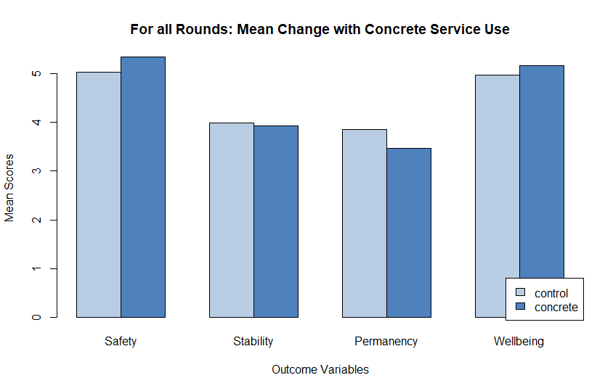
 | DV Outcome Scores
 | Safety |  |  | Stability |  |  |  | Permanency |  |  | Wellbeing
Service Levels | M±SD |  | M±SD |  |  |  | M±SD |  |  |  | M±SD
No Services | 5.04±.074 |  | 3.99±1.12 |  |  |  | 3.85±1.16 |  |  | 4.97±0.66
Yes Services | 5.34±.071 |  | 3.93±1.03 |  |  |  | 3.47±1.06 |  |  | 5.16±0.59
Change in mean | .30 |  | -.06 |  |  |  | -.38 |  |  | .19
Variable | F | Eta² | F |  | Eta² |  | F |  | Eta² | F |  | Eta²
Concrete Service | 105.43*** | .040 | 0.708 |  | .000 |  | 62.94*** |  | .022 | 66.09*** |  | .022
Covariates
Current place¹ | 139.50*** | .053 | 0.045 |  | . 000 |  | 273.40*** |  | .094 | 16.66*** |  | .006
Child Stress | 63.72*** | .024 | 69.26*** |  | .025 |  | 51.64*** |  | .018 | 515.53*** |  | .172
Placements | 0.007 | .000 | 31.48*** |  | .012 |  | 9.08** |  | .003 | 8.74*** |  | .003
Child Age | 0.067 | .000 | 0.362 |  | .000 |  | 3.523 |  | .001 | 60.98*** |  | .0020
Placement plan² | 56.08*** | .021 | 332.62*** |  | .122 |  | 217.87*** |  | .075 | 43.33*** |  | .014
** p <.01, *** p < .001, MΔ = mean change, ¹ custodial vs non-custodial, ² Parent plan vs. non-parent plan

Table 11. Descriptive statistics and ANCOVA Results

Additional Data Investigation:
Additional graphs were created by first looking at how the 'level of instability’ (or placement stability) in each family may account for this finding (Figure 2) as well as if the round which the data were collected impacted the permanency result (Figures 3-6). Instability was created using the number of placements a child had at the time of data collection which separated child in to low (<=1 placement) and high (>=2 placements) instability. Data were separated by the round collected (1-5). Two final graphs (Figures 7 and 8) were created that separated those in low and high instability in round 5 to examine the differences in grouping or instability had during the most recent round.

Figure 2. Mean changes in outcomes separated by level of instability for all rounds
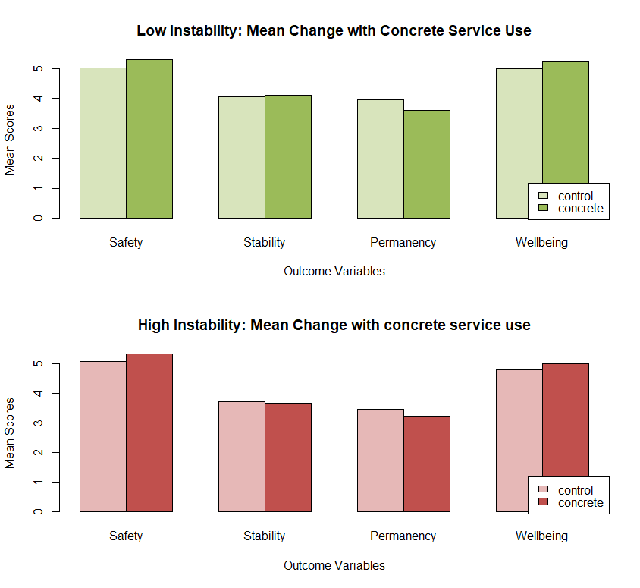

Figure 3. Changes in safety with concrete service use by round
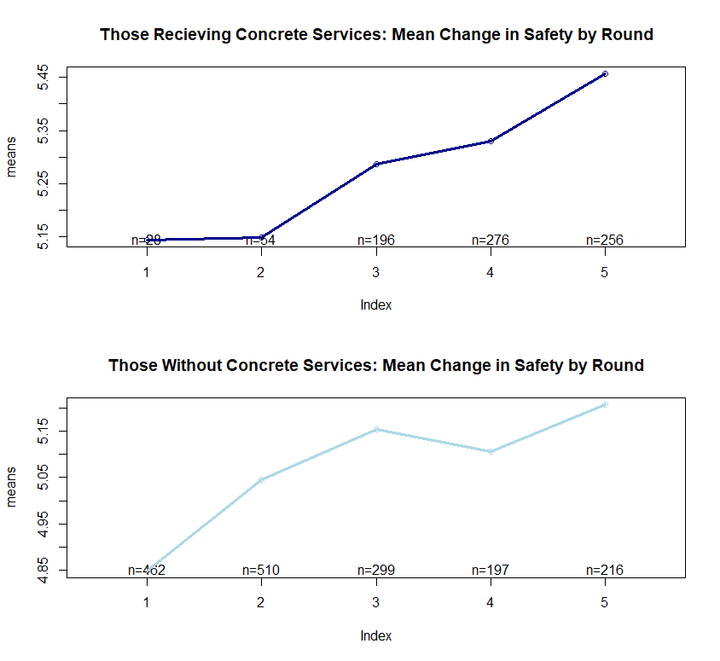
Those Receiving Concrete Services: Mean Change in Safety by Round

Figure 4. Changes in stability with concrete service use by round
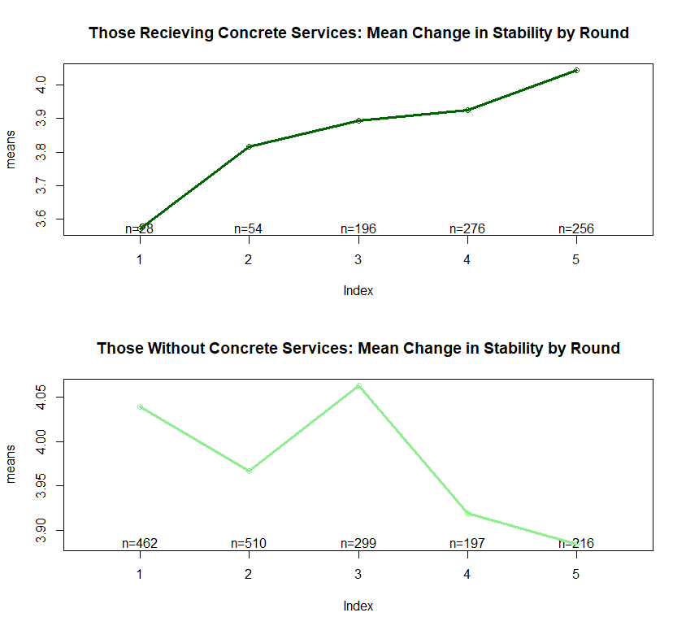
Those Receiving Concrete Services: Mean Change in Stability by Round

Figure 5. Changes in permanency with concrete service use by round
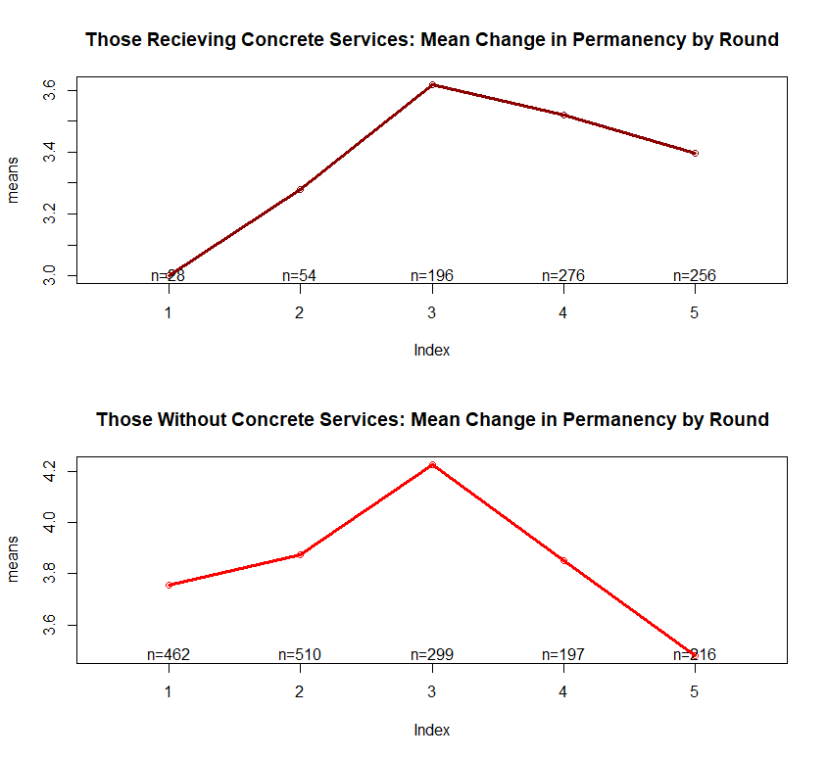
Those Receiving Concrete Services: Mean Change in Permanency by Round

Figure 6. Changes in wellbeing with concrete service use by round
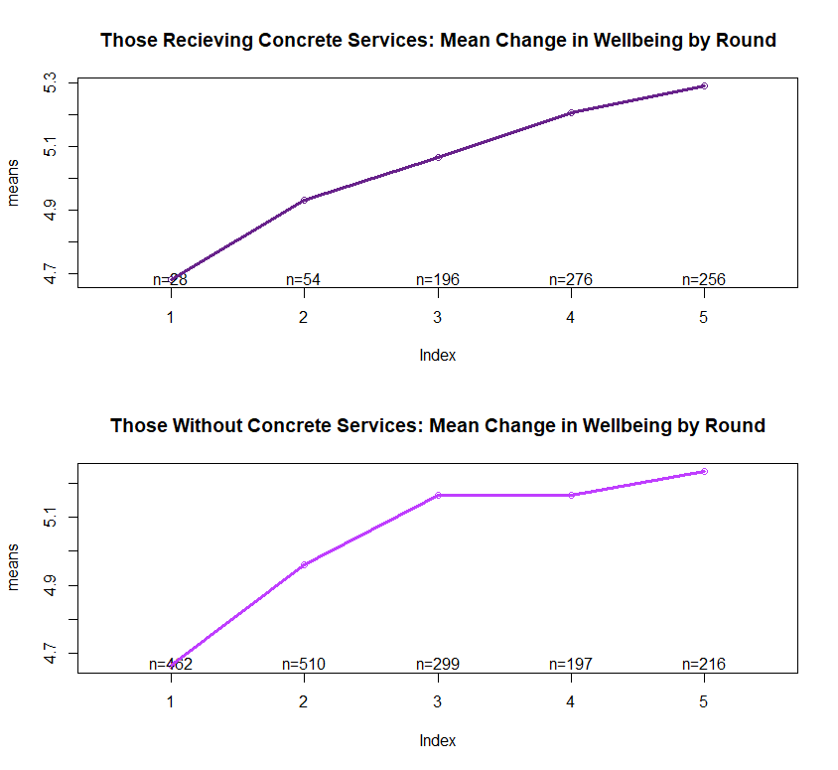
Those Without Concrete Services: Mean Change in Well-being by Round
Those Receiving Concrete Services: Mean Change in Well-being by Round

The results of these graphs suggest that children with higher instability (more placements) benefited slightly more than those with lower instability. There were significant increases in the use of concrete services in round 3 that continued to extend into the final round (figure 11). The increases in concrete service use was associated with outcome improvements in children with higher instability. When separated by level of instability at round 5, children saw improvements in permanency and stability as well as safety and wellbeing (figure 12).

Figure 7. Percentage of cases that have used concrete services by round
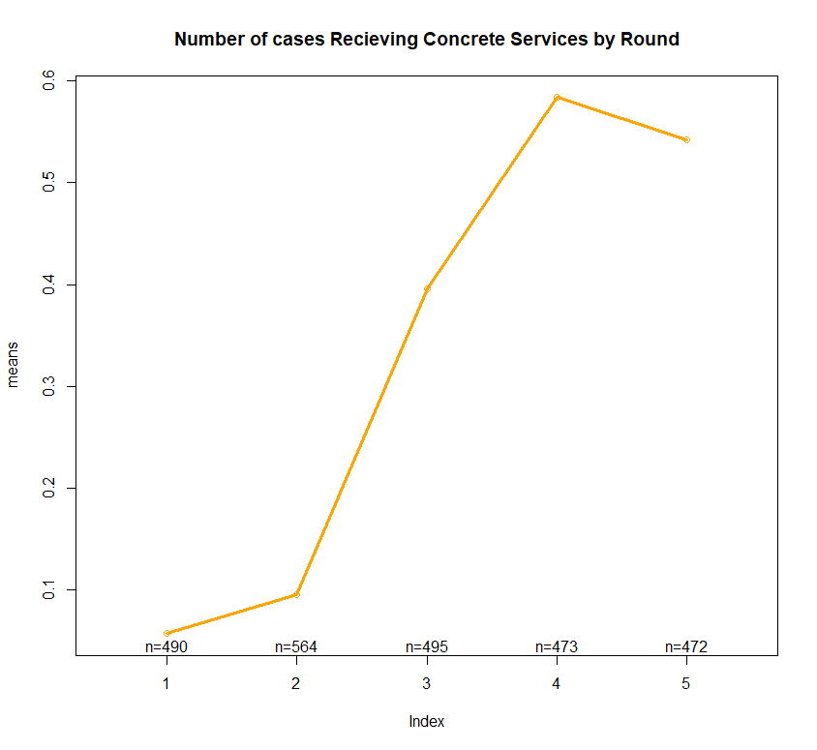
Number of cases Receiving Concrete Services by Round

Figure 8. Outcome differences in those who received and did not receive services by level of instability for round 5
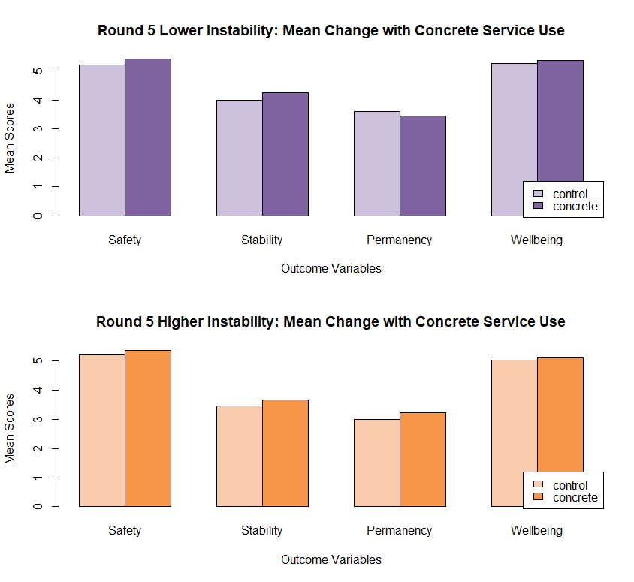

Conclusion:
Overall, these findings suggest concrete services use is associated with increases in safety and wellbeing. However, permanency, an important concrete service focus, decreased and stability did not change. Because it is probable that the level of family instability and round which the data was collected had an effect, additional graphs of these differences were created. Graphs grouped by level of instability indicated that permanency decreases associated with use of concrete services in those who had low instability (less placements); yet, remained stable for families who had higher instability. Graphs separated by round of data collection revealed that permanency and stability steadily increased each round for those who receive concrete services. This may coincide with the steady increase of concrete service during each round. A final graph of level of instability separated for just the 5th round of data collection revealed that the use of concrete services associated with decreases in permanency in those with low instability; but with those with high instability saw permanency and stability increases.

Take Home Message: Overall, the use of concrete services associates with increases in both safety and wellbeing. But, increases in the outcomes of stability and permanency associate with the way concrete services are used. For example, concrete service usage for some children who are in the system longer increase wellbeing but permanency goals may be difficult to achieve. More investigation is needed for the statistical and practical significance of these relationships and in what way concrete services can be used to improve these outcomes. Taken together, these findings suggest the use of concrete services show promise as a way to improve outcomes.

Factors associated with Concrete Service Usage
The following analysis answers the question: what factors predict concrete service usage for those cases reviewed in the Quality Service Reviews? Under this question it was important to understand if the time data that was collected had an effect on weather concrete services were received. Also, the number of participants who received concrete services for each region by round was calculated.
To test the hypothesis a probit model was used to test which factors correctly predicted who received and did not receive concrete services. Factors were entered into the model for stress (caregiver and youth), number of placements and round number with round one being the reference category. The predictive value of each factor was calculated along with the overall model’s percent of correct predictions compared against a model without the factors.
Results: Probit model predicting receiving concrete services
The probit model indicated significant association of caregiver stress, number of placements, and rounds 2 -5 with whether or not they receive concrete services (Table 12). The entire model had a predictive validity of 77.25% correct predictions which was significantly higher than a model without the predictors at 69.41%. When examining the differentiation between predictive probabilities of each factor entered into the model, individual factors and round 2 could not be distinguished as evidence by the overlapping confidence intervals in Figure 9. On the other hand, rounds 3-5 shown a significant increase in predictive validity with being in round 4 and 5 predicting 25-40% of those who received concrete services. These Waiver rounds indicate that they predicted who received services beyond individual factors as indicated by a clear separation of confidence intervals. It is likely that clients still had elevated needs in other rounds that required concrete services for support but because of the Waiver those funds were not available. These results suggest that Waiver concrete services spending significantly predicted whether clients would receive concrete services.

Table 12. Model of personal and time characteristics of receiving concrete services
 | Beta | SE
Youth stress | - .002 | .040
Caregiver stress | .055* | .015
Number of placements | .453* | .041
Round 2 | .724* | .216
Round 3 | 2.246* | .209
Round 4 | 2.819* | .211
Round 5 | 2.821* | .214
Number of cases 2140
-2 X Log-likelihood
(degrees of freedom) 2636.9

Model correctly predicted = 77.25%
Null model predicts = 69.41%

* = p< .05 two-tailed

Figure 9. Predicted probabilities of receiving concrete services by round and by individual factors
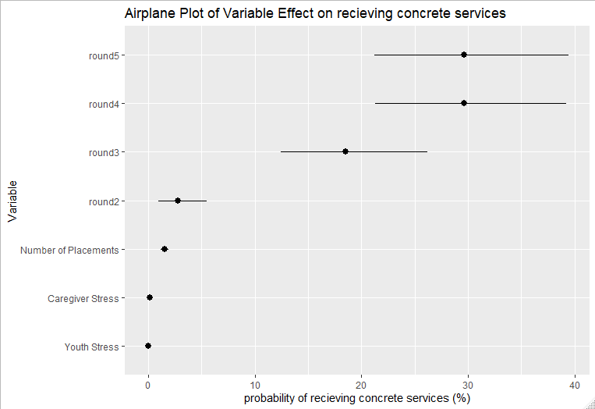

Additionally, trends in concrete service spending was calculated. These demonstrate decreases in children or families not receiving concrete services over time and steady increases in those receiving services and generally increasing for each region over time (Table 13).

Table 13. Number of cases receiving concrete services by region and round
 | Round 1 | Round 2 | Round 3 | Round 4 | Round 5
Region 1 received services | 9 | 13 | 28 | 31 | 25
Region 2 received services | 1 | 3 | 11 | 8 | 8
Region 3 received services | 1 | 4 | 6 | 9 | 10
Region 4 received services | 1 | 1 | 6 | 16 | 14
Region 5 received services | 3 | 2 | 6 | 7 | 6
Region 6 received services | 7 | 7 | 12 | 9 | 10
Region 7 received services | 2 | 0 | 4 | 11 | 4
Region 8 received services | 3 | 5 | 8 | 11 | 10
Region 9 received services | 0 | 4 | 4 | 8 | 9
Region 10 received services | 1 | 16 | 28 | 26 | 18
Region 11 received services | 2 | 2 | 5 | 7 | 10
Region 12 received services | 1 | 3 | 6 | 8 | 7
Region 13 received services | 3 | 4 | 8 | 5 | 4
Region 14 received services | 2 | 2 | 4 | 13 | 8
Region 15 received services | 1 | 2 | 5 | 9 | 10
Region 16 received services | 3 | 4 | 8 | 6 | 9
Region 17 received services | 2 | 3 | 6 | 8 | 11
Region 18 received services | 0 | 4 | 4 | 8 | 4
Total receiving concrete services | 42 | 79 | 159 | 200 | 177
Total number not receiving services | 425 | 455 | 263 | 176 | 170

Conclusion: Although concrete service needs were prevalent in earlier rounds, the introduction of the Waiver opened up funding and increased the predictive power of receiving concrete services to those who needed them. Results show that higher levels of stress and placements have an association with receiving concrete services suggesting that these factors are important indicators of those who need services. However, examining the predictive power of each factor, Waiver rounds added significantly more predictive validity for receiving concrete services.
Take Home Message: Overall, the introduction of the Waiver after round 2 appears to have opened up funding and allowed for support for children and families with higher concrete service needs.

Concrete Services and Stability
Overview
Two main questions were addressed in this section of the report: 1) does the amount of concrete service spending associate with improvement in stability (See Appendix A for QSR rating definitions) amongst those who receive those services, and 2) how do changes in the amount of concrete service spending over time associate with differences in stability. Under these two questions it was important to understand if there were differences by the amount spent in concrete service categories (general services, general products, material assistance, personal allowance, and total spending) made a difference in child outcomes.

Methods:
Preliminary analyses were conducted to examine the data’s context. First, evaluators tested group differences between youth who received services and those that did not on demographic factors (i.e. age, gender, race) as well as characteristics indicative of higher care needs (i.e. caregiver and child stress, home stability, number of placements). Next correlations among all categories of concrete service spending and outcomes of permanency and stability were used to quantify their relationships and identify which relationships to include in higher analyses. For all analyses statistical significance was defined as a two-tailed p-value < .05.

To answer the first question, two cross sectional multiple regressions were conducted using total concrete service spending’s association with stability and general products (e.g. clothing) spending on permanency. To reduce the interference of other contributing factors when testing these relationships, covariates of parent and child stress (i.e. number of stressful or potentially traumatic events endorsed), number of placements, and current placement plan (parental or relative placement in comparison to out of home placement) were included in the models. Prior to analysis, assumptions for normality and homoscedasticity for all variables were conducted and found to be appropriate for regression analysis. Because each variable is on a different scale, all variables were mean centered and standardized for comparisons. Post hoc fit analyses were conducted examining if any of the variables in the analysis significantly influenced the results inappropriately and not only for statistical significance but also for practical significance (i.e. effect size) with r² using Cohen’s thresholds for practical significance for multiple regression (small>.02, medium .15, large >.35).

To answer the second question, mean pooled time series analyses were conducted to examine trends over time and test their association with change in outcomes over time. This analysis method was chosen because it does not assume that each time point is associated with the previous time point. In other words, this approach can examine trends without having to follow the same participants over time. Trend analysis examines the mean stability over time to statistically determine the shape or trend of the relationship with unrepeated data at different levels. Time series modeling decomposes the mathematical process into a combination of signals and noise without assuming the underlying cause of each. Prior to analysis, scatter plots were created to examine the best fit for the data (i.e. linear, quadratic). To conduct the analysis a pooled time series linear model suggested by Walker (2014) was created in r and data were entered as the outcome of stability separated by the predictor of concrete service use over time. This model was assessed by statistical significance and the direction of the slope.

Results:
Preliminary analysis
The t-tests comparing groups who received and did not receive concrete services revealed that neither group differed in demographic factors; but participants who received concrete services had significantly less stability, more placements, and more caregiver and child stress (Table 14). This result indicates a higher level of need and greater barriers for participants in need of concrete services versus those who did not receive concrete services. Because of the significant differences between groups the hypothesis testing analyses separately analyzed the group that received concrete services with those that did not. Correlations cross-sectionally indicated the relationships of significance included total concrete service spending on stability (r=0.109, p<0.05) and general service spending on permanency (r=0.108, p<0.05) for the first question. However, when examining each time point only the relationship between total concrete service spending and stability was deemed appropriate for time series analysis in the second question.

Table 14. T-test Results
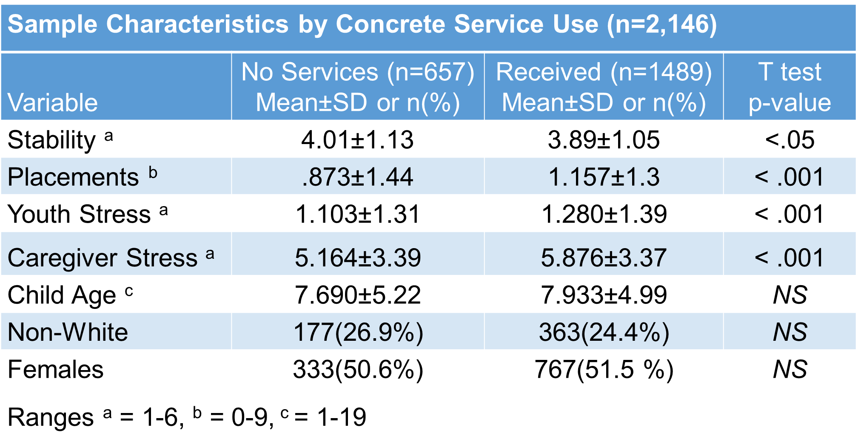
NS = not statistically significant
Cross-sectional multiple regressions
Testing effects of total concrete service spending on home stability found a significant model (f(6,425)=14.38, p <.001, r²=.17) that accounts for a significant amount of variance in stability (17%) indicated by r². Figure 10 demonstrates the fitted regression line that reduces the amount of residual error across the data showing the positive trend in the data. The individual association of total concrete service spending on stability predicts a positive increase of 0.01532(intercept)+0.125(total spending), p <.05. This suggest that, amongst those who need concrete services, when controlling for placement plan, stress, and number of placements, for every dollar increase in total concrete service spending you would expect an increase in stability of 0.125. Given the moderate effect size (r²=.17, crosses Cohen’s thresholds for moderate .15), this finding of is of practical significance, meaning this finding is generalizable in the larger community and could expect a similar effect.

Testing the effects of general services spending on permanency also found a significant model (f(6,301)=9.229, p <.001, r²=.16) that accounts for a significant amount of variance in permanency (16%) indicated by r². Figure 11 demonstrates the fitted regression line that reduces the amount of residual error across the data showing the positive trend in the data. The individual association of general service spending on permanency predicts a positive increase of -0.04927(intercept)+0.121(general services spending), p <.01. This suggests that, amongst those who need concrete services, when controlling for placement plan, stress, and number of placements, for every dollar increase in total concrete service spending you would expect an increase in permanency of 0.121. Given the moderate effect size (r²=.16, crosses Cohen’s thresholds for moderate .15), this finding of is of practical significance, meaning this finding is generalizable in the larger community and could expect a similar effect.

Figure 10. Total Concrete Services Spending on Outcome of Stability.
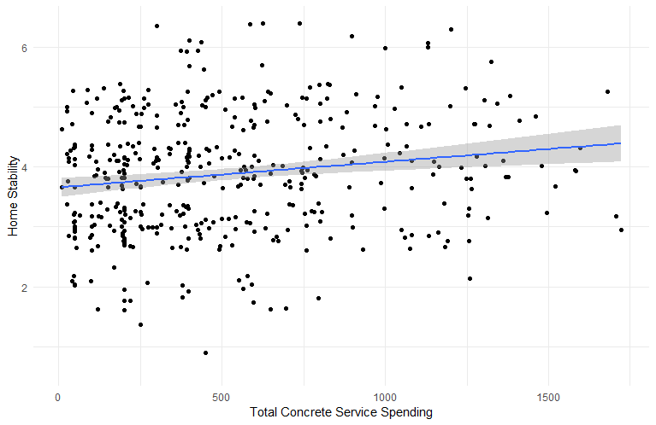

Figure 11. General Service Spending on Outcome of Permanency.
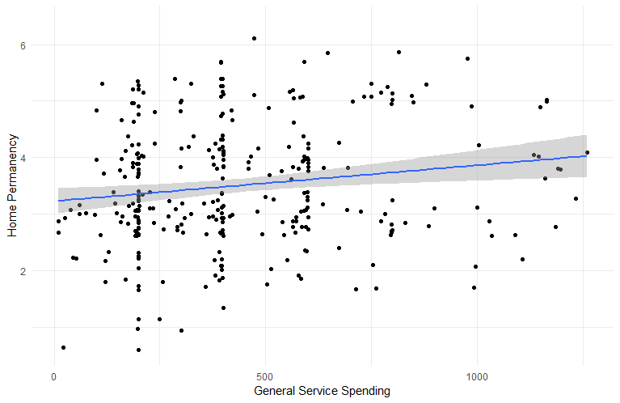
In Figures 10 & 11, The fitted regression line in blue represents the least residual error for all time points revealing the positive trend in the data. The grey area represents the amount of potential error in the line
Trend Analysis Across Time
Testing the effects of concrete services spending over time indicates significant increases over the five rounds for every spending category including total spending (Table 15). Figure 12 visually represents these relationships of increases in each category of concrete service spending over time. These relationships show increases from round 1 to round 5 that exponentially increase in-between round 2 and round 3.
Testing the relationship of stability on concrete service spending over time indicates a significant increase in those who receive services and an insignificant change in those not receiving services (Table 15). The relationship of home stability increases in youth receiving concrete services over time in relation to mean amount spent on concrete services for each round is visually represented in Figure 13. This figure depicts the high and stable stability in youth not in need of concrete services over time. And, for children in need of concrete services, the steady increase in stability over time has an increase in mean amount spend in total concrete services. These youth at a higher level of need requiring concrete services rise to a mean stability that meets children at a lower need level where concrete service funding is not required.

Table 15. Trend Analysis Results of Changes in Stability and Changes in Concrete Service Spending by Type
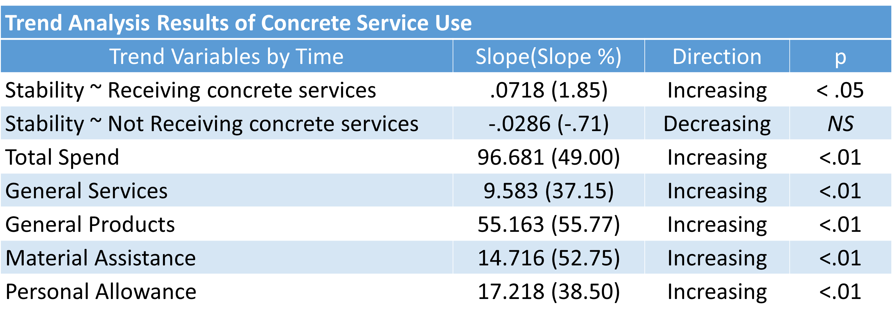
NS = not statistically significant

Figure 12. Trends of stability by time separated by those receiving concrete services and total spending mean.
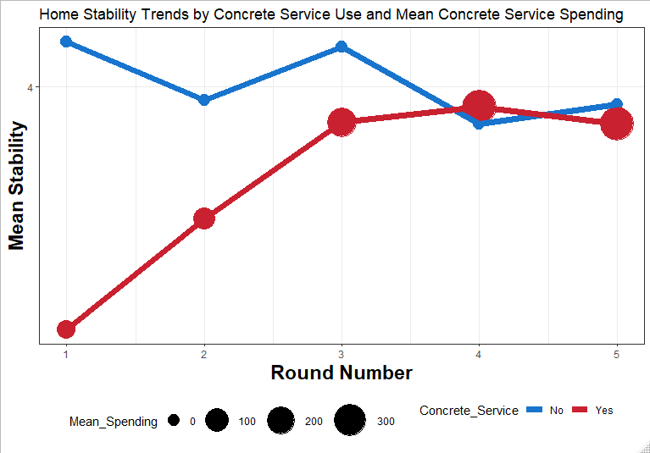
Size of each point represent the average amount spent on total concrete services for each time point. The line in blue is for those who did not receive services that stays high and consistent across time points. The line in red is of those who did receive services who started low in the first time point and slowly raised to a level of stability comparable to those who did not receive services as the average amount of concrete service spending increased.

Figure 13. Trends of spending by time separated by spend type.
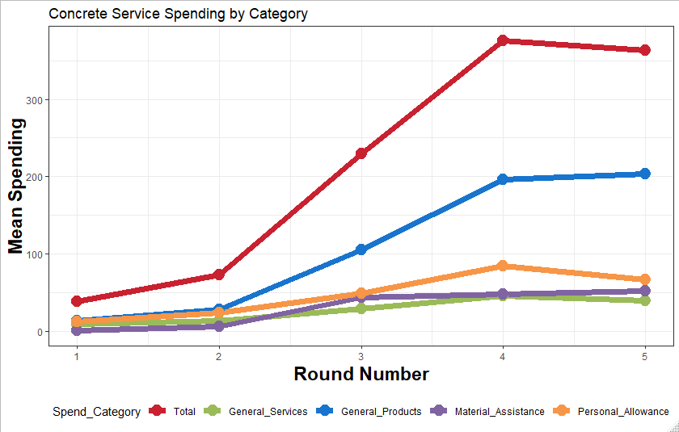
Each color line represents a different spend category with the red line representing total spending across all categories. Trends in each spending category have increased as the round number progress.
Conclusion:
For cross-sectional analysis, the present results suggest the use of concrete service spending associates with improved outcomes of stability and permanency. Stability depends on the total concrete service spending while permanency depends on general service (i.e. beds and clothes) spending. It is plausible that case managers spend more on beds and clothing when a permanent placement is found, and the placement may not be sustained without concrete service spending. Stability appears to depend on spend types from all categories rather than a specific one suggesting the complex concrete needs for stability to be maintained. The theoretical interpretation of this cross-sectional analysis is that concrete service spending affects outcomes of permanency and stability. Although this analysis does not account for all causes of variance as longitudinal data are needed to infer causality, the present study suggests spending on concrete services can improve child ability and permanency.

Accounting for changes over time using trend analysis, it is clear that increases in all categories of concrete services have occurred between round 1 and round 5. These changes are likely due to the expansion of concrete service availability since the introduction of Title-IV-E-Waiver in 2012. When looking at outcomes over time, the children who are at a higher need of services have seen an increase in stability meeting the stability of children who have a lower level of need and not in need of concrete services. These increases in stability in children in need of concrete services also have increasing mean spending in concrete services at each time point. This suggests that meeting basic needs of families at a higher need aid stability.

Take Home Message: Overall, the use of concrete services associates with increases in stability for children at a higher level of need. The expansion of concrete services coincides with increases in concrete service use. This expansion of concrete service use, over time, has improved stability outcomes in children who are at a higher level of need. The increases in stability associate with total concrete service spending providing evidence of the complex needs across concrete need categories necessary to promote stability. The findings from the present report suggest the use of concrete service for those in need improves stability outcomes.

Analysis of Concrete Service on Permanency and Stability by Level of Instability
Overview
The present report builds on previous reports identifying that concrete service spending has a positive association with outcomes of permanency and stability when controlling for other sources of variance. This report looks at whether there are differences in these outcomes in response to concrete service spending between groups of those who are at a higher level of need versus a lower level of need. The groupings were based on previous reports t-tests that found significant differences in indicators of levels of needs – youth and parental stress, and number of placements.

Sample:
Data were collected between 2007 and 2017 from five iterations of quality assurance reviews. The peer-review process of a random-like sample of child welfare cases was aimed at improving services to children in each region of the state. The majority of the 2,494 cases used in the analysis were Caucasian (74%), did not receive concrete services (68%), and had a mean child age of 7.79 (±5.14).

Methods and Results:
K-means clustering analysis was performed to identify important group differentiations among those who received concrete services. Specifically, identifying those who were at a higher level of instability versus those who were at a lower level of instability. To do this we used child stress, parental stress, and number of placements as the factors to distinguish these groups. In order to identify the correct number of groups in our clustering analysis, we used a within-cluster sum of square approach that minimizes the variation within each cluster. This procedure revealed that two groups fit the present data. Next, we performed K-means clustering to identify participants that belonged in each of the two groups. These groups were used in the following analyses

First, we conducted t-tests (Figures 14-16) to examine what differences existed between these groups on variables of interest. Both groups significantly differed on both permanency (t(430)=-3.151, p=.0017) and stability (t(430)=-2.801, p=.0053) with the group higher on instability being significantly lower. These groups were not different on: safety, wellbeing, or amount of concrete service spending overall or any category.

Figure 14. Statistically significant difference between instability groups on stability.
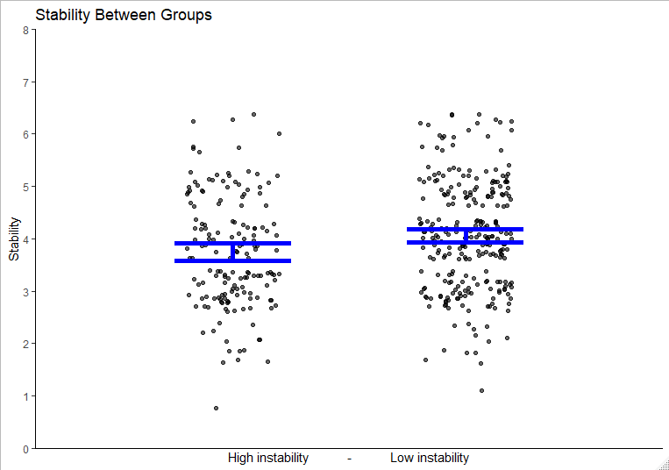

Figure 15. Statistically significant difference between instability groups on permanency
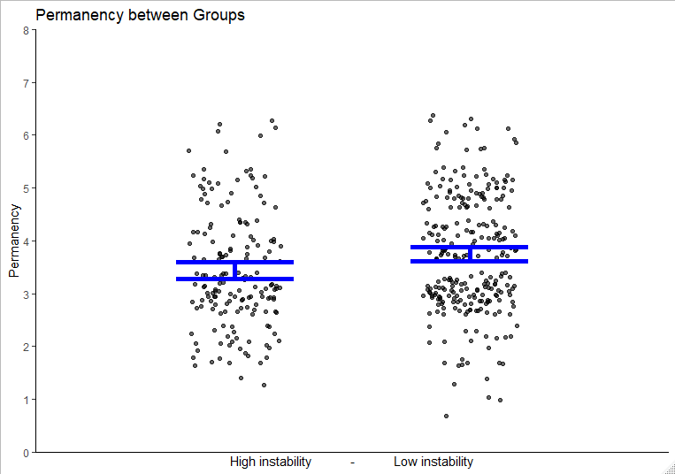

Figure 16. Non-significant difference between instability groups and total concrete service spending.
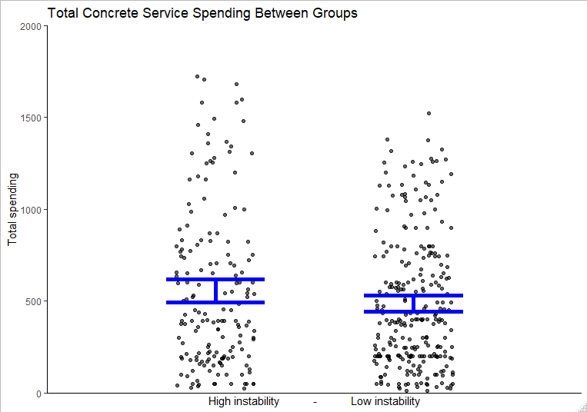

Next, we ran linear regressions (Figures 17 and 18) testing the interaction between total concrete service spending with level of instability groups on outcomes of permanency and stability. We ran two models, one for permanency and one for stability, controlling for placement type and round number to regress out additional sources of variance. Regression on stability revealed a significant overall model (f(6,425)=9.425, p<.001, r²=.11) as well as a significant positive association for total concrete service spending (b=.00042, p=.0157) and for level of instability (b=.342,p=.0338). Interaction effects were insignificant for this model (b<.0001, p = .619) indicating there were no interaction effects. Regression on permanency revealed a significant overall model (f(6,425)=7.127, p<.001,r= .093) as well as a significant positive association for total concrete service spending (b=.00038, p=.0460) and for level of instability (b=.428,p=.0142). Interaction effects were insignificant for this model (b=.002, p = .272) indicating there were no interaction effects.

Conclusion:
The present results suggest that level of instability influenced the response to concrete service on both outcomes of permanency and stability; such that a higher level of instability had a significantly more positive response to concrete service spending. On the higher end of spending both higher and lower levels of instability had almost equivalent levels for each outcome. This has significant implications for the ways that concrete service spending use used—those in higher levels of instability benefit from concrete service use.

Take Home Message:
Overall, the use of concrete services associates with increases in stability for youth at a higher level of need and this is particularly important for those at a higher level of instability. Both permanency and stability associated with total concrete service spending provides evidence of the complex concrete needs necessary to accomplish these aims.

Figure 17. OLS regression lines for higher and lower levels of instability in the relationship between total concrete service spending and placement stability.
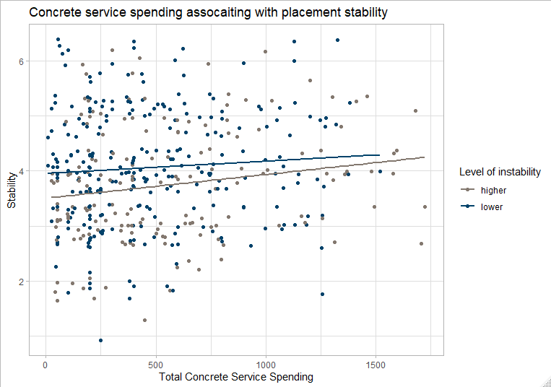

Figure 18. OLS regression lines for higher and lower levels of instability in the relationship between total concrete service spending and placement permanency.
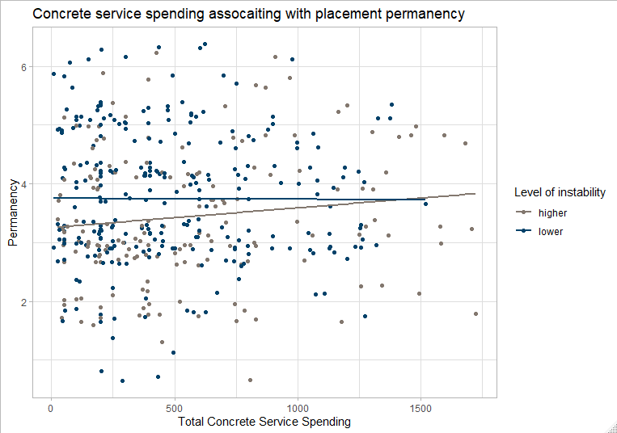

Interaction Analysis Using Propensity Score Matching
Overview
The present analysis tests if there is a substantial difference between those who are currently in an out of placements and those with stable placements in the outcome of placement stability when receiving and not receiving concrete services. The focus of this analysis was to develop comparison groups of children with unstable and stable placements to determine the effects of concrete service spending as a treatment to address placement stability.

Sample:
Data were collected between 2007 and 2017 from five iterations of quality assurance reviews. The peer-review process of a random-like sample of child welfare cases was aimed at improving services to children in each region of the state. The majority of the 2,494 cases used in the analysis were Caucasian (74%), did not receive concrete services (68%), and had a mean child age of 7.79 (±5.14).

Methods and Results:
Propensity Score Matching: First we needed to find common characteristics among those who received concrete services and did not in order to obtain a sample of comparable characteristics. The intention of this approach is to strengthen our inferences of effects being because of the intervention of concrete services and not just sampling error. To do this we matched participants on characteristics of caregiver and children stress, number of placements, the round number and whether they were currently in an out of home placement. Propensity score matched total of 864 participants (1,277 were unmatched and 353 were discarded due to missingness) with n=432 that received concrete services and n=432 who did not receive concrete services.

Data in the model included:
Assumption testing. Mahalanobis Distance was calculated following accepted guidelines and no multivariate outliers were detected
Child and caregiver stress. Both child and caregiver stress were rated by checking off items on a list of potentially traumatic or stressful events in either the child of caregivers’ life. Caseworkers checked off items and the total number of events were added and used in the analysis indicating the potential level of trauma and stress. Child items consisted of events such as “history of sexual abuse”; and caregiver items consisted of events like “abused/neglected as a child.” A higher score indicates more exposure to traumatic stress.
Number of placements. The number of placements is included as a control because it negatively affects both permanency and placement stability. Because placements ranged from 0-20 with very few above five, placements were recoded into four categories 0 were recoded to 0, 1-2 were recoded to 1, 3-4 were recoded to 2, and 5 or more placements were recoded to 4. Higher number indicates a greater number of placements.
Current out of home placement. The current placement was assessed by the reviewer at the current placement for the child at the time of data collection. This variable was a dichotomous variable with out of home coded as 1 and any in home placement coded as 0.
Future placement plan. The future placement plan was assessed by the reviewer as the current placement plan at the time data was collected for each case. Placement plans consisted of a parental plan (planned to be placed with parents), a relative plan (plans to be placed with a relative or kinship care), or an out of home placement (adoption or other out of home placement). The out of home placement plan was used as a reference category for the present analysis.
Data collection round number. This data was collected over 10 years with different participants at each collection. Effects of different time periods on participant outcomes were accounted for by including the round number as a control variable. There were five rounds at the time of this analysis (ranging from 1 – 5, each spanning just under 2 years between collection) that accounted for the different time period at each collection with higher number meaning the most recent data collection period.

A summary of the balanced data for treatment and controls are below in Table 16.

Table 16. Characteristics of propensity score matched data
Matched data (n=864)
 | Treated n=432 | Untreated n=432 | Mean difference | % balance improvement
Distance | .425 | .393 | .032 | 88.46%
Caregiver stress | 5.833 | 5.717 | .115 | 77.35%
Placements | 1.648 | 1.236 | .412 | 13.44%
Round number | 4.074 | 4.138 | -.648 | 96.92%
Out of home | .898 | .821 | .076 | 71.73%

Hierarchal multiple regression: Next we fit three regression models, two additive (a model with just control variables, Model 1 and a model with all relevant predictors, Model 2) and an one interaction model (the same model with an added interaction term, Model 3) using controls of children and caregiver stress, number of placements, the future placement plan, and the round number as seen in Table 17. .

The model fits were for both models 2 and 3 and were compared using an F-test to determine which fit the data best. The F test determined the interaction term had less error (additive RSS=861.17, interaction RSS=856.31) and significantly fit the data better than the additive model (F=4.855, p=.0278). The results of the interaction model are significant (F(9,854)=19.89, p<.001, R2=.1652) indicating our model did predict the outcome of placement stability better than chance. For the individual predictors, there was a significant interaction between those with unstable placements and received concrete services (B=.4533, p=.0278). This finding indicates that we would expect an increase in placement stability in those who are currently are in unstable placements when they receive concrete services after controlling for other sources of variance.

Table 17. Hierarchal regression results
Modeling QSR Stability (n=864)
 | Model 1 | Model 2 | Model 3
 | β | β | β
Child stress | -.135* | -.134* | -.136*
Caregiver stress | -.047* | -.046* | -.046*
Placements | -.368* | -.346* | -.350*
Relative plan | -.338 | -.329 | -.321
Parent pan | -.958* | -.963* | -.952*
Round number | -.025 | -.019 | -.033
Concrete services |  | .035 | -.340
Currently placed out of home |  | -.116 | -.276
Interaction: Concrete services & out of home |  |  | .432*
ΔF |  | .667 | 4.33*
F | 29.61* | 22.35* | 20.44*
Residual error | 1.00 | 1.00 | 1.00
Adj R² | .165 | .165 | .168
Cohen’s D |  |  | .3094
*FDR corrected p <.05

Conclusion and Take Home Message:
The present analysis suggests that the use of concrete services in children who are in unstable placements improves placement stability. This is a necessary condition for a child’s wellbeing and permanency. The use of concrete services in children who are in out of home placements shows promise for improving placement stability.

Process Study
The process study comprises the 2012 Waiver story and changing perceptions of key stakeholders within DCS over the demonstration period. The Waiver story consists of the mid-course correction and establishment and expansion of CQI. The investment in CQI and data driven policies continued at DCS during the demonstration and extension period.
During the extension period, DCS had multiple changes in leadership roles including the director, chief of staff, evaluation, services, and the field. Eric Miller became the new chief of staff in late 2017. On December 28, 2017 the governor of Indiana announced the new director of DCS, Terry Stigdon. In February 2018 the current Deputy Director of Field Operations retired. Sarah Sailors was named the new Deputy Director of Field Operations in April 2018. The field operations added two new Assistant Deputy Directors of Field Operation to make a total of four positions statewide.
Indiana recently launched a request for proposals (RFP) entitled: “Community-Based Family Preservation Services.” This RFP aims to select multiple Community-Based Family Preservation Services providers that can satisfy DCS’s need for the provision of Family Preservation Services in the 18 DCS Regions and the corresponding local offices in the State. Community-Based Family Preservation Services are services provided to families who have had a substantiated incident of abuse and/or neglect, but, where DCS believes the child(ren) can remain in the home with the introduction of appropriate services to the entire family.
Family Preservation Services include assessment of child/parent/family resulting in an appropriate service/treatment plan that is based on the assessed need. Family Preservation Services are homebased and monitor and address any safety concerns for the child(ren). Any interventions are strength-based and family-driven with the family actively participating in identifying the focus of services.
Family Preservation Services are all inclusive and must aim to preserve the family by addressing any present safety and supervision concerns. All family members (provided it is age-appropriate for children to do so) should be involved in treatment planning and establishment of goals. The overarching goal for these services is to preserve families by addressing and resolving identified safety and supervision concerns.
DCS must also be involved in the creation of treatment plans and safety plans. It is expected that Family Preservation Services providers will be actively engaged in the DCS Practice Model (https://www.in.gov/dcs/3208.htm) and attend scheduled Child and Family Team Meetings (CFTMs) whenever requested. Through the teaming process DCS will participate in the continuous development of family goals.
At the direction of the Indiana State Legislature, Family Preservation Services will move to a per-diem model for reimbursement with the execution of this Contract. Separately from this mandate, DCS is also requiring that evidence-based models be used in the provision of Family Preservation Services through this Contract. To classify as evidence-based, a practice must be classified at a minimum as a “Promising Practice” on the California Evidence-Based Clearinghouse (CEBC) (http://www.cebc4cw.org/). Models that are classified on the CEBC as “Supported” or “Well-Supported” may also be used. No practice that is classified as “Fails to Demonstrate Effect” or “Concerning Practice”, or that is not listed at all on the CEBC may be utilized except for concrete assistance. Examples of concrete assistance needs include: overdue rent when the family is facing an eviction or other loss of housing, past-due utilities that may result in electricity and/or gas to the home being suspended creating an unsafe or unsuitable living condition for the child(ren), and food or clothing insecurity.

This section will provide studies on the changes in concrete service spending by Regions, the Regional Manager interviews from 2019, a comparison of Regional Manager interviews over all five rounds, and the Family Case Manager (FCM) survey results. FCM analyses include safety, permanency, and well-being of the most recently opened and most recently closed cases, FCM understanding of FFPSA, FCM perceptions of the service array, perception of concrete service use, determinants of intent to stay in child welfare, evaluation of the fidelity of child family team meetings, and how that fidelity impacts child well-being.

Indiana’s Continued Investment in Innovation
During the 2012 Waiver, Indiana made a large investment in concrete services as described in our previous Final Report. Since that report, Indiana is particularly interested in how those investments have affected safety, permanency, and well-being of the children in DCS. Due to the nature of concrete service spending, DCS intends to design and implement an evaluation plan that will meet the rigor required by the IV-E Prevention Services Clearinghouse. Based on prior IV-E Waiver evaluation findings, DCS intends to further support concrete services and supports to keep children in their home of origin and reduce entry in out of home care. It is important to understand and quantify the impact of concrete service usage to prevent foster care placements, decrease the time to permanency, support children’s well-being, and provide supports for alternative placements.

Organizing CQI in Practice
DCS and the IU Evaluation Team have conceptualized how CQI will be organized and executed within the agency. This takes a great deal of commitment from all parts of the Executive Team. The Central CQI Team comprises of key Executive staff representing all areas of the Department from field to fiscal staff. This Central CQI Team meets bi-weekly for at least two hours per meeting. Up to this point, the primary goal of these meetings has been to document CQI initiatives and opportunities for each of the objectives listed in the DCS Child and Family Services Plan. All work completed or initiated for each objective and intervention, as well as responsible staff for that objective or intervention has been documented. For objectives and interventions that have not yet been initiated, the Central CQI Team is responsible for creating a priority level and timetable so that the objective or intervention is completed within the five-year period. The Central CQI Team desires a two-way exchange, whereby CQI needs and efforts are brought from the field to the Central CQI Team, and decisions and efforts at the Central CQI level are funneled down to the field. The Central CQI Team is committed to continuing these working meetings and formally disseminating findings and information to mid-level and field staff in an effort to be more transparent within the Department and to support data-driven decisions in practice.

Concrete Services Spending pre and post-Waiver by Region
Provision of concrete services help families by providing financial assistance to promote permanency and placement stability. Concrete service funding was expanded as a part of Indiana’s 2012 Title IV-E Waiver to prevent instability and improve family success. The IV-E Waiver allows states more flexible use of federal funds to permit states to test new financing approaches in an effort to improve outcomes for children and families involved with the child welfare system.

Concrete services spanned four broad categories: General Products (Birth certificates, children's bed and bedding), General Services (dental, GED/skills-based programs, summer school, tutoring), Material Assistance (Day care services, rent, utilities, and pest control), and Personal Allowance (computer/electronic devices, driver’s education, dues, class pictures, field trips).

The purpose of this report is to provide an explanation of the difference(s) between concrete service spending by region, pre-and post- Waiver implementation.

Methods
Concrete service spending data were collected using administrative data from Fiscal Years (FY, July-June) 2013 and 2017. In 2013 there were 45,657 disbursements totaling $3,696,176.30 to 42,437 individuals. In 2017 there were 154,623 disbursements totaling $15,568,658.84 to 79,568 individuals. The number of cases were calculated by the number of people involved (involvement) with DCS in each region for FY2013 and 2017 (see Table 18).

Table 18. Involvement by Region
Region | 2013 | 2017 | Region | 2013 | 2017
1 | 4208 | 5087 | 10 | 8044 | 14750
2 | 1542 | 3371 | 11 | 1722 | 4194
3 | 3264 | 4958 | 12 | 1142 | 2682
4 | 3721 | 5592 | 13 | 1245 | 3711
5 | 1285 | 2937 | 14 | 2079 | 3313
6 | 1995 | 2874 | 15 | 1150 | 2865
7 | 2022 | 4726 | 16 | 3227 | 5087
8 | 1440 | 3681 | 17 | 1012 | 3112
9 | 950 | 2903 | 18 | 2389 | 3725

Analysis / Results
Concrete spending was weighted according to the number of individuals involved with the regional system by multiplying expenditures by the proportion of the total population that region represented.

Prior to the Waiver implementation, mean concrete spending (M=$33 ±$1,862) ranged from $39-$145 per person involved in the waiver. Spending for concrete services increased post-Waiver to $84-$359 (M=$7±$63).

QGIS, an open source geographic information system (GIS) software, was used to map data by region for concrete service spending pre- and post- waiver implementation to provide a visual representation of the findings. Three maps were created illustrating spending prior to Waiver implementation (Figure 19), post waiver implementation (Figure 0), and how spending pre- and post- waiver implementation (Figure 21) differed. The stars in Figure 3 denote a statistically significant difference in regional spending pre- and post- Waiver.

Figure 19. Mean Spending Pre-Waiver
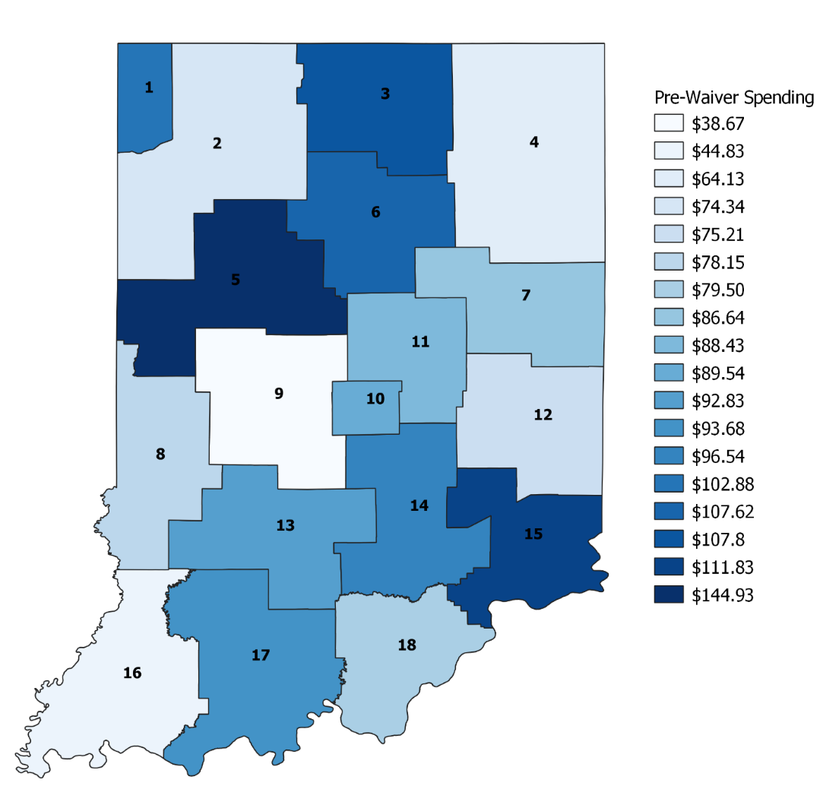

Figure 20. Mean Spending Post Waiver
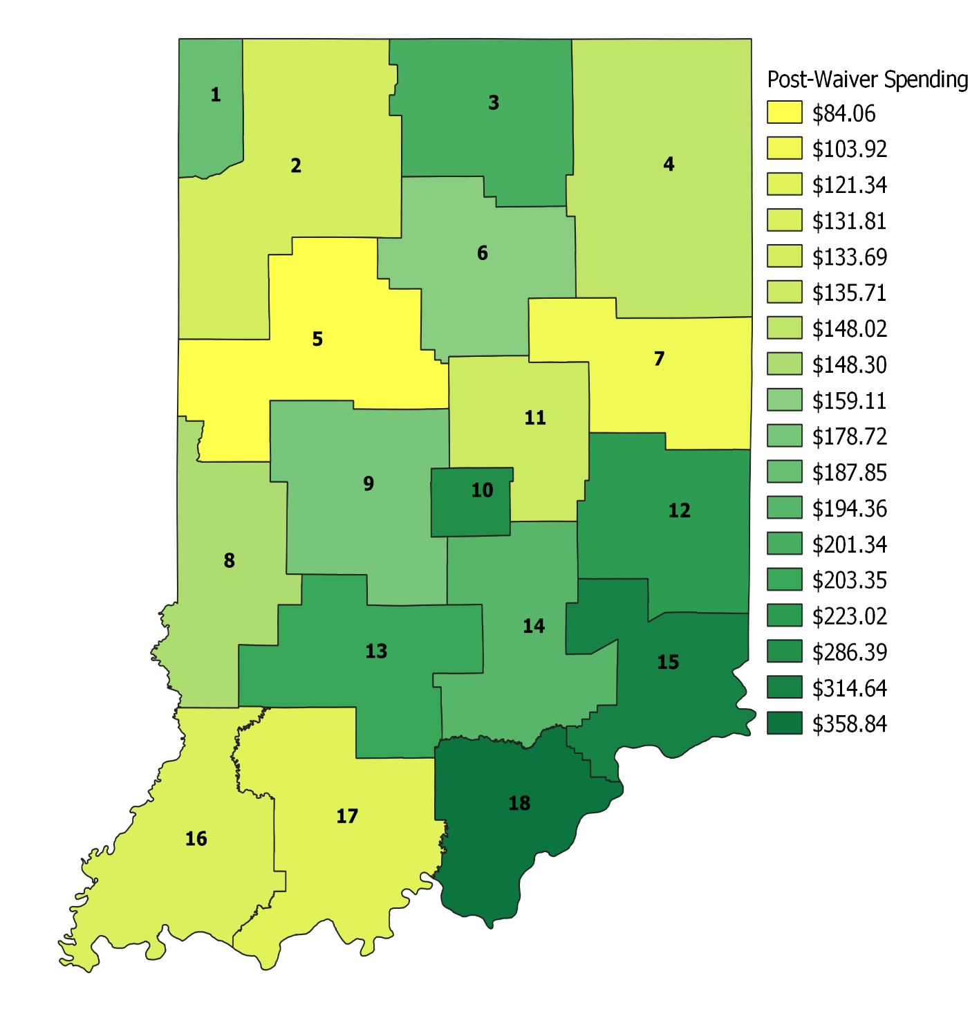

Figure 21. Mean Spending Difference
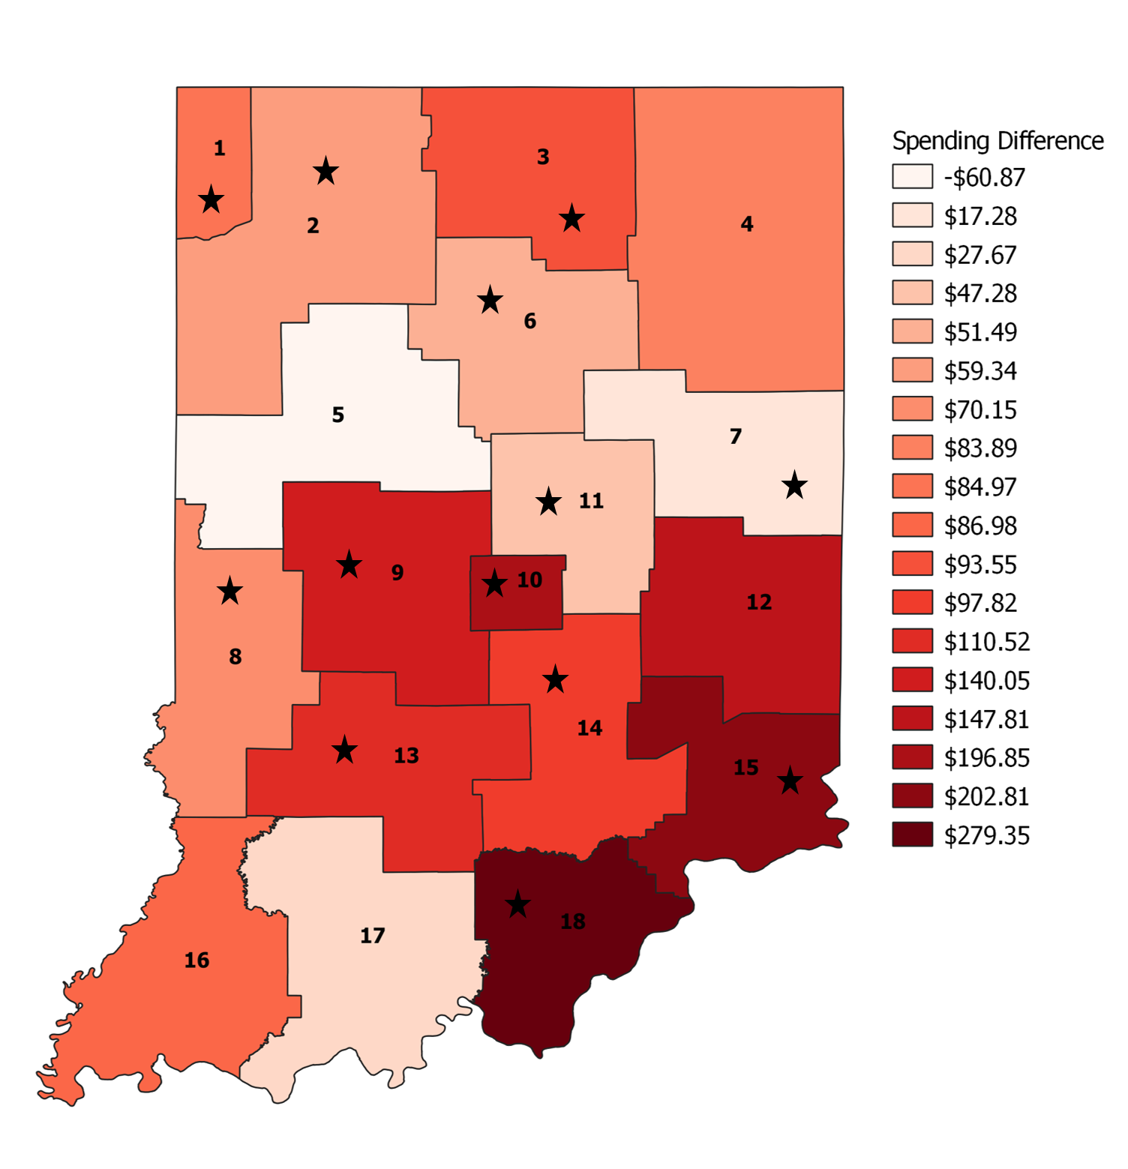
= significant (p<.05) difference in spending
before and after Waiver implementation
The majority of regions (N=17 ) saw an increase in spending after the Waiver implementation, with exception of Region 5.

SPSS v25 was used to conduct 18 paired t-tests to compare regional mean spending pre- and post-waiver. When looking at regional spending by year, mean concrete services spending was significantly different from 2013 to 2017 for 13 regions (see Figure 3).

SPSS v25 was used to conduct a multivariate analysis of variance (MANOVA) to determine if there were any statistically significant differences in mean concrete spending across regions for both 2013 and 2017. Using Pillai’s trace, and controlling for the number of individuals receiving services, there was an overall significant effect of time (before and after Waiver implementation) on regional concrete service spending, V = .014, F (34, 400,524) = 81.52, p < .001. Pairwise comparisons were conducted to discover if there were any significant relationships between regions’ mean differences in pre- post- waiver concrete spending. Only one region was found to have significantly different mean concrete spending from all other regions: Region 10.

Conclusion
It was to be expected that spending on concrete services would increase as this was the goal of the waiver. That said, higher expenditures could be the result of high rates of substance use or abuse, which can often lead to long and costly associations with the child welfare system. Regions have various resources that are specific to their particular geography. Hence, resource sharing might make it difficult or unnecessary to pay for services with concrete service dollars as a result of location or existing funding mechanisms.

Regions without a significant change in spending were all adjacent to other states who were not involved in this State’s Waiver. This might suggest that individuals or families use/access resources from contiguous states or private agencies (this could, for example, explain the decrease in spending in Region 5). This requires future research to determine fully, however.

Future studies should explore the payment for and use of concrete services in depth to understand how regions’ use of concrete service will support stakeholders in their fiscal and programmatic decision-making processes as this could become an evidence-based practice in child welfare. This is especially pertinent in light of recent Family First Prevention Act legislation.

Regional Manager Interviews 2019

Overview 2019
This section of the report presents content from the Title IV-E Evaluation Team’s qualitative interviews with Indiana DCS Regional Managers (RMs) and field operations administrators from the fall of 2019. Data were collected as a continuation of the Process Study component of the overall Waiver Evaluation Project. In the 2019 iteration of the study, the evaluation team interviewed 17 of 18 RMs (one RM was covering for an RM on leave), four Assistant Deputy Directors of Field (ADDs) – ADDs of the North, South, and Central regions as well as the ADD of Foster Care and Older Youth Services, and the Deputy Director of Field Operations (DD) for DCS. While the structure of the 2019 interviews was similar to prior rounds (participants’ perspectives regarding administrative responsibilities, regional services, strengths, and needs, use and effectiveness of concrete services, and Waiver impact), the 2019 round of data collection also ascertained participants’ reactions to self-care and professional well-being data collected with FCMs in 2018 as well as perceptions of the transition from the Title IV-E Waiver era into the Family First Prevention and Services Act (FFPSA) era.

Background 2019
The purpose of this 2019 study was to collect and analyze data from semi-structured, qualitative interviews with DCS Managers and administrators regarding their histories with DCS, the regions and areas they manage, and their perceptions and experiences related to the 2012 Title IV-E Waiver in the final year the Waiver demonstration period.
As in past iterations, the evaluation team employed case study analysis to analyze data and present findings. As reported previously, case study methods are not as explicit as some other forms of qualitative research and the subject matter can vary greatly. Case study research involves the study of an issue explored through one or more cases within a bounded system (such as a setting or context) over time through detailed, in-depth data collection, involving multiple data sources. The product of case study research involves a report of a case description and case-based themes. The 2019 analysis is considered a collective case study, making use of multiple cases (Regional and Field Operations Administrators) to illustrate an issue (the 2012 Waiver) within the bounded context of the Indiana DCS. This particular analysis is also bounded by the time frame of FY 2018 – FY 2019.

Research Questions 2019
The research questions for the 2019 Regional Managers and Field Operations Administrator interviews:
- What challenges and positives do managers and administrators experience in their positions?
- How do managers approach staff development?
- What are managers’ and administrators’ responses to self-care and professional well-being-related FCM data?
- How do managers and administrators perceive key relationships?
- What are managers’ perceptions of the 2012 Waiver?
- What are managers’ perceptions of the current state of relative care in the state?
- What are managers’ perceptions of concrete services?
- What are managers’ perceptions of practice sustainability in a post-Waiver DCS?

Methodology 2019
Consistent with past rounds, evaluators used a semi-structured interview guide, developed in collaboration with the DD, to collect this fifth round of data via telephone interviews. One evaluator worked individually with all participants to schedule a phone interview at a date and time convenient to each participant. Unlike prior rounds of interviews, all RM interviews in 2019 were audio-recorded, with permission, and transcribed verbatim.

Interview questions were designed to elicit information regarding participants’ tenure and roles with DCS as well as perceptions of regional/state strengths and needs; participants’ administrative responsibilities, strengths, and needs; reactions to self-care and professional well-being data collected with FCMs in 2018 via the evaluator’s FCM survey; use, role, and value of concrete services; reactions to agency and region-specific data regarding concrete services spending and disbursements; knowledge and effects of the 2012 Waiver; and understandings and perceptions of the FFPSA era.
One evaluation team member began interviews in mid-September and completed the 22 interviews by mid-October 2019. Interviews lasted approximately 75 minutes – 90 minutes. The average length of interviews increased with each year of data collection; added questions as well as enhanced rapport are thought to be causal factors for this increase in time spent in each interview. Following the completion of the 17 Regional Manager interviews, the same evaluation team member completed interviews with the state’s four ADDs and concluded data collection by interviewing the DD. Interviews with RMs helped to informed interviews with ADDs and interviews with ADDs helped to inform the interview with the DD. Interviews with ADDs and the DD were not audio-recorded, however, responses were recorded via notes by the interviewer in real time. The 2019 data were reviewed and coded by two researchers.

Sample Characteristics 2019
As noted above, data were collected with 17 RMs, four ADDs, and one DD for the 2019 study. Of the 22 participants, 18 are female and four are male. Participants have a wealth of experience with the agency. Tenure with the DCS ranged from 12 years to 43 years with an average of approximately 22 years among RMs. Administrators (ADDs and DD) also averaged approximately 22 years of experience with DCS and their tenure with the agency ranged from 14 to 28 years. In 2019, RMs had less experience in their RM position than in prior years (3 years), however, number of prior positions were consistent with previous rounds of data collection (3 positions). Less than half of participants reported holding a graduate degree (N = 10) and less than half (N = 9) reported holding at least one degree in social work.

Findings 2019
The 2019 interviews produced four grand themes. First, there was a perceived shift in the culture and climate of the agency. Participants reported a more positive, inclusive, engaged, and connected DCS. In large part, this shift was credited to leadership and leadership philosophies by the new (2018) State Director and DD (2018) as well as the new (2018) ADD structure (four versus the prior two ADDs). Under the grand theme of a perceived shift in the culture and climate of the agency emerged a secondary theme related to the development and well-being of direct line workers. Participants reported greater intentionality regarding staff development in terms of vision alignment, more effective supervision practices, greater training for supervisors, and more attention paid to employee support, self-care, and work/life balance. The second grand theme that emerged in the 2019 data is that of a shift in the way participants described the use and purpose of concrete services. Participants continue to conceptualize the 2012 Waiver as meeting child and family needs through concrete services. However, in 2019, participants consistently highlighted the need for concrete services to be used in responsible ways that promote sustainability for families. Participants discussed continuing to meet unique needs on behalf of families, but focused more on exploring and exhausting community-based resources first then, when needed, using concrete services disbursements with sustainable plans for families’ futures. The evaluators asked participants to discuss approaches to data-driven practices and also inquired into a new data management system that has begun rollout at the agency. In turn, data woes emerged as a third grand theme. Participants perceive data to be valuable, however, feel as if managers and their staff are inundated with data, that there are too many data management systems – which were not, at the time of data collection, compatible with one another, that new system has promise, but that managers’ understanding and practice with the new system were so varied that meaningful data and data sharing is still a challenge. The fourth and final grand theme of the 2019 interviews is that of the transition from the 2012 Waiver to practice under the FFPSA. Participants were asked to share perceptions related to the effectiveness of the Waiver. Again, on the whole, participants conceptualize the Waiver as meeting unique child and family needs through the flexibility of concrete services and continue to report the essentiality of being able to do so to achieve permanency on behalf of children and youth. Participants were also asked about knowledge and preparation for a post-Waiver DCS. Similar to earlier rounds of data collection in which participants were asked about Waiver-related knowledge, knowledge regarding policy and practice under FFPSA was limited and varied. The overwhelming perceptions, however, were that practice will not change significantly, that managers and staff need more training, but that individually and as an agency, DCS will continue to serve children and families under their current practice model and with same mission and values that guide their practice now.

Summary and Conclusions 2019
The 2019 RM and Field Operations Administrator interviews are assessed to be another successful and valuable component of the Process Study for the overall Title IV-E evaluation. The length and quality of the interviews demonstrate healthy, positive, and cultivated rapport and trust between the evaluation team and field managers and administrators at DCS. The 2019 interviews and data aided in the contextual picture and overall assessment of the evaluation and helped to connect the 2012 Title IV-E Waiver demonstration and the post-Waiver/FFPSA policy and practice era in Indiana.

Regional Manager Interviews 2013-2019

Overview and Background
This report presents an overview of an analysis completed as part of the Process Study component of the Title IV-E Waiver Evaluation Project. This study utilized qualitative interviews with Indiana’s Regional Managers and Field Operations Administrators (formerly referred to as Executive Manages) in 2013, 2014, 2015, 2016, and 2019 of the Waiver demonstration. Evaluators completed 100 semi-structured telephone interviews with participants across the five rounds of data collection. Evaluators used case study analysis to analyze each round of data as well as the collective case study. Research questions, methodology, case study participant characteristics, grand themes and collective case assertions, as well as a case summary and implications are shared here.

Research Questions
The primary research questions for this study include:
- What are Regional Managers’/Field Administrators’ perceptions of their roles & responsibilities?
- What are Regional Managers’/Field Administrators’ perceptions of various components of regional/state child welfare practice?
- What are Regional Managers’/Field Administrators’ perceptions of the 2012 Waiver?
Additional areas of inquiry include Waiver-related communications; gaps in Waiver-related knowledge; Positives and Challenges of Roles and Responsibilities; Perceptions of Key Agency Relationships; Regional and State Practice Needs and Strengths; Concrete Services Use and Effectiveness; Role of Experience in Performance; Staff Development Approaches; Use and Perceptions of Data; Responses to FCM Survey Data; Perceptions of and Plans for Practice Stability and Sustainability.

Table 19. Research questions by round are outlined in the below table.
Research Questions
2013
What do Regional and Executive Managers know about the 2012 Waiver?
How was information about the 2012 Waiver communicated to Regional and Executive Managers?
What are Regional and Executive Managers perceptions of the 2012 Waiver?
What gaps in knowledge exist regarding the 2012 Waiver?
2014
What challenges and positives to Regional and Executive Managers experience in their positions?
What are the needs and strengths of each region? The state?
How do Regional and Executive Managers perceive key relationships?
What are Regional and Executive Managers perceptions of concrete services?
What do Regional and Executive Managers know about the 2012 Waiver?
What are Regional and Executive Managers perceptions of the 2012 Waiver?
2015
What challenges and positives do Managers experience in their positions?
What are the needs and strengths of each region? The state?
How do Managers perceive key relationships?
What are Managers’ perceptions of concrete services?
What do Managers know about the 2012 Waiver?
What are Managers’ perceptions of the 2012 Waiver?
What can Managers tell us about the role of experience in performing their duties?
How do Managers approach staff development?
2016
What challenges and positives do Managers experience in their positions?
What are the needs and strengths of each region? The state?
How do Managers perceive key relationships?
What are Managers’ perceptions of concrete services?
What do Managers know about the 2012 Waiver?
What are Managers’ perceptions of the 2012 Waiver?
What can Managers tell us about the role of experience in performing their duties?
How do Managers approach staff development?
How do Managers respond to qualitative data from the 2016 FCM survey?
How will Managers maintain stability on behalf of children, families, and staff in the face of possible state administration changes?
2019
What challenges and positives do Managers and administrators experience in their positions?
How do Managers approach staff development?
What are Managers’ and administrators’ responses to self-care and professional well-being-related FCM data?
How do Managers and administrators perceive key relationships?
What are Managers’ perceptions of the 2012 Waiver?
What are Managers’ perceptions of the current state of relative care in the state?
What are Managers’ perceptions of concrete services?
What are Managers’ perceptions of practice sustainability in a post-Waiver DCS?
What challenges and positives do Managers and administrators experience in their positions?

Methodology
The methodological framework for this study is a collective case study. The study was conceptualized to be longitudinal in nature. Case study research involves the analysis of an issue explored through one or more cases within a bounded system, such as a setting or context, over time through detailed, in-depth data collection, involving multiple data sources (Creswell, 2007). The product of case study research involves a report of a case descriptions and case-based themes (Creswell, 2007). This present study is considered a collective case study, making use of multiple cases (Regional Manager and Field Operations Administrator interviews) to illustrate an issue (the 2012 Waiver) within the bounded context of the state’s child welfare agency and within the time frame(s) of fiscal years (FYs) 2012 – 2016 and 2018 – 2019. Of note, the evaluators did not collect interview data in 2017 and 2018 due agency leadership changes, IV-E Waiver demonstration changes (i.e., awaiting an extension), and a need to focus on alternative components of the overall evaluation.
In the first round of data collection (2013), three evaluators collected and analyzed interview data. In the following round (2014), two evaluators collected and analyzed interview data. After these initial two rounds, the project shifted to become the primary task of one evaluator. In all subsequent rounds (2015, 2016, and 2019), this one evaluator collected the data. Additional members of the evaluation team were kept abreast of study development and assisted in the overall analysis and reporting of the data. Of note, two researchers, including the primary evaluator for this study, coded the 2019 data. Interview data were consistently collected in the fall months. Collecting data at this time of year was strategic as most DCS employees take vacation over the summer months as well as during traditional holiday seasons. Data collection typically spanned two months (2013 – August and September; 2014 – October and November; 2015 September, October, and November; 2016 – October and November; and 2019 – September and October) with the exception of 2015.
The steps for analysis used in this study were inspired by Creswell (2007) and are as follows:
Steps in analysis:
- Become familiar/re-familiar with the issue (the 2012 Waiver and child welfare practice in the state)
- Read each case (notes/transcript)
- Provide a detailed description of each case (describe overall impressions)
- Re-read each case
- Identify themes within each case – within case analysis
- Identify common themes that transcend cases – cross-case analysis
- Develop assertions – an interpretation of the meaning of the cases, lessons learned
Analysis steps were completed for each round of data collection as well as for the collective case, reviewing all rounds of data.

Sample Characteristics
The collective sample consists of 100 total interviews including 87 individual RM cases and 13 individual administrator cases. Of note, throughout the study period, evaluators conducted interviews with 29 unique RMs and three unique administrators. Interview participants varied by round due to turnover, vacancies, and newly created positions. Turnover in child welfare practice, including among managers and administrators, is a common phenomenon (Child Welfare Information Gateway, n.d.). Six Managers/administrators participated in all five interview rounds. Participant characteristics by round are outlined in Table 20 below.

Background Info | 2013 N = 20 | 2014 N = 20 | 2015 N = 18 | 2016 N = 20 | 2019 N = 22
Ave. Dept. Tenure | 23 years | 22 years | 21 years | 19 years | 22 years
Ave. Role Tenure | 5 years | 5 years | 4 years | 4.5 years | 3.2 years
Ave. Add. Positions | 3 positions | 3 positions | 3 positions | 3 positions | 3 positions
Bachelor’s Degree | N = 20 | N = 20 | N = 18 | N = 20 | N = 22
Master’s Degree | N = 12 | N = 13 | N = 12 | N = 14 | N = 10
Social Work Degree | N = 11 | N = 9 | N = 10 | N = 11 | N = 9

Table 20. Participant characteristics

Findings

Table 21. Grand themes by round are outlined in the below table.
2013  Grand Themes | 2014  Grand Themes | 2015  Grand Themes | 2016  Grand Themes | 2019  Grand Themes
Administrative Challenges | Staffing | Role of Experience | Significant Staffing Challenges | Culture & Climate Shift
Rural Challenges | Key Relationships | People as Foundation of Practice | Gap between Field & Central Office | Concrete Services Sustainability
Substance Abuse | Substance Abuse & Treatment | Child Welfare Practice | Limited, Developing RM Mentorship | Data Woes
Service Quality | Unmet Service Needs | Relationship between Central Office & Field | Rooted in Mission during Change | Transitioning from Waiver to FFPSA
Gaps between Fiscal & Field | Rural & Urban Differences | Concrete Services | Expanded Concrete Services
Waiver Knowledge | Concrete Services | Connecting the Dots | Waiver Flexibility as Practice & Prevention
Waiver Unknown | Waiver Knowledge
 | Interests & Requests

The following are identified to be the common themes that transcend across rounds of data collection:
- Varied understandings of the 2012 Waiver
- Historic strains and disconnect between central administration and field operations
- Unique regional strengths and challenges
- Waiver as a funding mechanism to help meet the unique needs of families, expediting permanency

Summary & Conclusions
The final product of case study research involves case assertions or interpretations that represent take-away messages or lessons learned from all cases within the bounded context (Table 22).

Table 22. Assertions by round are outline in the below table.
2013 | 2014 | 2015 | 2016 | 2019
Praise local staff & report positive relationships with courts | Turnover is particularly challenging; management is capable & committed | Inexperience of new staff; strong management teams; dedication | Staffing challenges stem from the “perfect storm” of host of policy, practice, & personnel changes | Agency culture is more positive and inclusive compared to prior years
Experience many administrative & role-related challenges | Courts & provider relationships generally positive | Positive relationships with courts & service providers | Managers are attuned to staff discontent/desires for change; Providing data in interviews produces ideas for new data | The agency is actively pursuing positive change with regard to staffing, supervision, and staff development
Regions are unique, but particular needs consistently go unmet | Relationship between central administration & field has improved, room for progress | Regions are diverse, substance abuse is a pervasive challenge; treatment needs | Policy changes with practice implications are perceived to take place without appropriate consideration | Participants see the value in data; however, systems are confusing and cumbersome making utilization difficult
Rural areas experience unique challenges | Particular needs consistently go unmet | Contracting & service standards challenges | Substance abuse treatment & foster homes are significant needs | The Waiver remains contextualized via concrete services
Significant gaps exist between central administration & field staff | Rural & urban areas differ | Concrete services have expanded & are necessary for positive outcomes | Commitment to safety & strengthening families grounds leadership & practice, despite change/instability | Concrete services are still essential, but are reported to be used more responsibly and in sustainable ways
Very limited understanding of Waiver | Articulating Waiver is a challenge & there is no new knowledge in general | Concrete services & creativity linked to Waiver | Waiver is inextricably connected to enhanced use of concrete services | The Waiver is viewed as a funding mechanism that benefits children and families
Limited Waiver training & communication | Concrete services are helpful, but confusion exists | Evaluation data is source of Waiver knowledge & understanding | Conceptualizing practice without Waiver flexibility & creativity is difficult | Knowledge and training related to FFPSA is varied; participants want additional info but are not greatly concerned about practice implications

Assertions from the collective case, all five rounds of data, are as follows.
- Qualitative data are rich and can supplement administrative and outcome data, especially when studying process
- The rapport and trust between participants and the evaluation team became stronger each year of the Waiver demonstration
- Regional Managers, the majority of whom came up through the agency ranks – starting as FCMs – have a wealth of experience and expertise
- Regional Managers and Field Operations Administrators have a comprehensive understanding of their regions/areas in terms of staff, community, and practice
- Regions of the state have diverse needs and strengths
- Regional Managers value the leadership in their regions, stability and continuity are prized
- Regional Managers and Field Operations Administrators would benefit from increased and/or enhanced opportunities for their own supervision or mentoring, collaboration with other RMs, and professional development
- Data are valued, however changes in data management systems, the use of multiple, incompatible systems, and varied uses of data diminish the potential data have for informing practice
- The relationship between central administration and field operations, including perceived understanding and support from the top down, improved with each round of data collection – the healthiest reports of climate and culture coming in 2019, following administration and leadership changes
- Regional Managers initially struggled to conceptualize and contextualize the 2012; however, by the middle of data collection, participants overwhelmingly connected the Waiver with the ability to use concrete services to meet unique child and family needs
- Concrete service use is essential to meeting distinct safety and well-being needs of children, youth, and families, and expedites permanency
- While many Regional Managers continue to struggle to articulate the precise structure and function of the 2012 Waiver, Managers and Field Operations Administrators agree that the Waiver has been beneficial for countless children and families across the state
As a result of this study, the evaluators advocate for targeting middle managers, such as RMs and ADDs, as valuable data sources for studying process. Evaluators also recommend using qualitative methods to assist with contextualizing child welfare implementation data. Regional Managers and Field Operations Administrators hold an abundance of knowledge about the regions and areas they manage and the staff they supervise. These mid-level managers and administrators serve as a bridge between central administration and field staff and share unique perspectives of both. Regional Managers and ADDs are essential components of the feedback loop for state-level child welfare policy and practice implementation in Indiana. Acknowledging RM and ADD perceptions and experiences has the potential to support change efforts and may ultimately result in more positive outcomes for children and families across the state.

Family Case Manager (FCM) Survey

FCM Survey: Methods
As part of the Process Study component of the evaluation, FCMs were surveyed to explore the types of services available to achieve the goals of the Waiver. Beginning in 2012, plans were made to administer this survey (with amendments as appropriate) annually throughout the demonstration period to determine if perceptions of the array of services change following the Waiver’s implementation as well as whether or not new services are created, existing services are expanded, or a combination of both.

A pilot of the survey was conducted with 20 FCMs who were enrolled in a child welfare scholars program at the IU School of Social Work, as well as several DCS executives. Input and recommendations were incorporated into the questionnaire where applicable. To capture baseline information within a year of implementing the Waiver, the first FCM survey was distributed via email to all FCMs in April 2013. The electronic survey used the Qualtrics web-based survey tool.

After Round 1 in 2013, additional sections were added to the survey based upon how the Waiver was being utilized by DCS. Round 2 was administered in April 2014 and also aimed at capturing FCMs’ views on various practices and services for children and families.

With a more directed effort, the Round 3 FCM survey in 2015 went through significant edits and additions with the joint work of the Evaluation Team and DCS and was administered in May 2015. DCS included staff from the field, evaluation, services, and fiscal areas to formulate new questions. Sections were added to investigate teaming, older youth, crisis services, supervision, and placement challenges.

In Round 4, the Evaluation team again worked with DCS Executive staff to amend questions and create additions that provided more information about the most recently closed cases as well as questions to better investigate placement and workload challenges. Data collection occurred in June 2016.

Data for Round 5 of the FCM survey began in July 2017. This year included additional questions around placements and the workforce.

Data for Round 6 began collection in Nov 2018 and integrated new questions around worker’s stress, intention to stay with the organization, and supervision, and knowledge of the new federal Families First legislation.

Respondents
Demographic characteristics of those who completed the questionnaire are provided in Table 23.

Round 1
In 2013, 1287 surveys were distributed. Of the 968 survey questionnaires received, 889 were completed and usable for analysis purposes. The FCMs ranged in age from 22 to 69 years, with a mean of 34.9 years. The majority of respondents identified as being White, and the remainder identified themselves as either Black or Other. Also, FCMs had a mean of nearly eight years of experience working in social services and a mean of about 4.5 years working for DCS, or as an FCM.

Round 2
In 2014, 58% of the 1460 surveys distributed were completed. After omitting surveys of FCMs who did not carry an active caseload, 788 (54%) of all distributed surveys were used for analysis. FCMs were similar to the previous year ranging in age from 22 to 69 years, with a mean of 35.1 years. The majority identified as White and the remaining FCMs identified themselves as either Black or Other. The mean length of FCM experience was 4.3 years, slightly lower than the mean for the prior iteration of the survey.

Round 3
In 2015, 1300 (85%) of the 1535 surveys distributed were completed. Surveys completed by FCMs without an active caseload were omitted and the remaining 1238 (95%) of the surveys were used for analysis. Similar to the demographics in previous Rounds, FCMs ranged in age from 22 to 70 years, with a mean age of 34.39 years. Respondents’ reported races were similar to previous Rounds, in that the majority identified as White, followed by Black and Other. In this Round, FCMs had the lowest average of years worked in the position 4 years, while the previous two years were 4.4 and 4.3 years, respectively.

Round 4
In 2016, 1909 surveys were distributed, 1511 people started the survey (79%), and 1461 people finished the survey (76.5%). Of the 1461 people who completed the survey, 1351 (92%) were FCMs with active caseloads and used for analysis. Similar to previous years, respondents were primarily White (78%) and Female (83%), with a mean age of 34.9 years. In Round 4, respondents worked an average of 3 years in the position, which was lower than all other rounds.

Round 5
In 2017, 2,176 surveys were distributed, 1643 people started the survey (76%), and 1,570 people (with two hearing about the survey through anonymous link) finished the survey (74%). Of the 1,570 people who completed the survey, 1499 (95.5%) were FCMs with active caseloads and used for analysis. Similar to previous years, respondents were primarily White (77%) and Female (85%), with a mean age of 34.9 years. In Round 5, respondents worked an average of 3 years in the position, which was lower than all other rounds, and slightly lower than round 4. FCMs had less than 3 years in their position, for the first time in all the years since surveying began. This could be a consequence of the increased numbers of new case managers; there are more this year than ever before. This is a result of DCS increasing hiring to offset the gaps created by implementng a lower case to case worker ratio.

Round 6
In 2018, 2,310 surveys were distributed, 1550 people started the survey (67%), 1346 were FCMs used in the analyses, 210 were not FCMs with an active caseload, and 1093 people finished the survey (74%). FCMs were primarily white (81%) and Female (85%), with a mean age of 34.9 years.

Table 23. Family Case Manager Demographic Characteristics
 | 2013  Mean(SD) or % | 2014  Mean(SD) or % | 2015  Mean(SD) or % | 2016  Mean(SD) or % | 2017  Mean (SD) or % | 2018  Mean (SD) or %
Age (years) | 34.9 (10.0) | 35.1 (10.0) | 34.4 (9.4) | 34.6 (9.3) | 34.7 (9.8) | 34.9 (10.1)
Gender: Female Male Other | 83.4%  16.1%  N/A | 85.9%  14.1%  N/A | 84.9%  N/A | 83.3%  16.2%  N/A | 84.5%  15%  0.5% | 84.6%  14.4%  1.0%
Race: White Black Other | 76.9%  18.4%  4.7% | 75.2%  19.9%  4.9% | 78.4%  17.7%  3.9% | 77.6%  17.2%  5.2% | 76.8%  17.9%  5.3% | 80.7%  10.8%  8.5%
No. of yrs worked for DCS | 4.6 (5.0) | 4.4 (5.5) | 4.2 (4.7) | 3.6 (4.5) | 3.4 (4.5) | 3.3 (4.2)

FCM Survey: Most Recently Opened and Most Recently Closed Cases
Starting in 2013, FCMs have been asked to rate their most recently opened case and most recently closed case in the domains of safety, permanency, and well-being. Demographics of the cases are provided in Tables 24 and 25. The hypotheses were that since Waiver implementation, 1. FCMs most recently closed cases will improve in the domains of safety, permanency, and well-being over time and 2. FCMs most recently opened cases will remain the same or decline in the domains of safety, permanency, and well-being. Figures 22 and 23 present mean scores for the FCMs’ most recently opened and most recently closed cases over the five iterations of the survey (Range 1-5).

Table 24. Demographic Information about the Most Recently Opened Cases
 | Percent or Mean (SD)
 | 2013 | 2014 | 2015 | 2016 | 2017 | 2018
Gender
Female | 52.4 | 50.9 | 50.0 | 48.7 | 50.9 | 51.0
Male | 47.5 | 48.8 | 49.3 | 51.0 | 48.9 | 49.0
Other (non-binary) | 0.1 | 0.2 | 0.7 | 0.3 | 0.2 | .1
Age | 5.9 (5.4) | 5.9 (5.4) | 3.8 (4.9) | 5.7 (5.5) | 6.5 (5.4) | 6.5 (5.4)
Race
White | 73.8 | 72.9 | 70.5 | 72.1 | 73.9 | 75.0
Black or African American | 17.5 | 18.5 | 18.6 | 16.7 | 14.9 | 15.9
American Indian/Alaska Native/Native Hawaiian or Other Pacific Islander | 0.4 | 0.1 | 0.2 | 0.5 | 0.4 | 0.2
More than One Race | 6.9 | 6.6 | 8.8 | 8.8 | 8.9 | 7.9
Other | 1.4 | 1.8 | 2.0 | 1.9 | 1.9 | 1.0
Ethnicity
Hispanic | 8.5 | 6.9 | 5.7 | 6.3 | 6.4 | 5.6
International Cultural Affairs Referral (yes) | - | - | - | 11.1 | 42.9

Table 25. Demographic Information about the Most Recently Closed Cases
 | Percent or Mean (SD)
 | 2013 | 2014 | 2015 | 2016 | 2017 | 2018
Gender
Female | 49.8 | 53.2 | 51.5 | 49.3 | 50.8 | 28.0
Male | 49.0 | 46.8 | 48.3 | 50.4 | 49.0 | 26.5
Other | 0.0 | 0.0 | 0.0 | 0.2 | 0.2 | 0.0
Age | 7.5 (6.3) | 9.7 (5.9) | 6.4 (5.6) | 7.3 (6.7) | 8.4 (5.5) | 7.5 (5.7)
Race
White | 74.2 | 73.9 | 71.7 | 73.7 | 72.7 | 74.7
Black or African American | 16.6 | 18.4 | 17.0 | 16.5 | 17.8 | 16.1
American Indian/Alaska Native/Native Hawaiian or Other Pacific Islander | 0.3 | 0.1 | 0.1 | 0.6 | 0.6 | .2
More than One Race | 7.1 | 6.0 | 8.9 | 8.2 | 7.6 | 7.7
Other | 1.8 | 1.6 | 1.8 | 1.0 | 1.3 | 1.1
Ethnicity
Hispanic | 6.8 | 5.4 | 9.4 | 6.2 | 7.0 | 6.3
US Citizen
Yes | N/A | N/A | N/A | 99.2 | 99.8 | 99.8
Number of FCMs that served the case | 0.8 (1.1) | 0.9 (1.1) | 1.1 (0.3) | 1.2 (4.0) | 1.1 (0.2) | 1.1 (.2)
Difficulty of the case (1=not challenging- 10=very challenging | - | - | - | - | - | 4.2 (2.6)

Figure 22. Safety, Permanency, and Well-being (Range 1-5)

Figure 23. Well-being domains (Range 1-6)

FCMs perceptions of their last closed case were similar to the previous year, but continue to be higher in all domains than the earlier iterations of 2013 through 2015. Closed cases continued to be rated higher than opened cases, but had the smallest gains in developmental status and learning status. And although permanency had a slight decline in case close ratings, the increase from open to close widened slightly.

The status of the closed cases over the rounds is displayed in Table 26. Reunification remained the most common case closure type throughout the demonstration and extension, but the proportion declined slightly by 2018 with a slight increase in adoptions.

Table 26. Status of the Most recently Closed case
 | Percent
 | 2013 | 2014 | 2015 | 2016 | 2017 | 2018
Reunification | 70.6 | 55.9 | 70.1 | 64.5 | 67.1 | 63.5
Adoption | 10.4 | 8.2 | 8.4 | 6.0 | 7.8 | 11.6
Guardianship | 4.6 | 3.6 | 4.9 | 7.3 | 6.2 | 5.8
APPLA | 3.9 | 3.1 | 2.9 | 2.8 | 2.5 | 4.5
Fit and Willing Relative | 2.4 | 1.9 | 2.5 | 2.1 | 1.2 | 1.7
Runaway | 0.8 | 0.7 | 0.7 | 0.9 | 0.4 | 0.2
Aging Out w/o Permanency | 0.3 | 0.2 | 0.5 | 0.8 | 0.8 | 0.2
Closure by Court | 6.8 | 5.4 | 8.4 | - | - | -
Closed Assessment | - | - | - | - | 5.3 | 4.3
Other | - | 20.8 | 10.0 | 15.6 | 8.7 | -

FCM Survey: Family First Prevention Services Act Awareness
FCMs were asked to rate how much they know about the Family First Prevention Services Act (FFPSA) to assess awareness of the new legislation on a 5 point scale from ‘Not at all’ to ‘A great deal.’ Overall, FCMs were somewhat aware, but close to 20% were completely unaware of the FFPSA.

Figure 24. Knowledge of FFPSA

FCM Survey: Perceptions of the Service Array
The questionnaire listed a comprehensive array of services and, for each, FCMs were asked to rate: a) the need for that service; b) availability of that service when needed; c) utilization of that service when available; and d) effectiveness of that service when utilized. Questions focusing on services used by families were developed using components of the health services utilization model. Service need, availability, utilization, and effectiveness were each rated on five-point scales with high scores indicating greater need, availability, and so on.

In 2015, Waiver supported services were added to the list of services for FCMs to rate. These included comprehensive home-based services, trauma focused cognitive behavioral therapy, family centered treatment, child parent psychotherapy, children’s mental health initiative, and motivational interviewing.

Mean responses of questions over time relating to service arrays are displayed in Figures 25-28. Highlighting the figures, the need for substance abuse services grew over the Waiver period. Substance abuse services, mental health services, and basic needs had consistently the highest need over the waiver period (Figure 25). The availability of services grew substantially for trauma-focused CBT. The availability for Global funds (concrete services) hit its peak in 2017 with a sharp decline in 2018 (Figure 26).

Substance abuse had the highest utilization over the six years, followed by the other highest need categories of mental health and basic needs. Comprehensive home-based services also reached its peak in 2018 at the 3rd most utilized service from the list (Figure 27). The effectiveness of services differed from the need, availability, and utilization of services. Motivational interviewing was rated the most effective service from 2016-2018. It appears that evidence-based programs (EBPs) were not perceived as the most needed, but are the most effective services when they are utilized. Global funds and basic needs were the only two non-EBPs that were as effective as the EBPs (Figure 28).

Figure 25. Need over time

Figure 26. Availability over time

Figure 27. Utilization over time

Figure 28. Effectiveness over time

FCM Survey: Concrete Services
The FCMs were asked to provide information about their last closed case in regards to the services that particular case utilized and then rate the service on how well it met the needs for that particular family. These questions were asked in 2016, 2017, and 2018. The utilization of concrete services for the FCMs last closed case increased from 2016 (190 cases, 20.9%) to 2017 (282 cases, 28.1%) and decreased slightly in 2018 (241 cases, 27.9%) compared to 2017. (Figure 29)

Figure 29. Concrete service utilization in FCMs most recently closed cases

FCMs then rated how well concrete services met the needs of the family on a scale: 1 (not at all),
2 (somewhat), or 3 (completely). In all three years that FCMs rated concrete services, they rated them as completely meeting the needs of the family in over 80% of cases each year with the highest rating in 2017 (87.9%). These data are shown in Figure 30.

Figure 30. How well concrete services met the needs of the family

FCM Survey: Determinants of intent to stay in Child Welfare
The FCMs were asked three questions about their intention to stay within child welfare:
- I intend to remain in child welfare as my long-term professional career.
- I will remain in child welfare even though I might be offered a position outside of child welfare with a higher salary
- I am committed to working in child welfare even though it can be quite stressful at times.
The Goal of this analysis was to:
- Identify significant factors associated with caseworkers’ intent to stay in child welfare agencies.
- Examine whether the main effects of significant factors differ by worker characteristics

Methods
- Data: 2018 FCM survey. Measures used are in Table 27 below. Outcome was intent to stay.

Table 27. Measures for intent to stay analysis
Variables | Measures | Source
Intent to stay | 3 items to measure intent to remain employed in child welfare | Ellett (2009)
Emotional supervision | 10 items to measure caseworkers’ perceived emotional support by supervisors | Fukui et al., (2014) subscale
Distributive justice | 5 items to measure caseworkers’ perception of fair distribution of outcomes regarding evaluations, pay, rewards, promotions, job assignments, and other tasks at their agencies | Niehoff and Moorman (1993) subscale
Procedural justice | 7 items to measure caseworker’s perception of fair processes of decision-making about their evaluations, pay, rewards, promotions, job assignments, and other tasks at their agencies | Colquitt & Rodell (2015) subscale
Interpersonal justice | 3 items to measure caseworkers’ perception of fair treatment by their coworkers at their agencies | Colquitt & Rodell (2015) subscale
Regional administrative support | 10 items to measure caseworker’s perception of regional manger’s administrative support to promote staff’s performance, development, and well-being | Westbrook and Ellett (2009) subscale
Secondary trauma stress | 17 items to measure caseworkers’ self-reported secondary trauma stress | Bride et al. (2004)
Personal self-care | 7 items to measure caseworkers’ the level of personal self-care (e.g., get adequate sleep, engage in physical activity) | Factor analysis was conducted
Professional self-care | 8 items to measure caseworkers’ the level of professional self-care (e.g., acknowledge success at work, seek out professional development) | Factor analysis was conducted
Age | years
Gender | female=1, male=0
Race | white=1, other=0
Educational level | Graduate or higher degree=1, other=0
Work experience | Years of working at child welfare agencies
Workload | 1 item to measure caseworkers’ perception of manageable workload
Worker role | Assessment worker =1, ongoing and youth service worker=0
Blended work | Blended work managing at least two types of cases=1, single work managing only one type of cases=0
- Analysis: multiple regression analysis using SPSS

Figure 31. Results
Model Summary
Model | R | R Square | Adjusted R Square | Std. Error of the Estimate
1 | .516ª | .267 | .254 | .78234

ANOVAª
Model |  | Sum of Squares |  | df | Mean Square | F | Sig.
1 | Regression | 204.010 | 16 |  | 12.751 | 20.832 | .000^{b}
 | Residual | 561.256 | 917 |  | .612
 | Total | 765.266 | 933

Coefficientsª
Model | Unstandardized Coefficients |  | Standardized Coefficients | t | Sig.
 | B | Std. Error | Beta
(Constant) | 1.438 | .299 |  | 4.814 | .000
Emotional Supervision | .107 | .032 | .113 | 3.378 | .001
Org distributive justice | .316 | .051 | .252 | 6.230 | .000
Org procedural justice | -.009 | .044 | -.008 | -.200 | .841
Org interpersonal justice | -.011 | .036 | -.010 | -.311 | .756
Regional administrative support | .028 | .032 | .031 | .866 | .387
Secondary trauma stress, Bride scale | -.194 | .039 | -.174 | -5.033 | .000
Personal self-care | -.093 | .058 | -.064 | -1.587 | .113
Professional self-care | .161 | .059 | .105 | 2.701 | .007
Caseworker age | .021 | .003 | .239 | 7.317 | .000
Caseworker gender, female =1 | .131 | .072 | .053 | 1.828 | .068
Caseworker race white=1 | .106 | .065 | .048 | 1.642 | .101
Caseworker graduate degree=1 | -.165 | .082 | -.058 | -2.010 | .045
Caseworker work experience (years) | .003 | .007 | .013 | .400 | .689
Caseworker manageable workload | -.009 | .028 | -.011 | -.337 | .736
Assessment worker=1 | -.005 | .057 | -.002 | -.083 | .934
Blended work managing at least two case types=1 | .031 | .054 | .017 | .574 | .566
a. Dependent Variable: Intend to stay in child welfare

Results: Main Effects
- Emotional supervision significantly increased the intent to stay; clinical and professional supervision were excluded because of the multicollinearity issue. In addition, they were not significant factors when they were entered individually. Thus, it can be suggested that emotional supervision is more important than other aspects of supervision.
- Among organizational justice, distributive justice significantly increased the intent to stay. Distributive justice was a stronger factor than other significant factors.
- Secondary traumatic stress significantly decreased the intent to stay.
- Professional self-care significantly increased the intent to stay, but personal self-care was not significant.
- Older workers were more likely to intend to stay at child welfare agencies, where workers with graduate-level degrees were less likely to intend to stay.

Results: Interaction Effect of Worker Characteristics (age, gender, race, worker role, work experience, and educational level): Only significant interaction effects are reported as follows:

- The negative impact of secondary traumatic stress on the intent to stay was greater for ongoing and youth service workers (collaborative care workers) than assessment workers (Figure 32).

Figure 32. Secondary traumatic stress and intent to stay
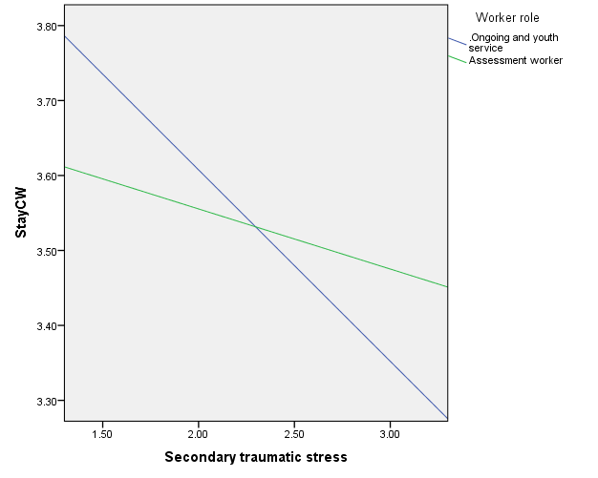

- The positive impact of emotional supervision on the intent to stay was greater for older workers (Figure 33).

Figure 33. Emotional supervision and intent to stay BY age
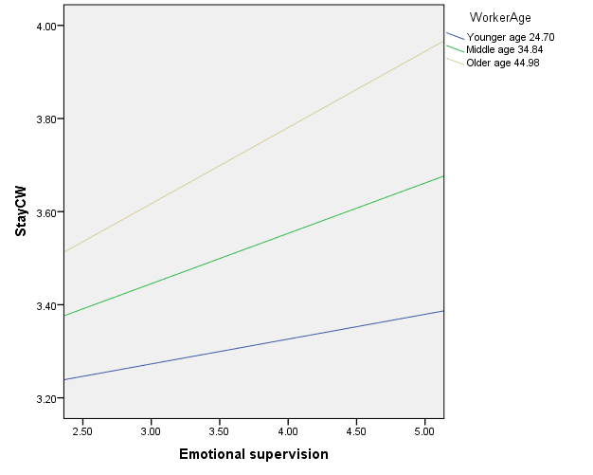
- The negative impact of secondary trauma on the intent to stay was greater for older workers at the marginal level (p < .1). See Figure 34.

Figure 34. Secondary traumatic stress and intent to stay BY age
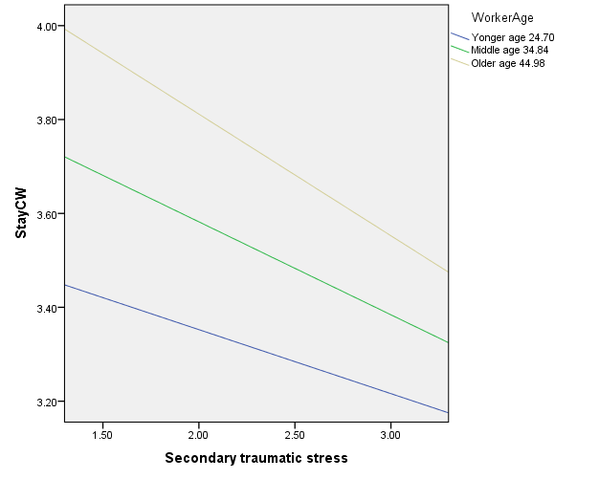
The ratings for FCMs secondary traumatic stress, justice, and their professional self-care are provided in Tables 28 – 30. FCMs identified themselves as caring individuals who enjoy helping others in Table 28, but around 20% of workers never or rarely took breaks or vacations as seen in Table 29.

Table 28. Secondary Traumatic Stress (Frequency of the feeling past 30 days)
1=Never to 5=Very often | Mean | SD
I am a very caring person. | 4.23 | 0.70
I get satisfaction from being able to (help) other people. | 4.12 | 0.70
I am proud of what I can do to (help). | 3.97 | 0.80
I feel connected to others. | 3.89 | 0.80
I am preoccupied with more than one person that I (help). | 3.87 | 0.90
I like my work as a (helper). | 3.87 | 0.80
I am happy that I chose to do this work. | 3.87 | 0.90
I believe I can make a difference through my work. | 3.84 | 0.80
I am happy. | 3.67 | 0.80
I have beliefs that sustain me. | 3.65 | 1.20
I have happy thoughts and feelings about those I (help) and how I could help them. | 3.65 | 0.80
My work makes me feel satisfied. | 3.58 | 0.80
I am pleased with how I am able to keep up with (helping) techniques and protocols. | 3.57 | 0.90
I have thoughts that I am a “success” as a (helper). | 3.55 | 0.90
I am the person I always wanted to be. | 3.49 | 0.90
I feel invigorated after working with those I (help). | 3.39 | 0.90
I feel worn out because of my work as a (helper). | 3.34 | 1.10
I feel overwhelmed because my case (work) load never seems endless. | 3.27 | 1.10
I feel “bogged down” by the system. | 2.85 | 1.20
I jump or am startled by unexpected sounds. | 2.72 | 1.10
I find it difficult to separate my personal life from my life as a (helper). | 2.62 | 1.10
Because of my (helping), I have felt “on edge” about various things. | 2.53 | 1.10
I think that I might have been affected by the traumatic stress of those I (help). | 2.51 | 1.10
I feel trapped by my job as a (helper). | 2.26 | 1.10
I am not as productive at work because I am losing sleep over traumatic experiences of a person that I (help). | 2.21 | 1.00
I feel depressed because of the traumatic experiences of the people I (help). | 2.17 | 1.00
I feel as though I am experiencing the trauma of someone I have (helped). | 2.09 | 1.10
I avoid certain activities or situations because they remind me of frightening experiences of the people I (help). | 2.07 | 1.10
I can’t recall important parts of my work with trauma victims. | 2.00 | 1.00
As a result of my (helping), I have intrusive frightening thoughts. | 1.93 | 1.00

Table 29. Professional self-care (Frequency of the activity in the past 30 days)
1=Never to 5=Very often | Mean | SD
I problem solve when I have challenges at work. | 2.93 | 0.71
I seek out colleagues I find supportive. | 2.85 | 0.84
I reserve work tasks for designated work hours (e.g., paperwork, emails, work related colleague contact). | 2.55 | 0.95
I am able to say “no” when appropriate. | 2.47 | 0.97
I acknowledge my successes at work. | 2.40 | 0.92
I seek out professional development opportunities that appeal to me. | 2.34 | 0.96
I attend to feelings of being overwhelmed with my work. | 2.31 | 0.88
I take small breaks throughout the workday. | 2.25 | 0.99
I take vacations. | 2.14 | 1.00

Table 28 presents the organizational justice items. Distributive justice items had the highest association with the intent to stay across all ages and gender.

Table 30. Organizational Justice
1=Strongly disagree to 5=Strongly agree | Mean | SD
Distributive Justice
I think that my level of pay is fair. | 2.84 | 1.03
I consider my workload to be quite fair. | 3.13 | 1.02
Overall, the rewards I receive here are quite fair. | 3.04 | 1.00
I feel that my job responsibilities are fair as compared to my coworkers. | 3.58 | 0.92
Procedural Justice
My agency’s decisions are made in an unbiased manner. (DecMkng) | 3.21 | 1.01
My agency makes sure that all employee concerns are heard before decisions are made. (EmployHeard) | 2.96 | 1.06
To make decisions, my agency collects accurate and complete information. (AccInfo) | 3.17 | 1.00
My agency allows employees to engage in decision-making procedures. (EmployEngage) | 3.26 | 1.02
All decisions are applied consistently across all affected employees. (Decision) | 2.99 | 1.08
Employees are allowed to challenge or appeal decisions made by my agency. (EmployChall) | 2.96 | 1.04
Decision-making procedures uphold ethical and moral standards. (Ethical) | 3.47 | 0.93
Interpersonal Justice
My coworkers treat me in a polite manner. (CoworkPolite) | 4.10 | 0.81
My coworkers treat me with dignity. (CoworkDig) | 4.09 | 0.80
My coworkers treat me with respect. (CoworkResp) | 4.10 | 0.80

FCM Survey: Evaluation of the Fidelity of CFTM
The fidelity of CFTM was evaluated by FCMs who coordinated CFTMs using a valid scale. The scale was developed by the Waiver team by selecting and modifying appropriate items from the fidelity index of the Wraparound model that provides the underlying principles of CFTM. The scale consists of nine items that reflect the core principles of CFTM (See Table 31). Caseworkers were asked to select their recently closed case and rate the fidelity of CFTM that they facilitated for the selected case on a four-point scale (1=strongly disagree to 4 = strongly agree) in 2017 and on a five-point scale (1=strongly disagree to 5 = strongly agree) in 2018. Because of the different scale points, the original scale was transformed to a binary variable that indicated whether FCMs strongly agreed or agreed with each item (1= agree; 0 =disagree). The overall CFTM fidelity was calculated by summing up the nine binary items, ranging from 0 to 9 with higher scores indicating high-quality fidelity.

Table 31. CFTM Fidelity Scale
Item | Principles | Items
1 | Family Voice and Choice | Important decisions are never made about the child/family when they aren’t there.
2 | Teamwork | The team develops any kind of written statement about what it is working on with the child and family. AND I can describe what the team’s mission says.
3 | Natural Support | The team finds ways to increase the support the family gets from friends and family members.
4 | Collaboration | The members of the team hold each other responsible for doing their part of the case plan.
5 | Cultural Competency | All members of your team demonstrate respect for the family.
6 | Individualized Plan | There is a crisis or safety plan that specifies what everyone must do to respond. AND this plan also specifies how to prevent crises from occurring.
7 | Strengths-Based Approach | The supports and services in the case plan are connected to the strengths and abilities of the child and family.
8 | Persistent Efforts | Some members of the team will be there to support the family when the case is finished.
9 | Outcome-Based Evaluation | The team assigns specific tasks to all members at the end of each meeting. AND the team reviews each member’s follow-through on tasks.

Table 32 presents the trends in the overall fidelity and individual fidelity indicators of CFTM. For the overall fidelity, FCMs agreed that at least 7 (SD = 2.16) out of the 9 fidelity indicators were implemented well for their closed cases. However, the overall fidelity score of the CFTM significantly decreased from 2017 (M = 7.94, SD = 1.55) to 2018 (M = 6.67, SD = 2.54). For the individual fidelity indicators, many FCMs agreed that their CFTMs were implemented successfully by ensuring its core principles, especially the strengths-based approach (91.0%) and cultural competency (89.4%). However, they were less like to agree that family voice and choice (63.8%) and teamwork (77.0%) were ensured in their CFTM as compared to the other fidelity indicators. The findings imply that CFTM may face more challenges in allowing family voices to be heard in decision-making as well as in creating the shared mission for the child and family among team members. Similar to the trends in the overall fidelity, the percent of rated agrees significantly decreased for the most fidelity indicators, although teamwork was significantly improved from 2017 to 2018.

Table 32. Trends in the Fidelity of CFTM
Overall Fidelity | Total  (N= 1,869) | 2017  (N= 1,005) | 2018  (N = 864) | t-test
 | M (SD) | M (SD) | M (SD)
Overall Fidelity | 7.36 (2.16) | 7.94 (1.55) | 6.67 (2.54) | 12.48***
Fidelity Indicators | Percent Rated Agrees | Percent Rated Agrees | Percent Rated Agrees | 𝝌²
Family Voice and Choice | 63.8% | 69.6% | 57.0% | 30.55***
Teamwork | 77.0% | 59.9% | 67.2% | 82.80***
Natural Support | 85.7% | 92.9% | 77.4% | 85.96***
Collaboration | 84.6% | 90.6% | 77.6% | 56.58***
Cultural Competency | 89.4% | 95.4% | 82.4% | 78.11***
Individualized Plan | 84.7% | 93.1% | 74.9% | 111.60***
Strengths-Based Approach | 91.0% | 96.8% | 84.3% | 85.06***
Persistent Efforts | 83.3% | 89.5% | 76.0% | 56.77***
Outcome-Based Evaluation | 83.5% | 90.5% | 75.3% | 73.88***
***p < .001

Table 33 shows the results of multiple regression to examine how FCMs’ characteristics are associated with their perceived fidelity of CFTM. Although FCMs’ age and race were not significant factors, female FCMs reported a significantly higher level of the overall fidelity than male FCMs did (β = .063, p < .05). In contrast, FCMs with social work degrees tended to perceive the lower level of the overall fidelity as compared to those with other educational degrees (β = -.062, p < .05). The overall fidelity was positively associated with FCMs’ perceived workload manageability rated on a five-point scale from 1=extremely unmanageable to 5=extremely manageable (β = .112, p < .001). Similarly, FCMs were more likely to report that they implemented CFTM with a high-quality fidelity when they felt more competent about facilitating CFTM (β = .147, p < .001).

The CFTM facilitation skills measured by four items that asked FCMs to self-report the level of their competencies for (1) encouraging teamwork, (2) managing power and control issues, (3) resolving conflicts between team members, and (4) addressing non-negotiable issues within CFTM (1=strongly disagree to 5=strongly agree). The results suggest that organizational support and effective supervision are necessary to effectively manage FCMs’ workloads so that they have enough time to prepare and implement the high-quality of CFTM. Furthermore, it is important to provide effective curricular and training activities that help FCMs improve their knowledge and skills to successfully implement CFTM.

Table 33. The Impacts of FCMs’ Characteristics on the Overall Fidelity of CFTM
FCMs’ Characteristics (n = 1,360) | β | SE | t
Age | .004 | .005 | .153
Female | .056* | .153 | 2.183
White | -.012 | .131 | -.456
Social Work Degree | -.039* | .117 | -1.418
Work Experience (Years) | -.054 | .140 | -2.074
Number of Open Caseloads | -.004 | .009 | -.144
Manageable workload | .104*** | .052 | 3.857
CFTM Facilitation Skills | .135*** | .083 | 5.220
2018 Survey | -.300*** | .110 | -11.374
F | 19.360***
R² | .114
*p < .05, ***p < .001

FCM Survey: Model Fidelity and Child Well-Being in Family Team Conference: The Moderation Effect of Racial Matching
In this section, the Evaluation Team explores two questions:
- Is CFTM culturally responsive? If so, how to implement CFTM in order to improve the well-being of children of color?
- Is racial matching effective for successfully implementing CFTM with high fidelity and improving its intended outcome?
The purpose of this study aims to explore how the quality of implementing CFTM (fidelity) differ between children matched with facilitators from the same or different racial groups and examine the moderation effect of racial matching on the relationship between the fidelity of CFTM and child well-being.

Measures:
Measures are provided below in Table 34.

Table 34. Measures
Variables | Measures | Alpha
Child well-being | - Used four items that assessed the four domains of child well-being: (1) health, (2) emotional, (3) developmental, and (4) learning status (1 = adverse to 6 = optimal) | .91
CFTM fidelity | - Used the fidelity index that assessed the ten core principles of CFTM: (1) family voice and choice, (2) strengths-based approach, (3) cultural respect, (4) teamwork, (5) collaborative process, (6) natural support, (7) community-based services, (8) individualized plan, (9) persistence, and (10) outcome-based evaluation (1 = strongly disagree to 5 = strongly agree) | .87
Racial matching | - Initially created racial matching between a caseworker and a child for seven racial groups  - Categorized the initial racial matching into four groups by considering the child’s racial minority status: (1) non-racial matching for white children, (2) racial-matching for white children, (3) non-racial matching for children of color, and (4) racial matching for children of color (reference group) | N/A
Control variables | - Child characteristics: age, gender, placement type, having multiple caseworkers, and the level of difficulty  - Caseworker characteristics: age, gender, educational level, caseload, work experience, and facilitation skills for family meetings | N/A
Results:
Descriptive analyses of the racial characteristics of caseworkers and children will be provided. Then, an ANOVA will compare the fidelity of CTFMs between four racial matching groups with a Bonferroni test. Finally, a multiple regression with PROCESS analysis will examine the main effects of major variables on child well-being, examine the moderation effect of racial matching, and conduct a pick-a-point approach that probes the significance level of the moderation effect.

The majority of white children (84.8%) were matched with white caseworkers. About 30% of children of color were matched with caseworkers from the same racial group. (Table 35)

Table 35. Racial Matching
Racial Groups | Children |  | Caseworkers
 | N | Percent | N | Percent
White | 533 | 72.7 | 544 | 77.7
African American | 113 | 15.4 | 115 | 16.4
Hispanic | 41 | 5.6 | 28 | 4.0
Asian | 2 | .3 | - | -
Native Hawaiian or other Pacific Islander | - | - | 2 | .3
American Indian/Alaska Native | - | - | 1 | .1
Multiracial | 44 | 6.0 | 10 | 1.4
Total | 733 | 100.0 | 700 | 100

In Figure 35 below, Caseworkers were asked to evaluate the ten core principles of FTC based on their experiences in the most recently closed case. As the figure demonstrates, they basically agreed that the FTC was implemented as planned. Interestingly, caseworkers rated the highest on cultural respect. However, Family voice and choice and teamwork are relatively lower than other principles. This result may imply that there may be more significant barriers to empowering families and actively engaging important team members in FTC even though they are the most important principles that make more culturally responsive.

Figure 35. Fidelity of CFTM
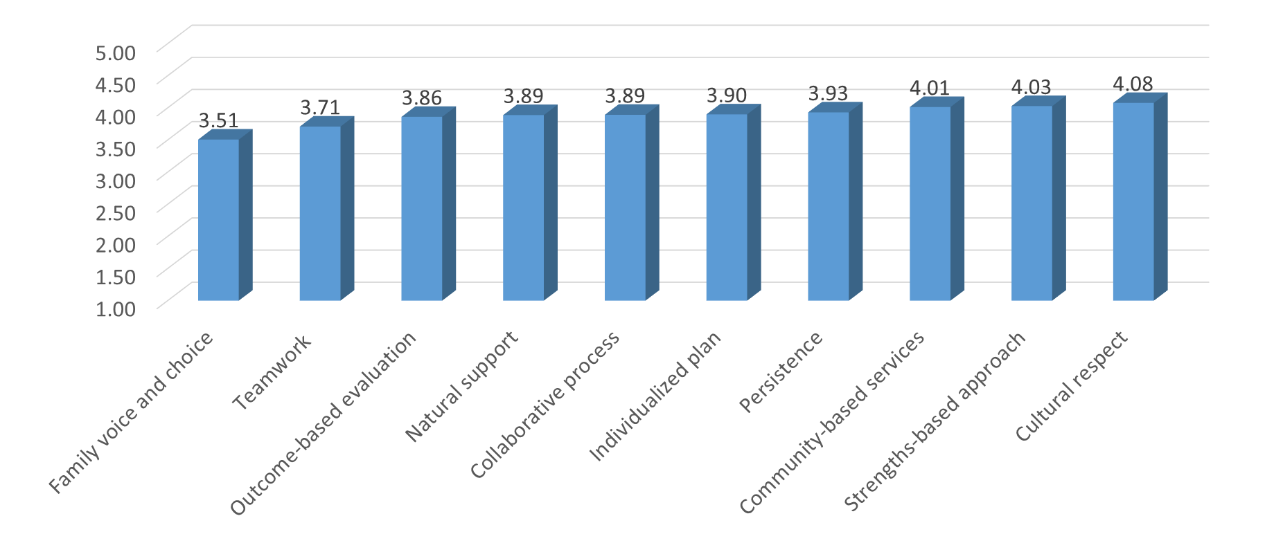
Range: 1=Strongly disagree 5=Strongly agree

Figures 36-39 show the overall fidelity and selected indicators that are directly associated with cultural responsiveness in CTFMs. Significant differences were detected in the cultural respect (at the marginal level) and community-based services between four racial matching groups. Non-racial matching groups tend to have the higher levels of cultural respect and community-based services than racial matching groups for both white children and children of color. Racial matching group for children of color tends to show the lower levels of most fidelity indicators.

Figure 36. Fidelity by Racial Groups

Figure 37. Cultural Respect by Racial Groups

Figure 38. Family Voice and Choice by Racial Groups

Figure 39. Community-Based Services by Racial Groups

Finally, Table 36 presents the main effect model and the moderation model findings summarized here:
Main Effect (Model 1):
High fidelity significantly increased child well-being reported by caseworkers.
Within the racial matching groups, white children had a significantly higher level of child well-being than children of color (marginal level)
Child well-being was significantly lower when children were older, placed in in-home care, had a higher level of difficulty.
Caseworkers reported a higher level of child well-being when they are older and have less work experience.

Moderation Effect (Model 2):
Racial matching was not a significant moderator that strengthens the positive association between the FTC fidelity and child well-being.

Table 36. Main Effect and Moderation Models
Variables | Model 1 |  | Model 2
 | B | SE | B | SE
Fidelity | 0.28*** | 0.05 | 0.19* | 0.05
Non-racial matching for white children | 0.07 | 0.13 | -0.37 | 0.25
Racial matching for white children | 0.12† | 0.10 | -0.26 | 0.49
Non-racial matching for children of color | 0.08 | 0.11 | -0.03 | 0.94
Child- age (years) | -0.21*** | 0.00 | -0.21*** | 0.00
Child- female | 0.02 | 0.06 | 0.03 | 0.50
Child- out-of-home placement | 0.14*** | 0.06 | 0.15*** | 0.00
Child- level of difficulty | -0.17*** | 0.01 | -0.17*** | 0.00
Child- having multiple caseworkers | -0.01 | 0.06 | -0.01 | 0.75
Caseworker- age (years) | 0.10* | 0.00 | 0.10* | 0.02
Caseworker- female | 0.02 | 0.08 | 0.01 | 0.74
Caseworker- graduate degree | -0.01 | 0.09 | -0.01 | 0.86
Caseworker- caseload | 0.03 | 0.01 | 0.03 | 0.42
Caseworker- work experience (years) | -0.08* | 0.01 | -0.09* | 0.04
Caseworker- FTC facilitation skills | 0.01 | 0.05 | 0.01 | 0.82
Fidelity X Non-RM for white children |  |  | 0.46 | 0.16
Fidelity X RM for white children |  |  | 0.39 | 0.30
Fidelity X Non-RM for children of color |  |  | 0.12 | 0.76
F (df) | 9.60 (15, 586)*** |  | 8.12 (18, 583)***
R-square | 0.197 |  | 0.200
†p<.01, *p<.05, **p<.01, ***p<.001

Summary:
Although the racial composition is similar between children and caseworkers, children of color were less likely than white children to be matched with caseworkers from the same racial groups. Racially matched children of color seem to face more challenges to cultural responsiveness in FTC, perhaps due in part to their higher risks and challenges. The fidelity of FTC was a stronger factor to enhance child well-being. Racial matching in FTC was less effective for improving the well-being of children of color. Caseworkers’ facilitation skills significantly increased child well-being and strengthened the positive impact of the fidelity on child well-being.

Implications:
Enhance cultural responsiveness in the entire process of FTC
- Allow families to choose their team members and hold family meetings in culturally appropriate settings
- Empower families to embrace their culture in decision-making
- Create flexible processes to respect cultural traditions with ongoing communication and joint problem-solving
- Monitor and evaluate the fidelity of FTC to address cultural barriers and improve child and family outcomes
Develop culturally responsive workforce
- Improve cultural knowledge, values, and skills
- Encourage critical awareness of caseworkers’ cultural bias and institutional racism based on an intersectionality perspective
- Provide organizational support and supervision that allows caseworkers to maintain high-fidelity of FTC, such as cultural respect
Promote community engagement and partnerships
- Reach out to communities to recruit and engage cultural representatives
- Build community partnerships to provide culturally responsive services

FCM Survey Summary
In this report, the Evaluation team provided a FCM analyses including safety, permanency, and well-being of the most recently opened and most recently closed cases, FCM understanding of FFPSA, FCM perceptions of the service array, perception of concrete service use, determinants of intent to stay in child welfare, evaluation of the fidelity of child family team meetings, and how that fidelity impacts child well-being. A total of 7,133 survey responses were analyzed over the demonstration and extension periods. These responses provided rich data on the experiences of FCMs during the demonstration.

Of note, the most recently opened cases over the demonstration declined in safety, permanency, and well-being supporting the hypothesis that the Waiver may keep families out of the system who do not need interventions from the State. And FCMs perceptions of the safety, permanency, and well-being of cases at closure increased positively over the demonstration. In regards to the service array, EBPs were not perceived as the most needed, but were the most effective services when they are utilized. Global funds and basic needs were the only two non-EBPs that were perceived as effective as the EBPs. Distributive justice significantly increased the intent to stay working in child welfare. Distributive justice was a stronger factor than other significant factors. Secondary traumatic stress significantly decreased the intent to stay, particularly for ongoing and youth service workers (collaborative care) than assessment workers. Professional self-care also increased the intent to stay. Finally, fidelity to CFTMs decreased over the demonstration period, and better fidelity significantly increased child well-being reported by caseworkers.

Cost Study
The Title IV-E Capped Allocation Waiver that the State of Indiana has been participating in over the last several years has had many benefits that have been well discussed throughout this report. One of the impacts realized by the state has been the flexibility of the funding. The state has been able to utilize this funding for more cost than were traditionally eligible, including unlicensed relative placements and community-based services. All of this has been done while keeping under the state’s overall allocation amount for the time period.

Figure 40. Total DCS Spending (By State Fiscal Year)

* Does not include the transfer of DCS appropriation to cover Medicaid match of DCS wards.

As the graph above shows, total spending by the Indiana Department of Child Services has been increasing in an almost dramatic fashion over the course of the Waiver. This has made the review of this cost very difficult as so many other variables have been a factor during this time period. One of the main reasons for this is the drastic increase in total caseload over that time period resulting in an increased cost in direct services. During the extension period, administrative costs also increased as DCS hired more caseworkers, attorneys, increased salaries, and created several new positions to support agency goals and needs. Many of these administrative adjustments were due to a review by the Child Welfare Group and the related recommendations on how to improve the DCS culture. Investment in culture and the DCS team was one key component of better serving the kids and families in Indiana.

Figure 41. Total Cases

Figure 42. CHINS Placements

Since the beginning of the current iteration of the Waiver, there has been a near doubling of the number of cases in the system. Although this increase has seen substantial rise in the amount of children in the system, it has not seen a lot of variation in the breakdown of the placement types. We see that our system continues to operate within the same percentage of placement type during the Waiver period. Over the extension period, there was a slight decrease in the proportion of cases in-home, which may be due to the policy changes at DCS that addressed intervening with families only when necessary.

Figure 43. Breakdown of total cases

Figure 44. Breakdown of CHINS placements

Other factors have come into play with the rising total cost of the agency. Indiana’s cases where parent drug abuse is indicated as a removal reason have increased by 153% between 2013 and 2017. Agency spend on substance abuse related services increased 45% between 2016 and 2017.

As the spending has increased during this time period, funding from non-Waiver grants has remained generally consistent. This means that as overall spending has increased, funding of those expenses came from either the state general fund or the Capped Allocation Waiver. The state of Indiana works on a two year budget cycle which makes state funding flexibility very difficult. The increase in the amount of children and the Opioid epidemic pushed cost up so quickly that without the ability to move Waiver funding forward, the state would have been unable to cover cost. This can be seen in the 2016 funding chart. Additionally, the state reduced its utilization of the Waiver in 2017 and 2018 to allow it to remain cost neutral. By the end of the current Waiver Extension to March 31st 2018 Indiana will only claim the amount of the allocation tables and no more. Indiana was able to increase utilization during the middle of the period but then reduce in the following years to be able to remain neutral.

Figure 45. Total DCS Funding

During the period of the original Capped Allocation Waiver, Indiana and ACF agreed to extend the Waiver under the prior methodology. This extension also allowed Indiana to prepare for the end of Waiver authority. Now that the Family First Prevention Services Act and then the Family First Transition Act were passed, Indiana is applying its learning from the waiver to continue improving how the state helps families stay safely together as well as understand the importance of community services to de-escalate situations and prevent unnecessary residential treatment.

Sub-Study: Family Centered Treatment (FCT)

FCT background
Family Centered Treatment (FCT) is a home-based, family centered approach for family preservation. It is an intensive intervention with demonstrated positive outcomes for children in residential treatment as well as providing a way to divert children from residential treatment. It is an evidence-based practice with proven outcomes for the probation population as well as those children involved in the child welfare system. There are four phases in FCT:
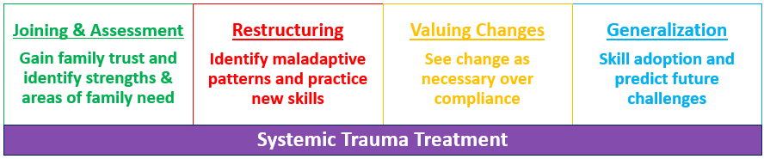
*Retrieved from: http://www.familycenteredtreatment.com/home/#family-centered-treatment
In addition, FCT is often effective for families with very complex needs that have not responded to previous home-based services.

FCT in Indiana is available statewide. There are five providers in Indiana: Centerpointe Community Based Services, Family Solutions, Ireland Home Based Services, Lifeline Youth and Family Services, and SCAN (Stop Child Abuse & Neglect). Each county aims to have one designated provider for FCT with the exception of Marion County (Indianapolis) which has three. Estimated team sizes were calculated by considering the number of youth currently in residential treatment, those youth entering residential treatment, and families for which more than $16,000 of home based services have been provided.
Implementation of FCT began with trainings in September of 2013.

The sub-study included all of the newly opened cases for families enrolled in Family Centered Treatment FCT from January 1, 2015 until December 31, 2015. Each focus child in the home will be matched to a child within DCS not receiving FCT. Each focus child in the home will assessed individually and as a member of the family group. This will allow the evaluation to look within and between families in FCT.

Data on those who have entered FCT since Jan 1, 2015 was provided by DCS to the Evaluation Team in June 2016. Data included CANS, risk/safety assessments, the case plan goals, placements, CFTMs, demographic characteristics, maltreatment type, removal reason and risk factor, Permanency and Practice Support Team (PPS) referrals, permanency round table, other services, and the fidelity tracker. This report will provide key demographic information about the families in FCT during 2015.

Research Questions:
Safety
- Do children who are placed in-home when treatment is initiated remain in-home throughout the treatment period and after treatment for FCT and non-FCT families?
- Are families who participate in FCT less likely to have an incident of repeat maltreatment (substantiated abuse or neglect) than non-FCT families?
- Are families who participate in FCT less likely to have an incident of re-entry into the DCS system than non-FCT families?

Permanency
- Do families who participate in FCT achieve permanency more timely than non-FCT families?
- Are families who participate in FCT more likely to have their children reunified than non-FCT families?
- How much time elapses to case closure after treatment concludes for FCT and non-FCT families?

Well-being (related to family functioning)
- Does family functioning improve for families who participate in FCT?
- Do families who participate in FCT have greater improvement in family functioning than non-FCT families?

Cost
- What are the costs associated with FCT and non-FCT families?

FCT comparison
Propensity-score matching (PSM) was used to match children within DCS receiving FCT with children within DCS who did not receive FCT. Matching characteristics were age, gender, race, region, county, number of focus children, involvement status, permanency goal, cans score, and risk score. PSM uses the matching characteristics identified to determine the probability of receiving FCT. PSM then finds the child who did not receive FCT that has the exact same probability, using the same matching characteristics, as the child who received FCT. Once the probabilities are matched, a dataset of probability-matched children who received FCT and those that did not is created.

Overall, 20,779 children were within DCS during January 1, 2015 and December 31, 2015. There were 230 children within DCS that received FCT and were not involved with juvenile detention. Matching characteristics (age, gender, race, region, county, number of focus children, involvement status, permanency goal, cans score, and risk score) were too restrictive and we were unable to obtain a sufficient amount of pairs to conduct analysis. Region and permanency goal were removed as they were the two characteristics restricting the matching. The final dataset included 187 children who received FCT and 187 children who did not receive FCT.

PSM matches children on the probability of their chances of having FCT based on a collective score of their characteristics. Therefore, the children receiving FCT and those that did not receive FCT may not match exactly on characteristics, rather they match exactly on their probability of receiving FCT.

Extension Period Sub-study Activities
During the extension period of the Waiver, the Evaluation Team provided data to other jurisdictions who were submitting FCT for transitional payments to the IV-E Clearinghouse. Following the work, FCT was approved for use by all states during the transition period as a ‘well-supported’ evidence-based practice.

Updated Sub-study Analyses

Services
Prior analyses for the effectiveness of Family Centered Treatment (FCT) focused on comparing youth that had received FCT to those that had not received FCT. The prior analyses did not examine which type of services Non-FCT youth had received during the same time period as FCT youth. The first section details which services Non-FCT youth were given and the frequency of those services.

Table 37. Types and frequency of services provided to Non-FCT youth.ª
Service Offered | Non-FCT youth  Number of times services offered (%)
BX Health Services | 670 (1.5)
Child Caring Institutions | 706 (1.6)
4. Comprehensive Home-based Solutions | 2996 (6.8)
Counseling | 1754 (4.0)
Cross-System Care Coordination | 137 (0.3)
Day Treatment | 426 (1.0)
DCS Foster Home | 1896 (4.3)
Detoxification Services | 33 (0.1)
Diagnostic and Evaluation Services | 334 (0.8)
Domestic Violence Batterers | 229 (0.5)
Domestic Violence Victim and Child | 123 (0.3)
Drug Testing and Supplies | 257 (0.6)
Father Engagement Programs | 1159 (2.6)
Functional Family Therapy | 75 (0.2)
General Products | 882 (2.0)
Group Home | 156 (0.4)
2. Homemaker/Parental Aid | 4926 (11.2)
3. LCPA Foster Home | 4491 (10.2)
Material Assistance | 1697 (3.9)
OYS- IL Services | 69 (0.2)
Parent Education | 733 (1.7)
Parenting/Family Functioning Assessment | 157 (0.4)
Personal Allowance | 397 (0.9)
Private Secure | 472 (1.1)
5. Random Drug Testing | 2466 (5.6)
Residential Substance Use Treatment | 120 (0.3)
Specialized Services | 54 (0.1)
Substance Use Disorder Assessment | 235 (0.5)
Substance Use Outpatient Treatment | 2435 (5.5)
Transition from Restrictive Placement | 27 (0.1)
Tutoring/Literacy Classes | (2.1)
1.Visitation Facilitation – Parent/Child/Sibling | 12934 (29.4)
ªOmits any services offered twenty times or fewer because these are less than 1/10th of a percent of the total services provided
Non-FCT youth were provided 42 different types of services from 2015 – 2017. The five most frequently provided services include: 1. Visitation Facilitation – Parent/Child/Sibling (n = 12934 [29.4]); 2. Homemaker/ Parental Aid (n = 4926 [11.2]); 3. LCPA Foster Home (n = 4491 [10.2]); 4. Comprehensive Home-based Solutions (n = 2996 [6.8]); and 5. Random Drug Testing (n = 2466 [ 5.6]). The full list of services is provided in Table 36 above.

Several services were provided to Non-FCT youth and provided so infrequently that they comprised less than a tenth of a percent of the overall services provided. These are listed below.

Services offered twenty times or fewer from 2015-2017:
- BX Counseling
- Collaborative Care Host Home
- Court Ordered Paid Placement
- Med Assessment for MRO
- NRAE Services
- Residential detoxification
- Sex Offender Treatment
- Specialized Youth Career Training Program
- Start Treatment Program
- Substance Abuse Assessment, Treatment, & Monitoring

Services and cost of services provided to youth
From 2015 to 2017, youth in FCT had 13,093 instances of a service being provided to them and/or their family and non-FCT youth had 13,475 instances of a service being provided to them and/or their family. The average cost of services provided to youth in FCT was $270.46, while the average cost of services provided to youth not in FCT was $210.40. FCT youth had a significantly higher cost in services than non-FCT youth $(t\left[df\right]= -5.41 \left[26566\right], p< .001)$.

FCT youth were significantly less likely to receive services classified as preservation services (n=10,539 vs. 9,256) and care of wards in foster homes (n=1,556 vs. 1,139) than non-FCT youth. FCT youth were significantly more likely to receive miscellaneous costs for wards (n=973 vs. 324) and care of wards in institutions (n=1,522 vs. 762) than non-FCT youth $(χ^{2}\left[df\right]=738.76 \left[6\right], p< .001)$. FCT youth received approximately 70 instances of provided services and non-FCT youth received approximately 72 instances of provided services, on average. The number of services provided, by classification is provided in figure 46 and the number of services provided by the description of the service is provided in figures 47 and 48.

Figure 46. Type of Service Provided to Youth

Figure 47. Description of the Service Provided to Youth (1)

Figure 48. Description of the Service Provided to Youth (2)

Safety and Risk
Risk assessment:
FCT youth were significantly more likely to have high risk assessment at first visit $(χ^{2}\left[df\right]=80.83 \left[3\right], p< .001)$ and at last visit $(χ^{2}\left[df\right]=70.74 \left[3\right], p< .001)$ than non-FCT youth. FCT youth had a median score of “high risk” while non-FCT youth had a median score of “moderate risk” at first visit. FCT youth had a median score of “moderate risk” at the last visit and non-FCT youth also had a median score of “moderate risk” at the last visit. FCT youth had 4.61 higher odds of having a higher risk level at last visit than non-FCT youth (Table 38).

Table 38. Difference in risk assessment score from first visit to last visit
 | First Visit |  | Last Visit
 | FCT | Non-FCT | FCT | Non-FCT
Low | 0 [0.00] | 16 [12.03] | 0 [0.00] | 51 [38.35]
Moderate | 32 [26.23] | 90 [67.67] | 96 [78.69] | 59 [44.36]
High | 75 [61.48] | 27 [20.30] | 16 [13.11] | 23 [17.29]
Very High | 15 [12.30] | 0 [0.00] | 10 [8.20] | 0 [0.00]

Safety assessment:
As seen in Table 39, FCT youth were significantly more likely to have an unsafe assessment at first visit $(χ^{2}\left[df\right]=29.66 \left[2\right], p< .001)$ than non-FCT youth. FCT youth were less likely to have an unsafe assessment at their last visit $(χ^{2}\left[df\right]=92.41 \left[2\right], p< .001)$ than non-FCT youth. The median safety level at first visit for FCT youth was “conditionally safe,” while the median safety level for non-FCT youth at first visit was safe. At last visit, the median safety level for FCT youth moved to “safe,” as well as the median safety level for non-FCT youth. FCT youth had 58.92 higher odds of having an unsafe level at first visit than non-FCT youth.

Table 39. Difference in safety assessment score from first visit to last visit
 | First Visit |  | Last Visit
 | FCT | Non-FCT | FCT | Non-FCT
Safe | 21 [42.86] | 31 [56.36] | 38 [86.36] | 91 [84.26]
Conditionally Safe | 2 [4.08] | 19 [34.55] | 6 [13.64] | 2 [1.85]
Unsafe | 26 [53.06] | 5 [9.09] | 0 [0.00] | 15 [13.89]

Well-being: CANS score overtime
Those youth in non-FCT services trended steadily upward in their CANS score over time (2015 – 2017) meaning they had more needs over time, while those not in FCT trended slightly downward in their CANS score overtime. However, neither of these trends were statistically significant (Figure 49).

Figure 49. CANS score trends over time

Well-being: Family Functioning
We analyzed the trend of the family functioning score from January 2015 – December 2017 for both Non-FCT youth and FCT youth. FCT youth started with a significantly lower family functioning score (using the CANS scoring tool) than Non-FCT youth. It took nearly two years for FCT youths’ family functioning scores to catch up to Non-FCT youth. This suggests that FCT youth begin with a higher risk than Non-FCT youth (Table 40)

However, FCT youths’ family functioning climbed at a statistically significantly higher rate than Non-FCT youth over time, whereas Non-FCT youths’ scores climbed at a slower rate (Figure 50). It appears that about at the three year mark a shift in family functioning scores. Thus, FCT appears to be more effective in increasing the overall family functioning over time for youth.

Table 40. Effectiveness of FCT on Family Functioning (FF) from January 2015 – December 2017.
 | Overall | Non-FCT |  | FCT
 | Exp (B) | Mean | Exp (B) | Mean | Exp (B)
FCT Treatment (Yes) | .151*** |  | - |  | -
Timepoint of average FF score
Time 1 (Jan – Mar, 2015) REFERENT | - | 1.51 | - | 0.53 | -
Time 2 (Apr – Jun, 2015) | .225*** | 1.52 | .009 | 1.02 | .486***
Time 3 (Jul – Sep, 2015) | -.043 | 1.14 | -.367*** | 0.80 | .273***
Time 4 (Oct – Dec, 2015) | .138*** | 1.03 | -.476*** | 1.21 | .676***
Time 5 (Jan – Mar, 2016) | .183*** | 1.31 | -.192*** | 1.08 | .547***
Time 6 (Apr – Jun, 2016) | .206*** | 1.44 | -.064 | 0.97 | .441***
Time 7 (Jul – Sep1.15, 2016) | .363*** | 1.63 | .126** | 1.09 | .558***
Time 8 (Oct – Dec, 2016) | .656*** | 1.45 | -.054 | 2.08 | 1.54***
Time 9 (Jan – Mar, 2017) | .212*** | 1.30 | -.207*** | 1.15 | .623***
Time 10 (Apr – Jun, 2017) | 1.39*** | 1.78 | .277*** | 2.97 | 2.43***
Time 11 (Jul – Sep, 2017) | 1.50*** | 2.4 | .889*** | 2.76 | 2.22***
Time 12 (Oct – Dec, 2017) | 1.71*** | 2.82 | 1.31*** | 2.52 | 1.99***
**p < .01; ***p < .001

Figure 50. Trends of family functioning scores from January 2015 – December 2017.

Summary and Conclusions
This report serves as the final report for the Indiana Title IV-E Waiver Demonstration project. The Indiana Title IV-E Waiver project was implemented statewide in order to spend federal dollars to expand services and invest in evidence-based services for Hoosier children and families. This evaluation involved four studies: outcome; process; cost; and a sub-study, which evaluated Family Centered Treatment. Overall, there were some successes and some areas for improvement within the Department. As the Federal Government moves to implement the FFPSA, Indiana continues to invest in data driven approaches to best serve the children and families in Indiana.

Outcome Study
The outcome study during the extension investigated key findings of the initial final report: re-entries in care over the Waiver period, relative placements, the impact of concrete service use on outcomes, and the impact of substance abuse on outcomes. Care should be taken for older children entering the system to avoid re-entry. Children who spent more time out of the home also had more re-entries. Closure of cases for older children and those with longer placements may need to facilitate connections to community-based organizations to aid in the prevention of those at high risk for re-entries.
The licensure of relatives were associated with fewer placements. Caregivers who were able to manage the child’s stress and had a significant network were more likely to have licenses. Efforts should be made to extend caregivers’ networks of support by connecting them with support groups or community partners. In the QSR data, relative care was a good alternative to in-home care with trying to re-unify families. Relative placements were better suited to maintain family relationships and support child well-being.
Substance abuse affected many of the QSR cases. While the substance abuse of a caregiver did not impact the child’s safety or permanency in the QSR, it did impact the child’s well-being. Of importance, those with parents who had substance use, maintaining relationships positively impacted well-being and teaming negatively impacted well-being. Maintaining relationships was more impactful to well-being when the parent suffers from substance abuse. Alternatively, teaming with families where a parent if suffering from substance abuse can have a negative impact on the child’s well-being. Special care should be taken for those children around the teaming process to minimize the impact of conflict on the child.
QSR Stability increased over time for those who used concrete services and decreased for those who did not use concrete services. Overall, the use of concrete services was associated with increases in stability for children at a higher level of need and this is particularly important for those at a higher level of placement instability. Concrete services can be an effective way to increase placement stability for children.

Process Study
During the extension period, Indiana has invested in more case managers, evaluation, and data. These investments have seen a cultural shift within the agency. With the hiring of many new case managers, the FCM survey demonstrated a decrease in CFTM fidelity, which may impact child well-being as seen in the results. It is also important to keep the turnover of FCMs down. Some of the mechanisms found in the survey were distributive justice, or the idea that distribution of outcomes regarding evaluations, pay, rewards, promotions, job assignments, and other tasks at their agency is fair. Efforts should remain and possibly increase to address secondary traumatic stress for FCMs, particularly for those who work on CHINS and collaborative care cases and those who were older. Effective tools include emotional supervision, which had a larger impact on the intent to stay in child welfare on those who were older.
Perceptions of recently opened and recently closed cases followed the initial hypotheses of the evaluators that safety, permanency, and well-being indicators would decrease over time for the most recently opened cases and increase for the most recently-closed cases. The hypotheses were made under the assumption that flexible funding would be able to front load services, expand the service array, and increase investments in community partners to keep children out of care who did not need it and to better serve those that did need intervening.

Cost Study
During the period of the current Capped allocation Waiver, Indiana and ACF renegotiated the amounts of the capped allocations because Indiana showed an increase in IV-E eligible cost. Indiana has shown that an increase in the amount of children and the Opioid epidemic has contributed to rising IV-E Foster Care cost. These factors have gone to negative the impact of the Waiver shifting funding to services whose goal is to prevent entry into the foster care system. Indiana continues to review the traditional IV-E eligible Foster Care cost and sees that they outpace the Capped allocations by year. This shows that the Waiver has a lower cost than traditional. Overall, Waiver funding has remained cost neutral and funds saved by reducing more expensive services utilization were shifted to early intervention service delivery – a major goal of Waiver funding.

Sub-study
The extension period provided the Evaluation Team to further examine the differences between the FCT families and the non-FCT families matched with Propensity Score Matching. Of note, family functioning and CANS scores were positively affected during the sub-study. In fact, their family functioning scores were worse off than the non-FCT group at case opening and progressed to better scores at the end of the year.

Limitations
Overall, the Waiver evaluation team experienced some difficulty obtaining data over time. The initial message that the Waiver is “simply a fiscal mechanism” initially sold the potential of the Waiver opportunity short. Once Casey Family Programs intervened in 2013, data sharing and messaging improved. Since this Waiver involved statewide implementation there was no opportunity to use random assignment as a sampling technique. The Evaluation Team is encouraged by the investments by DCS in their own evolutions and their dedication to improving and expanding the service array.

Opportunities
Use of formative evaluation strategies by Waiver evaluation teams may provide child welfare agencies with the opportunity to learn to use data more effectively in their day-to-day practice. Of great importance and potential is the Evaluation Team and DCS working on providing manuscripts on the effectiveness of concrete service use in the hope of submitting them to the IV-E Clearinghouse.

Appendix A: QSR Outcome and Practice Indicator Scoring and Definitions
Outcome | Range | Definition
Safety
Safety | 1 High Safety Risk – 6 Optimal | The degree to which: The child is free of abuse, neglect, and exploitation by others in his/her place of residence and other daily settings. • The child free from injury caused by others in his/her daily home, school, and community settings. • Parents and caregivers provide the attention, actions, and supports necessary to protect the child from known risks of harm in the home. [past 30 days]
Behavioral Risk (Age 3 and Older) | 1 Serious and Worsening – 6 Optimal & N/A | The degree to which the child/youth consistently avoiding self-endangerment situations and refraining from using behaviors that may put him/herself or others at risk of harm. [past 30 days]
Permanency
Stability | 1 Adverse – 6 Optimal | The degree to which: The child’s daily living, learning, and work arrangements are stable and free from risk of disruption. • The child’s daily settings, routines, and relationships consistent. • Known risks being managed to achieve stability and reduce the probability of future disruption. [Timeframe: past 12 months and next 6 months]
Permanency | 1 Adverse – 6 Optimal | The child/youth is living with parents or out-of-home caregivers that the child, parents or out-of-home caregivers, and other stakeholders believe will sustain until the child reaches adulthood and continue onward to provide family connections and supports. • If not, the permanency efforts presently being implemented on a timely basis that will ensure that the child/youth soon will be enveloped in enduring relationships that provide a sense of family, stability, and belonging. [Consistent with requirements for sustainable, safe case closure] [past 30 days]
Well-Being
Appropriate Living Arrangement | 1 Adverse – 6 Optimal | The degree to which: The child in the most appropriate/least restrictive living arrangement, consistent with needs for family relationships, social connections, age, ability, special needs, education, and positive peer group affiliation. • The child is in temporary out-of-home care, does the living arrangement meet the child's needs to be connected to his or her language and culture, community, faith, extended family, tribe, social activities, and peer group. [past 30 days]
Physical Health | 1 Worsening – 6 Optimal | The degree to which: The child achieving and maintaining his/her optimum health status. • The child has a serious or chronic physical illness, is the child achieving his/her best attainable health status given the disease diagnosis and prognosis. [past 30 days]
Emotional Status (Age 3 and Older) | 1 Adverse – 6 Optimal | The degree to which: The child presenting age-appropriate emotional development, adjustment, attachment, coping skills, and self-control. • The child achieving and maintaining an adequate level of behavioral functioning in daily settings and activities, consistent with age and ability. [past 30 days]
Learning and Development (Under age 5) | 1 Adverse – 6 Optimal | The degree to which: The young child’s developmental status commensurate with his/her age and developmental capacities• The child’s developmental status in key domains consistent with age-appropriate expectations. [past 30 days]
Learning and Development (Age 5 and older) | 1 Adverse – 6 Optimal | The child [according to age and ability] is: (1) regularly attending school, (2) in a grade level consistent with age, (3) actively engaged in instructional activities, (4) reading at grade level or IEP expectation, and (5) meeting requirements for annual promotion and course completion leading to a high school diploma or equivalent. [past 30 days]
Pathway to Independence (Older youth) | 1 No development – 6 Optimal | The degree to which: The youth gaining skills, education, work experience,  connections, relationships, income, housing, and necessary capacities for living safely and functioning successfully independent of agency services, as appropriate to age and ability. • The youth developing long-term connections and informal supports that will support him/her into adulthood. [past 30 days]
Overall Child Status | 1 Adverse – 6 Optimal | If the child’s safety score is in the concerted action needed area (1, 2, 3), then the Overall Child status rating would be equal to the safety score. Give weight to stability and permanency when they score in concerted action needed and all other indicators are in the refine and maintain area.

Process Indicators
Outcome | Range | Definition
Engaging
Role and Voice of family members (mother, father, child, other) | 1 Absent or Adverse – 6 Optimal & N/A | The degree to which family members with whom the child is living and/or will be reunited, active ongoing participants (e.g., having a significant role, voice, influence) in decisions made about child/family change strategies, services, and results. [Role and voice in recent meetings] They are active participants in the plans and services they identified. A trust-based relationship exists between all team members.
Teaming
Team Formation | 1 Absent or Adverse – 6 Optimal | The degree to which: The people who provide support and services for this child and family have been identified and formed into a working team • The team has the skills, family knowledge, and abilities necessary to organize effective services for a child and family of this complexity and cultural background.
Team Functioning | 1 Absent or Adverse – 6 Optimal & N/A | The degree to which: Members of the family team collectively function as a unified and coordinated team in planning services and evaluating results. • Actions of the family team reflect a coherent pattern of effective teamwork and collaborative problem solving that benefits the child and family.
Assessing
Cultural Recognition | 1 Adverse – 6 Optimal | How well any significant cultural issues, family beliefs, and customs of the child and family have been identified and addressed in practice (e.g., culture of poverty, domestic violence, mental illness or incest). • The natural, cultural, or community supports are appropriate for this child and family being provided. • The degree to which the necessary supports and services are provided being made culturally appropriate in the family engagement, assessment, planning, and service delivery processes. • The degree to which family values and beliefs are recognized when developing plans for sustainable, safe case closure. Plans to address the family’s maladaptive behaviors, values, and beliefs should not adversely affect the child’s safety, permanency, and well-being.
Assessing & Understanding (the child, the family) | 1 Absent, Incorrect or Adverse – 6 Optimal & N/A for family | The degree to which: The team has a shared, big picture understanding of the child and family's underlying issues, needs, strengths, protective capacities, hopes, and safety risks that must change for the child to live safely and permanently with the family of origin or adoptive family without agency supervision. •These understandings are reflected in the family change process used for helping the family achieve safety, permanency, and well-being. • Ongoing situational awareness of the child and family is being maintained throughout the child and family change process.
Planning
Long-term View | 1 Absent or Adverse – 6 Optimal | There is an explicit guiding view for the child and parents that should enable them to live safely and successfully without DCS supervision. • How well the LTV defines: (1) Permanency goals (primary and concurrent, if necessary) for the focus child. (2) Things that must change in the family’s situation. And 3) outcomes that must be achieved for sustainable, safe case closure.
Child and Family Planning Process | 1 Absent, Ambiguous or Adverse – 6 Optimal | The planning process is individualized and relevant to needs and  Goals. • Change strategies, interventions, and supports are organized into a holistic and coherent service process that provides a mix of elements uniquely matched to the child/family's situation and preferences. • The combination of strategies, interventions, and supports fit the child and family's situation so as to maximize potential results and minimize conflicts and inconveniences.
Planning Transitions and Life Adjustments | 1 Adverse – 6 Optimal & N/A | The degree to which: The current or next life change transition for the child is being planned, staged, and implemented to assure a timely, smooth, and successful adjustment for the child and family after the change occurs. • Transitional staging plans/arrangements are being made to assure a successful transition and life adjustment in daily settings • The child is returning home and to school following temporary placement in foster care, treatment, or detention, the transition and life adjustment sequence is working. • There is follow-along support for the adjustment period.

Table 13. QSR Practice Indicator Scoring and Definitions
Intervening
Intervention Adequacy | 1 Absent or Adverse – 6 Optimal | The degree to which the change-related interventions, actions, and resources are provided to the child and family of sufficient power (precision, intensity, duration, fidelity, and consistency) to produce desired results and make timely progress necessary to meet sustainable, safe case closure requirements and to sustain family independence from the service system following closure.
Resource Availability | 1 Absent or Adverse – 6 Optimal | The degree to which formal supports, services, and resources are necessary to implement planned change strategies available as required (i.e., timeliness, fit to the situation, and change strategy used, intensity, duration, locally accessible) for use by the: (1) focus child, (2) the parent, and (3) the caregiver in meeting family change requirements and conditions for sustainable, safe case closure (and beyond).
Maintaining Relationships (Birth mother, Birth father, Siblings, Extended family) | 1 Absent, Fragmented, Declining in Quality or Frequency, or Inappropriate – 6 Optimal & N/A | When children and family members are living temporarily away from one another, specifically planned strategies and supports are working well to build and sustain family connections through appropriate visits and other means, unless compelling reasons exist for keeping them apart. • The degree to which strategies and efforts have been put into place to support the following between the child and his/her parents for: (1)  Building and maintaining positive interactions. (2) Creating and using opportunities for providing emotional support. And (3) Using varied and creative opportunities for family members to nurture one another.
Tracking and Adjusting | 1 Absent, Adverse, or ineffective – 6 Optimal | The team monitors the child and family’s progress, intervention process, changes results routinely, and makes the necessary adjustments. • Strategies and services are modified to respond to the changing needs and to apply knowledge gained about planned strategies and results to create a self-correcting service process for finding what works for the child and family.
Overall Practice Performance | 1 Adverse – 6 Optimal | Give weight to those items judged to be most important in practice at this time for this child and family.

Duwve J, Hancock S, Collier C, Halverson P. Report on the toll of opioid use in Indiana and Marion County. Available at: https://www.inphilanthropy.org/sites/default/files/Richard%20M.%20Fairbanks%20Opioid%20Report%20September%202016.pdf
Rudd RA, Seth P, David F, Scholl L. Increases in Drug and Opioid-Involved Overdose Deaths — United States, 2010–2015. MMWR Morb Mortal Wkly Rep 2016;65:1445–1452. DOI: http://dx.doi.org/10.15585/mmwr.mm655051e1
Imburgia TM, Armstrong-Richardson E, Winters DE, Pierce BJ. The Increase and Impact of Relative Placements on Safety, Permanency, and Well-Being during Indiana's IV-E Waiver. Oral symposium presented by Imburgia at the Society for Social Work and Research. Washington, DC in January, 2020.
Imburgia TM, Hensel DJ, Pierce BJ, Armstrong-Richardson E, Hall JA. Strategies to improve adolescents’ status in caregiver substance abuse cases in the child welfare system. Society for Adolescent Health and Medicine Annual Meeting, Seattle, WA, March 2018.
Winters DE, Imburgia TM, Armstrong-Richardson E, Pierce BJ. Effects of Concrete Service Spending on Stability for Youth Receiving Child Welfare Services. Oral symposium presented by Winters at the Society for Social Work and Research. Washington, DC in January, 2020.
Bloomquist KR, Pierce BJ. Transitions from the Title IV-E Waiver to Family First Prevention and Services Era: Regional Child Welfare Managers’ Perceptions and Experiences. 16th International Congress of Qualitative Inquiry. Urbana, IL, May 2020.
Davidson, P. L., Andersen, R. M., Wyn, R., & Brown, E. R. (2004). A framework for evaluating safety-net and other community-level factors on access for low-income populations. Inquiry, 41(1), 21-38.
Kim J, Pierce BJ. Model fidelity and child well-being in family team conference: The moderation effect of racial matching. Presented by Kim at the Society for Social Work and Research, Washington, DC, January 2020.
Muzzey FK, Imburgia TM, Pierce BJ. Effectiveness of Family Centered Treatment Using Propensity Score Matching in the Indiana IV-E Waiver Demonstration. Oral symposium presented by Muzzey at the Society for Social Work and Research. Washington, DC in January, 2020. Muzzey FK, Imburgia TM, Pierce BJ. Effectiveness of Family Centered Treatment Using Propensity Score Matching in a Child Welfare Setting. National Child Welfare Evaluation Summit. Washington, DC, August 2019.

